DQ 1
Q1. Based on intercultural research, what are meaningful ways to address intercultural conflict? Cite any sources used.
Being competent on the cultural fronts can help the employees in any organization to understand people from different cultural backgrounds and generate better ways to communicate with them. However, where people from different cultural backgrounds come together to work, intercultural conflict is a very common thing to take place (Neuliep, 2017). There are different methods to resolve these types of conflicts but four conflict resolution styles have proven to be very successful over the years:
- Discussion Style
- Engagement Style
- Accommodation Style
- Dynamic Style
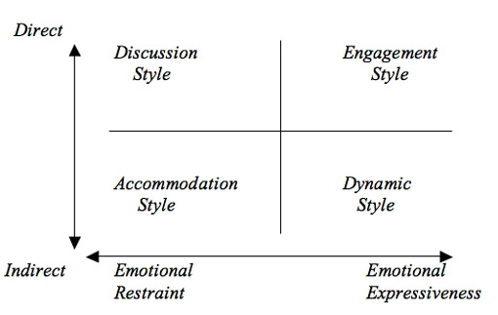
Q 2. How does your cultural background affect how you handle conflict? How might the Christian worldview as a “cultural background” influence the way someone might handle conflict?
Being from a strict Christian family, I have always tried to resolve my conflicts, whether they are of personal nature or cultural type, in the light or Biblical verse and teachings. The “Christian Worldview” discusses the conflict resolution by Rejoicing in the Lord always (Phil 4:4) and “By letting the reasonableness be known to everyone” (Phil 4:5a)

Q 3. If you travelled to another country, what elements would most likely cause you to experience culture shock?
I happen to travel a lot and most of my trips are international. Whenever I have travelled abroad, I have experienced a visible change in cultural values and norms. Sometimes, I have faced difficulty while adjusting to these new cultural values and traditions, which can also be referred to as cultural shock. The cultural elements that mostly become the reason for this cultural shock are the dressing style, language, food, climate and the social roles, different people are playing in society.

Q 4. What strategies do you think are most helpful for coping with culture shock?
Various strategies can be adopted to adjust to a different culture and adapt the values and traditions of a new culture. These strategies are:
- Being open-minded and adaptive
- Accepting the fact that it is completely normal to feel anxious
- Accepting the change and more appropriately, welcoming it.
- Trying to understand the values and the traditions instead of being aggressive and defensive.
- Using observational skills to learn more and more about the new culture.

References
Neuliep, J. W. (2017). Intercultural communication: A contextual approach. Sage Publications.

