Circle of Satisfaction
[Author Name(s), First M. Last, Omit Titles and Degrees]
[Institutional Affiliation(s)]

Circle of Satisfaction
Customer Satisfaction is a measure of how products and services offered by a company meet or exceed consumer expectation. It is important because it directly influences the health of the business. Customers will continue their association with a company either by buying their product again or by continuing subscription to their service, only if they are satisfied. Satisfied customers also encourage their family/friends/acquaintances to buy the product/services. It is measured through Customer Satisfaction surveys, analysis of customer behaviour and by several market analysis activities. Its most reliable indicator, however, is customer loyalty (longevity of the customers' association with the company).
Large and medium-sized companies usually have a dedicated customer service department that focuses on after-sale services and the experience of their customers during acquisition. Call centres, service centres, outlets, websites and their chat stations, email response teams and other teams that interact with customers directly/indirectly during and post-acquisition belong to customer service division. Service industries invest heavily in customer retention to achieve customer satisfaction. Many organisations have shifted their focus from customer churn reduction to pro-active retention. They regularly analyse the market and consumer behaviour in order to predict and stop customer churn.
The circle of satisfaction is one of the mega marketing concepts. All the three marketing concepts, buyer decision-making process, total product concepts and the circle of satisfaction make up "the marketing concept" (Fanning, 2019). This concept spins around how customers of a product or a service form expectation and later evaluate the quality, value and satisfaction that a product or a service can offer. After that, customers form attitudes that are the determinants of future actions of the customers regarding purchase; this attitude impacts the brand and product in the long-term. As the buyer decision-making process indicates, there are three time zones in consumer decision, before, during and after the purchase. These zones can also be referred to as stages, first pertaining to pre-purchase behaviour, second to the experience of product and service values while third to post-purchase behaviour. The circle of satisfaction commences in the first time zone when customer anticipates about the product quality. In the second stage, the customer experiences the quality while the circle of satisfaction mainly exists in the third time zone of the buyer's decision-making process, i.e. post-purchase behaviour. At this stage, the customer has consumed the product or service and based on the experience customer is assessing the exchange. After evaluation, an attitude is formed about the product, brand or the company.
The concept of the circle of satisfaction deliberates on how consumer enters in decision-making process, owing to some expectations from the product and how they will react in response to their operations (Fanning, 2019). It also considers the cumulative behaviour of a single customer and considering the collective behaviour of all the customers. Companies are able to get a competitive advantage in the market resulting from the collective satisfaction. Furthermore, this concept of the circle of satisfaction compliments other concepts in the key marketing concept.

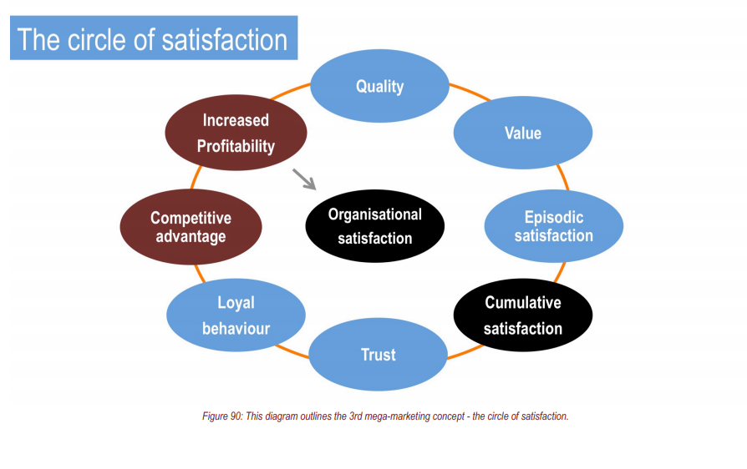
The circle of satisfaction consists of various stages; these comprise quality, value, episodic satisfaction, commutative satisfaction, trust, loyalty, competitive edge, high profitability and eventually high organisational satisfaction. Every product has to go through all these steps to achieve customer satisfaction and ultimately, organisational satisfaction. This report seeks to explore Netflix, the online video streaming service through all the stages of a circle of satisfaction.

Company Introduction
Commenced on August 29, 1997, Netflix, Inc. is considered a pioneer in the online video streaming and delivery of TV shows. The company's operations can be divided into three segments comprising domestic DVD, and domestic and international streaming of TV shows. For the revenues from the US domestic market, the company relies on the domestic streaming segment. Contrarily, the international segment is responsible for generating revenues from outside the US via monthly subscriptions. DVD by mail service is another segment of operations pertaining to domestic DVD segment. Netflix Inc. is amid the leading online video streaming service providers alongside Hulu, Amazon Prime and HBO Now. Netflix allows its subscribers unlimited access to TV shows on mobile devices, personal computers and TV. The company had licensed a large amount of content since 2007 when the streaming services were first launched. The content viewers can watch on Netflix ranges from feature films, movies, documentaries and original series to TV shows, for both local and international subscribers. Some of the subsidiaries are Netflix International BV, Netflix Studios, LLC, Netflix KK, Netflix Streaming Services, Inc., Netflix Entretenimento Brasil LTDA.
Netflix has gained immense popularity, and its subscribers belong to almost 190 countries as of the data until December 2016. The access to content also depends on location and time, and it keeps on changing accordingly. The company is always seeking opportunities for expansion in various potential markets and has set an excellent example of a prosperous global corporation. As part of its operations, the company has signed various partnership contracts with a different distribution, marketing and production companies, such as ABC/Disney and Starz, etc. Owing to its excellent performance, the company has shown significant growth in terms of revenues and operations in the past decade.

Stages of Circle of Satisfaction
In order to attain the marketing objective of customer satisfaction with the aim of organisational satisfaction, the first element to be considered in the circle of satisfaction is quality.

Quality
Customers evaluate their level of satisfaction based on the qualities they receive in the product or service. Before making the purchase decision customers try to assess the qualities in the service or product. Prior to the actual purchase, that is the first time zone of the decision-making process; customer perception plays a vital role. Products and services are embedded with many qualities such as emotional qualities, epistemic qualities, spiritual qualities, sensory qualities, functional qualities and social qualities (Fanning, 2019). Quality can be defined as the ability of a product, service, or process to provide the intended value. So basically it understands what the intended value is or in this case, we could say customer needs. A perceived quality need not be directly related to the reality of the situation one is attempting to perceive it needs to be coherent as a mental or perceptual entity. It is perhaps by sheer chance or more likely environmental Darwinism that our senses and perceived qualities that result accurately model reality to a certain degree of fidelity. Quality is something that is estimated, assessed and evaluated by the customer, though provided by the company. Generally, quality can be discussed in terms of three dimensions such as technical quality, functional quality and relationship quality.
Netflix's main product is its video streaming subscription service. Though they have other product offerings (e.g. DVD rental by mail, product placement advertising, brand licensing) most of these are also generally known as services as opposed to goods (Clark, n.d.). The only non-service Netflix products I can think of are its video content that is distributed by 3rd party in China and certain home video products they make themselves. Netflix is one of the most successful online video streaming service and service quality is a predominant factor that determines the success and efficacy of its operations. The services offered by Netflix are characterised by functional qualities such as performance, reliability and durability. The company aims at providing the best quality video and audio services, alongside protecting the privacy and confidential payments data of their subscribers. The business model of the company spins around the epistemic qualities since customers seek to reduce boredom by continuously watching the latest novel shows (Oat, 2013). Studies report that Netflix offers the most high-quality shows according to Business Insider based on customer ratings of the top five video streaming services. The company continuously commits to offering quality in the products and services.

Value
Value can be defined as the ratio of total cost and total benefits obtained from the consumption of a product or a service. When benefits outweigh the cost, the value of a product or service is considered worthy. Companies are the providers of value, while the customers are the judges of value. 'Value' is a subjective term, which may mean price or benefits or worthiness. A customer may pay the exact price, printed on the price tag. Apart from the cost, there are certain terms like time, energy, effort, travel, inconvenience, standing in a queue, etc., to be considered. Some customers focus on the honesty, integrity, trust, sustainability, ethics and morals of a company while buying a product. Similarly, the quality of the product, services, brand image, etc., have to be taken into account while measuring customer value. Value is subjective, and it is associated with wealth.
Netflix is aimed at creating value for its customers in many ways. First of all, the experiences of the content shared on Netflix is tailored to the interests and needs of different customer segments (Buckle, n.d.). It offers the viewers to choose from different narratives and in this way, offers a unique experience to each customer. In the example of Black Mirror: Bandersnatch, viewers can experience a sense of power and control. The increasing experience of users also enhances their ability to perform different tasks. Consumers are allowed to take charge and choose how the story unfolds; the decision making power is given to the consumers. The business model adopted by Netflix is based on joint profitability; value to both the company and customers. Netflix utilises the unique interactive experience and hence, by means of customer participation and engagement, the veiled needs of consumers are discovered. Based on the data obtained, the creative potential of consumers is utilised to develop new products and services (Bell & Koren, 2007). What is more outstanding in the case of Netflix is that it creates the "illusion of free choice" yet guiding the customers through several predefined choices. Customers, on the other hand, feel that that they have given a choice and have full control on the way they experience the content. In this way, customer engagement increases and eventually, Netflix offers them more content relevant to their needs and preferences. Hence, by way of active participation, Netflix, together with their customers, create superior personalised value for them that rewards to the company as well in return.

Satisfaction
When customers receive something beyond their expectations, value higher than what they anticipated, they are highly satisfied. On the other hand, if the customer receives something below their expectations, that are dissatisfied. When it comes to measuring satisfaction, customers are not able to distinguish between the types of satisfaction. Episodic satisfaction is referred to the satisfaction gained after one episodic transaction with the product, service or a brand.On the other hand, after the multiple episodes of transactions, the satisfaction consumer can calculate is total or Cumulative Satisfaction. It is sometimes also referred to as collective satisfaction. Next comes the aggregate satisfaction, where there are multiple total products, considered as single customer experience in his or her mind.
Netflix Inc.'s performance makes it an ultimate example of a company that disrupted the industry through exceptional customer experience. According to the statistics of 2016, Netflix reported about 75 million subscribers worldwide. The rise of this entertainment program is witnessed globally and is regarded as a tale of disruption. Netflix is regarded as a corporation obsessed with customer satisfaction. On such an approach is to provide personalised customer experience and allows its subscribers whittle down many choices through website personalisation. The company has developed algorithms to serve up customer artwork that allows its subscribers to watch the content that caters to their needs and taste (Hallinan & Striphas, 2016). With the Netflix app, Netflix can gather so much more information about each user, what movies they like, they don’t like, which movies they finish or stop short or skip through, what kind of movies do they watch over and over, what time of day do they watch movies and what days during the week, how their tastes change over time and as they grow older, etc. This data is powerful and valuable, it not only drives how the Netflix app works, but also what Netflix’ catalogue of shows/movies looks like and it now also drives the type of movies and shows that Netflix itself produces (Xu, Frankwick, & Ramirez, 2016).
In addition, customer engagement is the key to keep customers satisfied and retained. This is the reason for which a subscription company lives or dies. The recommendation system based on the customer data recommended shows and personalised landing cards creates an ultimate mechanism for choosing the shows. One more factor that is regarded as the major contributor to the excellent customer experience is responding to customers’ feedbacks. Customer insight is best utilised and shared across different teams in an organisation. The more people having data on customer insight, the higher is the likelihood of solutions and programs tailoring to customer needs.

Trust
After the multiple episodes of customer satisfaction, referred to as cumulative satisfaction, customers form an attitude towards the product. They generally come to the conclusion that they can trust a company or a brand. Having trust in a brand means that the customer is sure about he or she will be provided with the best every time they will interact with the company (Fanning, 2019). Customer trust is linked with the brand through a product or a service. Building customer trust can result in many benefits for the company; monetary benefits include high sales, revenue and long-term value of the business. Non-monetary benefits include high customer satisfaction, positive word of mouth and long-term value (Macintosh, 2007).
Building trust in customers is the toughest thing. On top of that, the company do not has that scope always to interact with every customer face-to-face. So, winning their trust and convincing them for sales is a hard job. Establishing trust with their customers is the most important thing they do at Netflix. Customer trust and safety of their personal data is always the priority of the company. To build trust with their customer companies generally, listen to them and understanding what they need to do in order to be successful in their business. Secondly, they also work to understand what problems they are trying to solve and how they will measure success.
Netflix is a customer relationship company that has been successful in strengthening its customer trust and brand loyalty. Netflix understands its customers better than the customers themselves by analysing every customer interaction. The company is a pioneer in building a direct relationship with their customers. Netflix climb from a DVD provider to one of the best video streaming services is stemmed from putting customers at the heart of the company (Smith, n.d.). From day one, the company lives on the philosophy of customer obsession; the culture of prioritising customers is spread across all the functional departments. Owing to having a molecular understanding of their customers, the company has been able to build customer trust. The big data approach company has employed informed this specific path; satisfied customers are the bottom line of the company.

Loyal Behaviour
Customer loyalty is an instrumental objective that leads to customer behaviour generally desired by every company and it is the outcome of customer satisfaction (Bowen & Chen, 2001). Loyalty is also regarded as a service that the customers provides to the company in return for their exceptional services. In an era of tough local competition and aggressive startups, every business wants to get the upper hand over its rivals. Technology and globalisation have been crucial in bridging boundaries amongst businesses today. Some of the ways to build loyalty include, Communicate with your customers. Engaging with clients will give them a sense of community and belonging. Luckily, social media platforms are an easy way to do that. Being consistent with the quality, customers should get the same feeling of satisfaction every time they purchase something from a brand. Here something is worth mentioning; no loyalty cannot be declared as dissatisfaction. Delivering promises whenever the company makes and providing customers with occasional surprises are also great ways to build loyalty. Be it a small gift or a discount; any client will be glad to receive something unexpected. One could occasionally throw such surprises to the most loyal customers (Jeyakumar, 2014).
Moreover, investing in customer service is a great way not only to keep loyal customers but possibly even turn some dissatisfied customers into raving fans. At a minimum, implement omnichannel customer support, respond quickly, and be polite. These are some of the most recommended strategies to build a loyal customer base. The success of Netflix not only lies in getting an increasing number of subscribers but having 805 of loyal customer subscribers. Netflix is said to have loyal subscribers base that gives a competitive advantage to the company over its competitors. According to a study by Recode, Netflix customers do not pay to their video streaming services such as HBO Now and Hulu (Molla, 2017). On the other hand, the subscribers of these companies do pay to Netflix, while amid Netflix subscribers, they remain loyal to the company. The customers of other competitive services want to have Netflix as their top choice. Owing to its loyal customer base, the company has been able to increase its rates without losing customers since customers are alacritous to pay higher prices. Every month loyal customers are subjected to new prices, resulting in a high market share of the company. As discussed in the above sections, customer obsession of Netflix has led to high customer satisfaction, high customer trust and eventually, a loyal customer base of millions of subscribers.

Competitive Advantage
The loyal behaviour of customers creates a situation highly desirable for almost all of the companies. The behaviours and actions of loyal customers lead to a competitive advantage for the companies. Generally speaking, competitive advantage refers to the actual or perceived advantage that a competitor has over his competitor for a specific competition, even before both have begun their efforts, due to some inherent qualities. A competitive advantage is a core competence (or combined competencies) an organisation has that differentiates it from the competition and is also relevant to its target audience. It needs to be sustainable; hence, it has to be in-built by the organisation, and cannot be purchased. "Word-of-mouth marketing" is a term used by the layman who is under the misconception that word-of-mouth activity is a method of marketing when, in fact, it is a primary goal of marketing. Many marketing methods are used to generate this result, starting with customer experience at the most basic level. That is a self-generated and inevitable result of making a sale and therefore requires no marketing efforts. Loyal customers spread positive word of mouth about the company, its products and services, and also go for repeat purchases over time. The positive word of mouth results in the most cost-effective marketing of the company and increases the customer base. This results in reduced cost of marketing and business operations increased sales revenue and high business value amid new and existing customers.
Many of the criticisms regarding competitive advantage of the company concerns their business model, characterized by low-cost monthly subscriber charges for a buffet-style video streaming service. Though Netflix takes benefit of being the first-mover in such a business framework, Netflix is somehow familiar with the fact that it is unsustainable if the competition increases from as other more experienced filmmakers. This disruptive business model seems unsustainable, though it was good for the company to gain traction in beginning years.

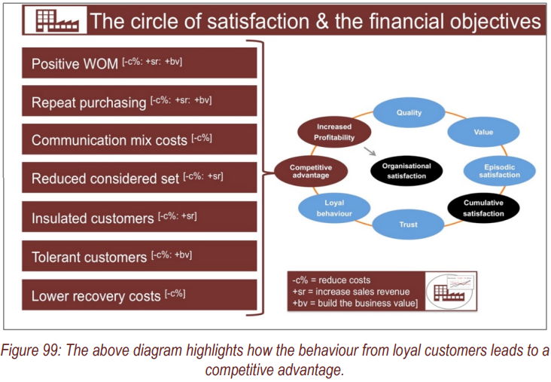
Many opponents also point to Netflix relatively new strategy to invest seriously in original and exclusive productions as not something that will sustain. They say that most of company’s profits are eaten up by the content. Though they have already increased prices, they cannot compete with Hollywood's Big 6 (who also happens to control the US TV production industry as well) in terms of content for US audiences. As Hollywood's Big 6 (i.e. Disney-Fox, Time Warner's HBO, Hulu) focus on streaming, they can take the US streaming market from Netflix. Though Netflix is spending big money to get big-name Hollywood talent (e.g. ABC's Shonda Rhines, Fox's Ryan Murphy), dependence on Hollywood for content is unsustainable.
The sustainable competitive of the company lies in its global strategy. The company is not yet available in all the countries, but it is planning to do so to produce international content. From live-action series (e.g. Black Mirror, Narcos, 3%) to Japanese Anime to documentaries Netflix is taking benefit its international connections to take on Hollywood. Additionally, Netflix has strengthened its brand in the minds of customer all over the globe, as a good content creator. Filmmakers also consider it a goof buyer of their content for international release. Given their string of efficacious projects, the company actually also elevates the appeal of their original films akin to the HBO or Disney.
The repeat purchases help companies calculate the customer lifetime value, which indicates how profitable or valuable one customer to the company is. The loyal customers who keep coming back and bring new customers to the company are the most profitable customers and offer high lifetime value to the company.

Increased Profitability
The primary source of revenue and profits are the number of subscribers on the company's website. The original content is not that profitable, yet it helps the company in attracting more subscribers. The financial performance of the company reveals that the company is one of the most profitable companies, and its continued success and growth has been witnessed. Some of the indicators of financial performance such as earning per share, stock price, sales revenue, number of subscribers, stakeholders statements reveal positive results about the company’s performance.
The profitability of Netflix arises from its edge over its competitors. Studies and surveys report that streaming content viewers consider Netflix much better than other streaming services. If one in the US, there's no shortage of services, but abroad Netflix tends to be the one and only choice. Prime is getting around as well, but with much less content. In addition, Netflix has the upper hand again in terms of originality of content, though alongside each good show came a load of duds. While Prime invests a lot, Netflix has the experience and pays well-known writers and directors to do good stuff (and every now and then gets a good actor to go along with it). Netflix invests a lot in content for other languages, and often it's great content. "Marseille" is an amazing series (subtitles are good too) and "Rain" might have just discovered some upcoming your stars. Prime has nothing here. Netflix has a lot more to offer which it cannot in some Asian countries due to licensing issues or costs, and that is the reason the subscription costs so much less than what it is in UK or US. Thus, for a movie buff or an individual with a high affinity towards cinematic content, Netflix is perfect.
Netflix is profitable, but looking at profitability alone is not enough in Netflix's case. That's because, for the company to make its subscription revenue model work, it has to pay in advance for a library of streamed content that makes its subscription compelling in the long run. In other words, Netflix it's profitable as the advancement made on content are amortised on the balance sheet and gradually expensed on the income statement on a yearly, basis which makes the company profitable from the accruing standpoint. That doesn't necessarily mean the company is not sustainable. But it poses additional financial risks for the company.

Conclusion
To sum up, Netflix has been the single best entertainment value the streaming customers can have, the customer service reviews reveal. It amazes viewers with the range of options available if you're willing to open yourself to new venues. In addition to a lot of mainstream American / British fare, shows from all over the world that was terrific and eye-opening that can never be viewed easily on regular TV or movie venues. The best thing is It all being available when viewers are available, and inclusive in the price makes it way easier to give it a chance. If one subscribes, they can enjoy all of it, expand their limits and try new things and it will amaze them. The high satisfaction of Netflix customers is analysed through the circle of satisfaction, it deliberates on how the company creates and offers quality to its subscribers, offers the high value that results in customers' satisfaction. Resulting from that, the company is able to build their customers’ trust and loyalty, a desirable situation for every company. This helps Netflix build competitive advantage and retain its position as the most profitable company that stems from organisational satisfaction. The success of a company can be regarded as many factors; Netflix is dominant because of the vast amounts of data it collects on its users. In the "old" way of consuming media, you would rent movies from a store, watch channels through cable or antenna, or watch movies in a theatre. None of these methods of consuming media provides much powerful user data at all, you can measure viewership in sample sizes, poll the audience, tabulate rental statistics and movie ticket sales; but that’s really about it. There's no entertainment company on earth (besides YouTube) that has more powerful data than Netflix, which allows them to fully understand their customers.

References
Bell, R. M., & Koren, Y. (2007). Lessons from the Netflix prize challenge. SiGKDD Explorations, 9(2), 75–79.
Bowen, J. T., & Chen, S. L. (2001). The relationship between customer loyalty and customer satisfaction. International journal of contemporary hospitality management, 13(5), 213-217.
Buckle, H. (n.d.). The Relentless Pursuit of the Perfect Customer Experience: A Netflix Story. Retrieved October 28, 2019, from Business 2 Community website: https://www.business2community.com/customer-experience/the-relentless-pursuit-of-the-perfect-customer-experience-a-netflix-story-02240302
Clark, T. (n.d.). Hulu is the best streaming service for high-quality TV and Netflix is a close second. Retrieved October 28, 2019, from Business Insider website: https://www.businessinsider.com/hulu-top-streaming-services-for-high-quality-tv-then-netflix-2019-9
Fanning, S. (2019). The marketing concept. themarketingconcept.com.
Hallinan, B., & Striphas, T. (2016). Recommended for you: The Netflix Prize and the production of algorithmic culture. New Media & Society, 18(1), 117–137.
Jeyakumar, N. (2014). Netflix-Loyal Customer Base.
Macintosh, G. (2007). Customer orientation, relationship quality, and relational benefits to the firm. Journal of Services Marketing, 21(3), 150–159.
Molla, R. (2017, October 23). Most Netflix customers don’t pay for other streaming services. But Hulu and HBO Now subscribers do. Retrieved October 28, 2019, from Vox website: https://www.vox.com/2017/10/23/16488506/netflix-streaming-services-hbo-hulu-subscribe
Oat, E. (2013). Analysis of Netflix architecture and business model. Seminar on Internet Working.
Smith, A. (n.d.). How To Create A Customer-Obsessed Company Like Netflix. Retrieved October 28, 2019, from Forbes website: https://www.forbes.com/sites/anthonysmith/2017/12/12/how-to-create-a-customer-obsessed-company-like-netflix/
Xu, Z., Frankwick, G. L., & Ramirez, E. (2016). Effects of big data analytics and traditional marketing analytics on new product success: A knowledge fusion perspective. Journal of Business Research, 69(5), 1562–1566.

