Unit 5 Hazard Control
[Name of the Writer]
[Name of the Institution]

There are different types of hazards such as fall hazards and mechanical hazards. Each of the hazards is threatening enough to risk human life. This paper will analyze falling off a lift and rotating equipment hazard.
Mechanical Hazard
Mechanical hazards are created as the product of either powered or the manual use of equipment, machinery, plants or some tools. One of the major types of mechanical hazards is rotating equipment (Osbourn, A., & Irwin, C, 2016).
There are different processes that are associated with rotating equipment such as pinch points. It refers to the simultaneous movement of the two parts together in a circular movement. There are several examples of it, such as feed roles, and belt drives. Wrap points are also included in it such as rotation of shafts such as PTO shafts, watch components and splined shafts. Shear points may also cause mechanical hazards such as cutting of soft material by the movement of shafts (Osbourn, A., & Irwin, C, 2016).
Risk assessment of the mechanical hazard
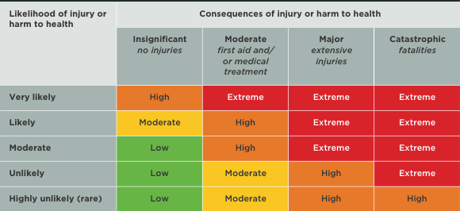
The risk assessment highlights that there are high risks associated with the rotating machinery.

Steps for risk assessment
Following are the steps that are chosen for carrying out a risk assessment
Risk categorization
In the first step, risk categorization is done in which the types of risk are defined along with its properties in terms of low, medium and extreme. These classifications were drawn on determining the intensity of harm that can be caused to the worker (Osbourn, A., & Irwin, C, 2016).
Risk assessment
Risk assessment refers to the decision regarding "reasonable practice". This step highlights how employees can be harmed. It includes identification in terms of the type of injury that might happen to the worker (Osbourn, A., & Irwin, C, 2016).
Risk evaluation
This step refers to the “what to do situation”. It infers and entails what is required by an assessor in terms of mitigating the risk. This step is one of the crucial steps because it highlights future prospects of the identified risk, or how can they be treated well (Osbourn, A., & Irwin, C, 2016).
Recommended controls
Following are the controls that are recommended to address rotating equipment hazards
One of the major controls is the use of training opportunities. It is a common observation that there is a less ratio of issues and damages when workers are trained and educated. This training can be in the form of self-protection or ensuring a safe working environment (Osbourn, A., & Irwin, C, 2016). Protective clothing is also one of the best measures because it can prevent serious damage to the human body. In addition, the use of better and up to date machinery is also one of the best options that can be used to overcome the rotating machine hazards.

Second Risk Assessment
After incorporating control measures, the risk can be reduced to very low, taking into account the measures of adequacy in the contrail measures.
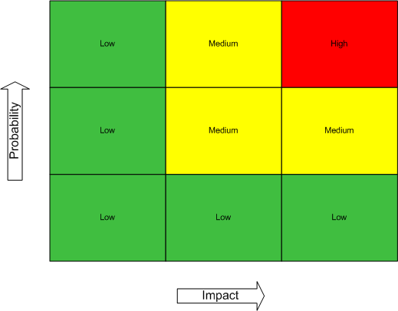

Falling off a lift
Fall hazards are one of the major types of hazards that are traced by workers on a daily basis. Fall hazard can be termed as anything that can enable an individual to lose balance and lead to a fall (Hau et al. 2007). There are different processes that can pave the way for falling off a lift such as a scaffold collapse under the weight of the workers as well as the weight of the equipment. Falling off a lift can also be caused by carrying a sheet of plywood on a flat roof (Hau et al. 2007). Some other processes are any kind of object in the way, or any designer flaw that might lead to the lack of functionality of life. Also, distraction and impaired physical attention can also cause falling off a lift.
Risk assessment of falling off the lift is as follows
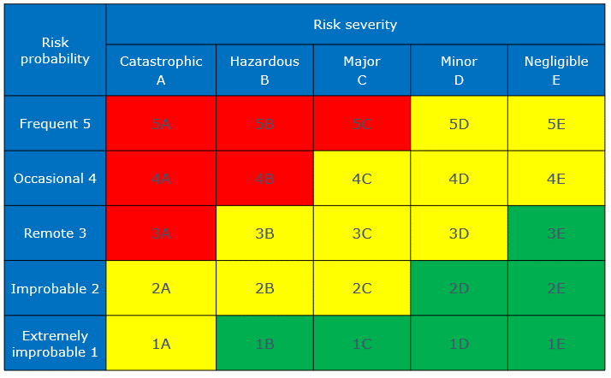
This risk assessment ensures that it is one of the major risks that the workers have to face while they are working in a lift.
Risk assessment

Following are the steps required for risk assessment
Step 1
The first step is to identify the hazards that can cause any kind of harm. It also includes the classification of the hazards, either it is physical, chemical, biological and mental. Then the subject will be analyzed such as the population who will be harmed (Hau et al. 2007).
Step II
The second step of risk assessment is an assessment of the risk and leading to preventive action. It means that the assessor must consider and analyze the likely hood of the harm. It includes special recognition of the risks that remains the same even after special precautions (Hau et al. 2007).
Step III
This step involves making a record of the findings that are made from the risk assessment. It is highlighted that this section should contain a detailed analysis of the risk assessment. This step is further proceeded by reviewing the risk, which can ensure that safe working practices are employees. Also, it will be a reference to some new practices that help to reduce the risk (Hau et al. 2007).
Control measures
There are different control measures that can be used for mitigating the ratio or intensity of risk associated with falling off the lift such as training of the employees, ensuring the assessment of the lift before it is being used. Then, employees should be taught to remain focused and a clean workplace should be ensured especially the lift that is under use (Hau et al. 2007). It also includes the prevention of oil splitting in the lifts and ensuring that the edges of the lift are not damaged and hammered. There is some other control measure as well such as the use of lifts that have strong walls and have the ability to bear weight and security initiative so that any fall can be managed appropriately and without any delay (Hau et al. 2007).
.

Second Risk Assessment
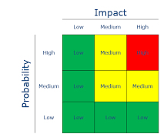

References
hau, N., Gauchard, G., Dehaene, D., Benamghar, L., Touron, C., Perrin, P., & Mur, J. (2007). Contributions of occupational hazards and human factors in occupational injuries and their associations with job, age and type of injuries in railway workers. International Archives of Occupational and Environmental Health, 80(6), 517–525. https://doi.org/10.1007/s00420-006-0158-8
Osbourn, A., & Irwin, C. (2016). ARREST THAT FALL. ISHN, 50(10), 73. Retrieved from http://search.proquest.com/docview/1833973811/

