Student’s Name
Professor’s name
Course Code
Date
MyRA
Q1: The myRA is defined in the article as a long term national saving for starter, which are used to cover many areas. The national account is described as the retirement saving accounts created by the department of Treasury for people without retirement accounts. Investment is regarded as putting a specific amount in terms of shares or bond for purpose of earning gains.
Q2: Loanable Curve after the introduction of MyRA
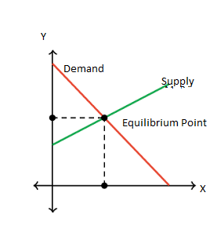
Diagram 1: Loanable Curve
The inelastic supply has a huge positive slope and an elastic supply has a small slope. When the supply is inelastic, it means that the investment and saving declined and therefore, interest increases. If the supply is perfectly inelastic then there would be response by private savers. If the saving and investment is lower, then the interest rate would smaller as well.
Q3. The old equilibrium is the equilibrium which existed before the change was introduced in the market and the new equilibrium is introduced by the market changes. The change in equilibrium is affected by supply and demand, when the products are over supplied the prices will be reduced and this affect the equilibrium (Sullivan, 2019, p. 14). In both cases, the equilibrium depends on the how the product is being supplied in the market and the demand in the market.
Q4.
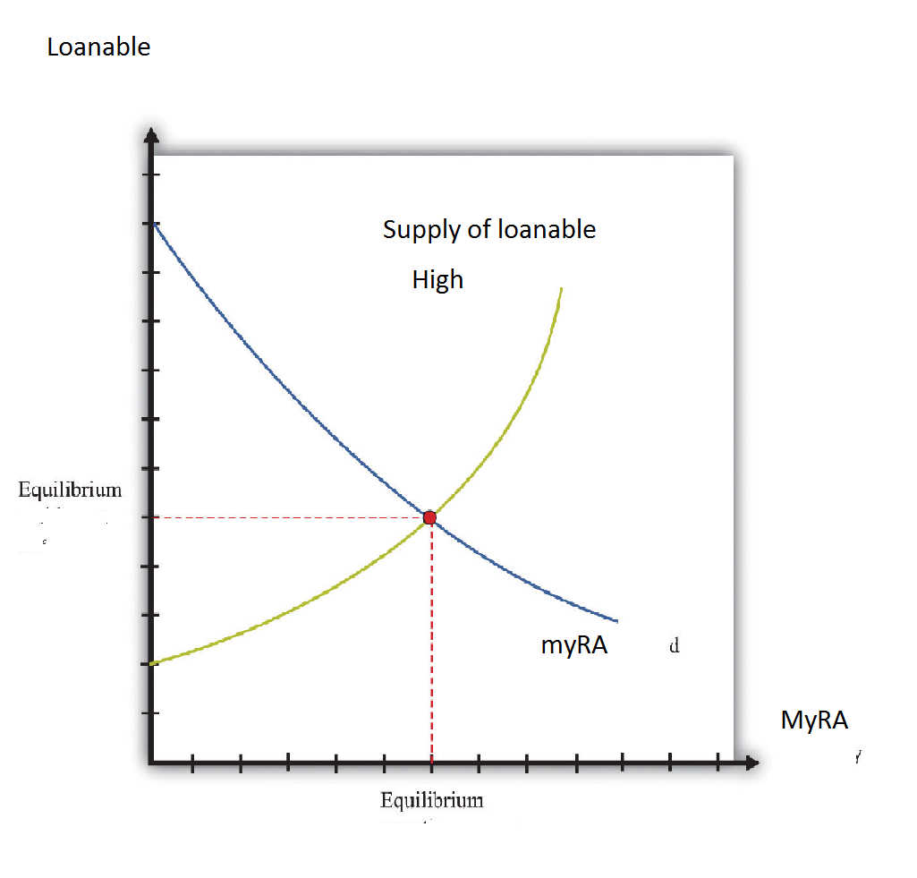
Graph 2: Loanable curve -Supply elastic
The slope curve means that the supply decreases when myRA is introduced by the government. It can be translated that when the myRA was introduced the demand become high and therefore, the supply reduced since organization could not provide loan top everyone.
- The equilibrium point indicates the point where the demand and supply are equal. And in graph 2, which is the second graph, the equilibrium is the point where the loanable could be enough for everyone wanted credit facilities. However, in graph 1, the equilibrium is the point where the demand and the supply are equal. At this point the credit facilities available can supply all clients, which are in need of the loans.
- The curves for part 1 and 2 are different because of the increase demand due to increase of income from the public. In part one the loanable is inelastic and therefore, the high demand does not affect it, in part 2, the loanable is elastic. It means that in part two, the position of the curve changes based on the increase or decrease of thee demand and rate of market supply as well.
- The introduction MyRA was meant to give Americans the financial security to ensure that the people can be able to access credits. The myRA was introduced by the government to create a pool of resources through saving for those who do not have retirement benefit scheme. First, it looks into the interest of the future by ensuring that people have enough security which can be used to secure funds. With myRA majority of Americans under the program can secure credit facility without difficulty. This is good for the economy because it increases the flow of money and business activities. It can also help in regulating the inflation rate because of the increase of the cash circulation through the program. It helps people to plan for their future, which is a good thing for the economy. By planning for the future, people would not burden the government after retirement. It would be able to give people who have been into the program, a decent housing, and living standard, which is a good thing for developed economy like the United States.

Works Cited
Roell, Sophie. "The Best Introductions to Economics." Economic Analysis (2018): 2-15.

An inelastic demand has a larger (negative) slope. For an inelastic demand, theincrease in the interest rate is larger but the fall in savings and investment issmaller. On the other hand, if the demand is elastic (small negative slope) thenthe change in interest rates is smaller but savings and investment see a largerdecline.

