1.In astronomy, light units are a convenient way to measure distances. Light travels at a speed of approximately 3×10⁸ m/ s which means that one light second is approximately 3×10⁸ m. Below we list seven distances in light-units and nine physical sizes. Match each distance to one size.
- light hour
- light second
- light year
- light millennium
- light minute
- light century
- light nanosecond
- across a small galaxy
- across the known Universe
- between planets in the outer solar system
- across a child's limb
- across a medium-sized country
- between planets in the inner solar system
- between stars in the center of our galaxy
- reach of human-made radio signals out into the Universe
- between the Earth and the Moon

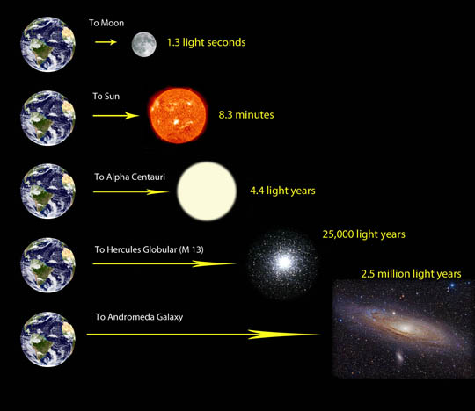
LicensePoints possible

2.When astronomers discuss objects that give off light, such as the Sun, we discuss a concept called "luminosity" which is measured in units of energy per unit time. Typically, this is given in "Watts", the same unit of power that is used to rate lightbulbs. The luminosity of the Sun is L==3.8×10²⁶ Watts.
However, the brightness of a luminous object depends on how far away you are from it. This is called the "flux" by astronomers. Flux is calculated using the formula F=L/4πD².
The flux of light we receive from the Sun here at Earth (a distance of one astronomical unit or =1 AU=1.5×10⁸ km from the Sun) is called the "solar constant". It's measured to be F=1362 Watts per square meter.
Saturn is 10 AU from the Sun. What is the flux that Saturn receives from the Sun in Watts per square meter? (HINT: There is a very simple way to calculate this using "scaling" techniques and realizing that Saturn is 10 times further from the Sun than the Earth.)
Watts per square meter.
Note: The exactly value of flux we receive from sun on the earth is 1344 watts/m² but you gave it as 1362 Watts/m^{2.} As per scaling technique the value of flux for Saturn would be 100th time less than value of flux for earth.
So I wrote both the answers. One of them is according to the value you provided and the other one I calculated using the formula.

LicensePoints possible: 1
Unlimited attempts.

3. Recall that light is a wave and so we can use the relationship that the speed of light is the wavelength of a photon multiplied by the frequency of a photon. . A famous photon in astronomy is the photon emitted by a hydrogen atom with a frequency of MHz. What is the wavelength of this photon in centimeters? centimeters.
The value for the wavelength of above photon is calculated as c/f= λ
3X10⁸ / 1440 X10⁶ = 0.208 m or 20.8 cm

4. Light that is red has a frequency of 4.5 × 10¹⁴ Hertz. What is red light's wavelength?
The value for the wavelength red light is calculated as c/f= λ. The value for the velocity was taken equal to the speed of light because red light travels faster than any other color so we took the velocity equal to the maximum speed of light i.e. v=c=3X10⁸ m/s. So, the calculated values for the wavelength of red light having frequency = 4.5 X 10¹⁴ Hz.
3X10⁸ / 4.5 X10¹⁴ = 6.66X 10⁻⁷ meters.
 | ×10 |  | meters

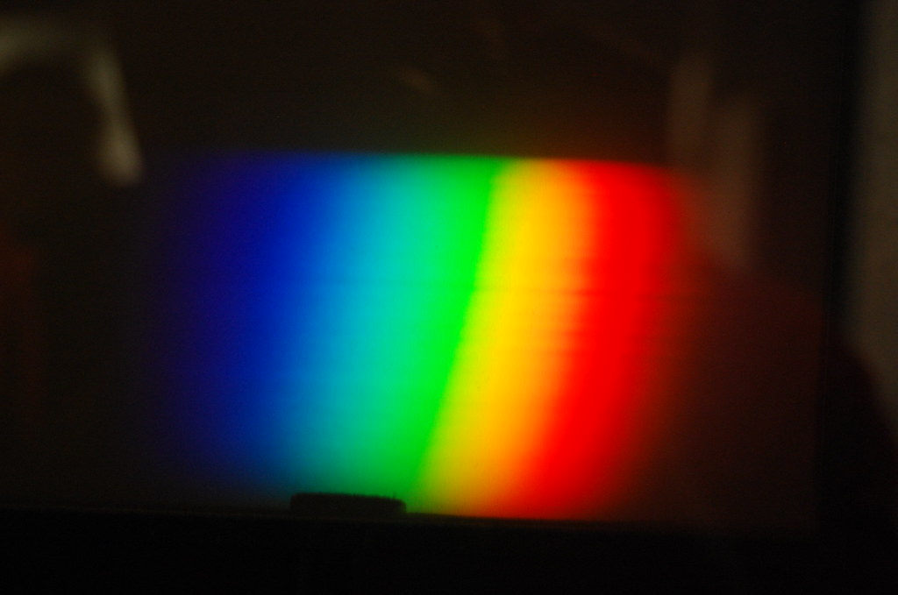
LicensePoints possible: 1

5. Kepler's third law states that for any object in a gravitational orbit,
P²∝a³
where P is the orbital period of the object and a is the average distance between the object and what it is orbiting.
In our Solar System, the natural units are distances measured in astronomical units (A.U.) and orbital periods measured in years. This can be seen for the Earth-Sun system which has an orbital period P=1 year and an average distance a=1 AU. Using these natural units in the Solar System, the proportionality becomes an equality, so for our Solar System:
(Pyears)²=(aA.U.)³.
Using your mathematical prowess, determine what the orbital period in years would be for an asteroid that was discovered orbiting the Sun with an average distance of 36 astronomical units.
years.
HINT: The following table of so-called perfect squares and cubes can be used to solve this problem without a calculator:
NUMBER | 2 | 3 | 4 | 5 | 6 | 7 | 8 | 9 | 10
SQUARE | 4 | 9 | 16 | 25 | 36 | 49 | 64 | 81 | 100
CUBE | 8 | 27 | 64 | 125 | 216 | 343 | 512 | 729 | 1000
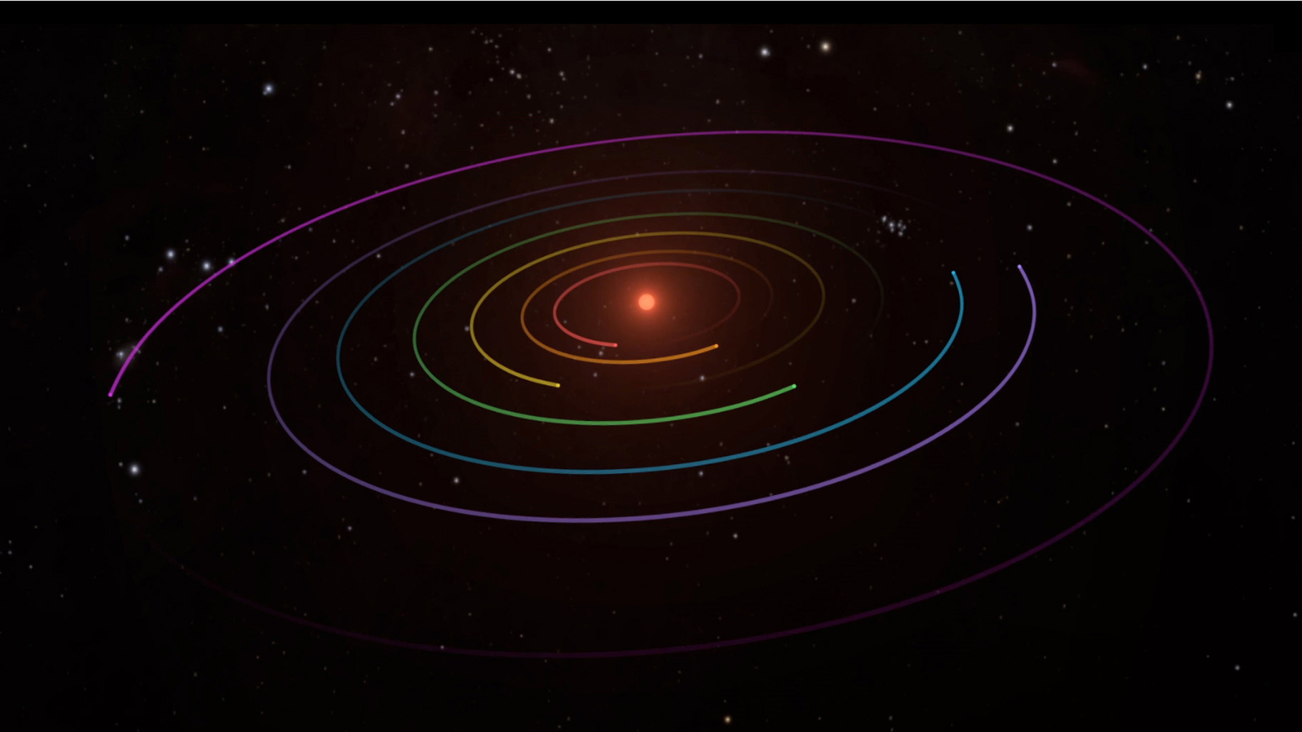

6. We use the equation escape velocity equation that
vescape=11 km/s, formula for escape velocity is v_{escape=} √2G(M⊕)(R⊕)−1.
On this basis, calculate the escape velocity from our Solar System in kilometers per second starting here at Earth. Hint: it helps to express the mass of the Sun as M⊙=3.33×105M⊕ and the distance between the Sun and the Earth as R=1 AU=2.35×104R⊕. km/s
. Hint: the galaxy has a mass of M=2×^{1017M}⊕ and our Solar System sits at a distance of R=4×10¹³R⊕ from the center of the Milky Way. km/s
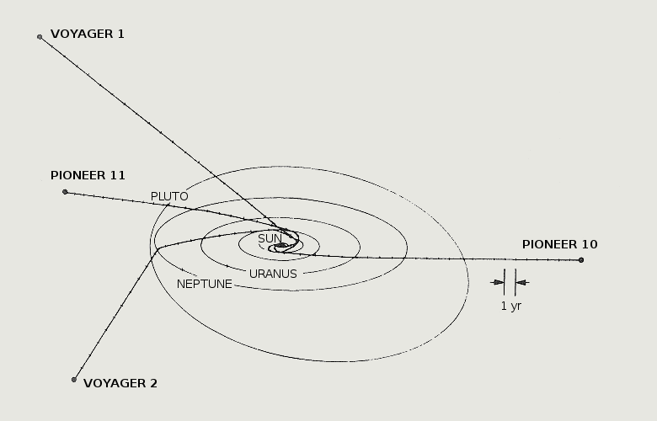

7. When you step on a scale in the U.S., your weight is typically given in pounds (lb) and you can easily convert pounds to kilograms (kg). Pounds are a measure of force while kilograms are a unit of mass -- you weight depends on the gravity at the surface of the world you are standing on, and the surface gravity depends on the mass and radius of the world. On Earth's surface, the conversion is approximately 1 kg = 2.2 lb.
The surface gravity on the Moon is about 1/6 that of the Earth. If you weigh 220 lb on a scale on Earth's surface, how many pounds would the scale read on the surface of the Moon?
pounds
Note: 36.4 lbf will be the weight on the surface of the moon.
What would be your mass in kilograms on the Earth's surface if you weigh 220 lb on Earth's surface?
kilograms
Note: if the weight on earth is 220lbf then corresponding mass in pounds will be 6.8lb and after applying conversion factor mass in kilograms will be equal to 3.08kg
What would be your mass in kilograms on the Moon's surface if you weigh 220 lb on Earth's surface?
kilograms
Note: Mass will remain same as mass is the base quantity and do not depend upon the value of gravity, so it will remain same on earth and moon. Weight changes on the moon’s surface because it depends upon the value of “g” but mass remains same everywhere.
Take a look at the surface gravity on the various other worlds: http://www.exploratorium.edu/ronh/weight/
If you weigh 220 lb on a scale on Earth's surface, how many pounds would the scale read on Europa?
pounds
Explain why worlds with a very low or very high surface gravity would pose a challenge for humans exploring such worlds.

