Name
Name of Professor
Class
Date

Billboard Advertising
- Mountbatten Program
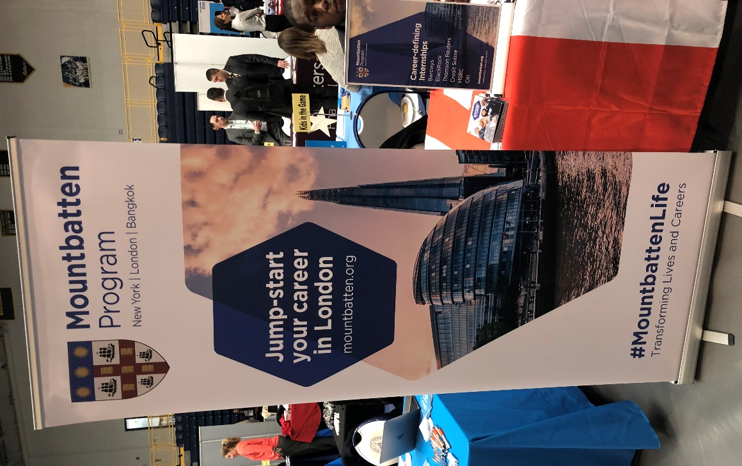
The business objective of Mountbatten Program is to ensure proper connection between successful international businesses and the motivated young professionals. Proper career directions are provided by this particular program considering the options of an international internship, and cultural exchange, etc.
This particular organization effectively utilize different aspects of billboard advertisement. The logo and the main features of the company are clear for the observers which are a good strategy to indicate potential customers about the customers. The tag line of the company, “transforming lives and career” is also successfully delivered through advertisement.
- PM Business Advisors
The organization of PM Business Advisor functioning in the market with the objective to provide necessary instruments to clients to ensure unique opportunities that eventually helps them to enhance their operations.
All the business services offered by the organization are clearly illustrated in the form of a billboard advertisement in the fair. The missing features of this form of advertisement are recognized in the form of proper contact address and the punch line of the business.
- Top Prospect Group
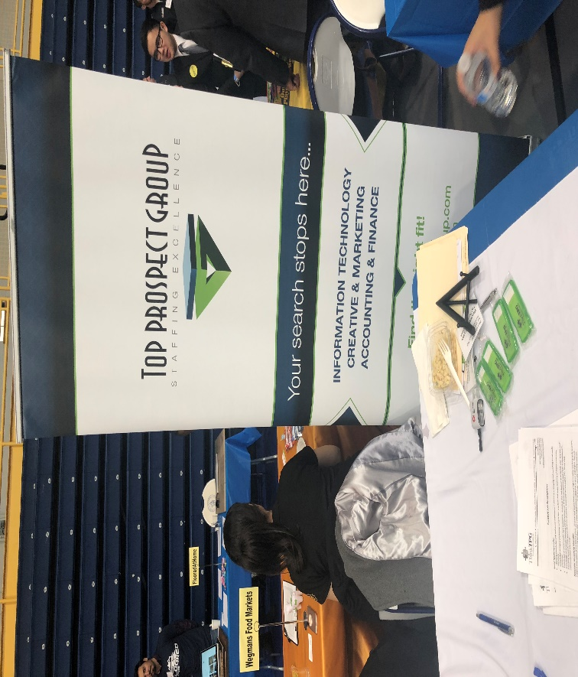
The business organization of Top Prospect Group deliver leading IT and finance/accounting solutions to its customers. A focused approach of this organization helps clients to identify suitable talent.
All the metrics of billboard advertisement are successfully utilized by this specific organization. The most attractive part of this form of advertisement is that the message of business is clear for the customers. The web address of the organization is also present to make it easy for the target customers.

- Barnum Financial Group
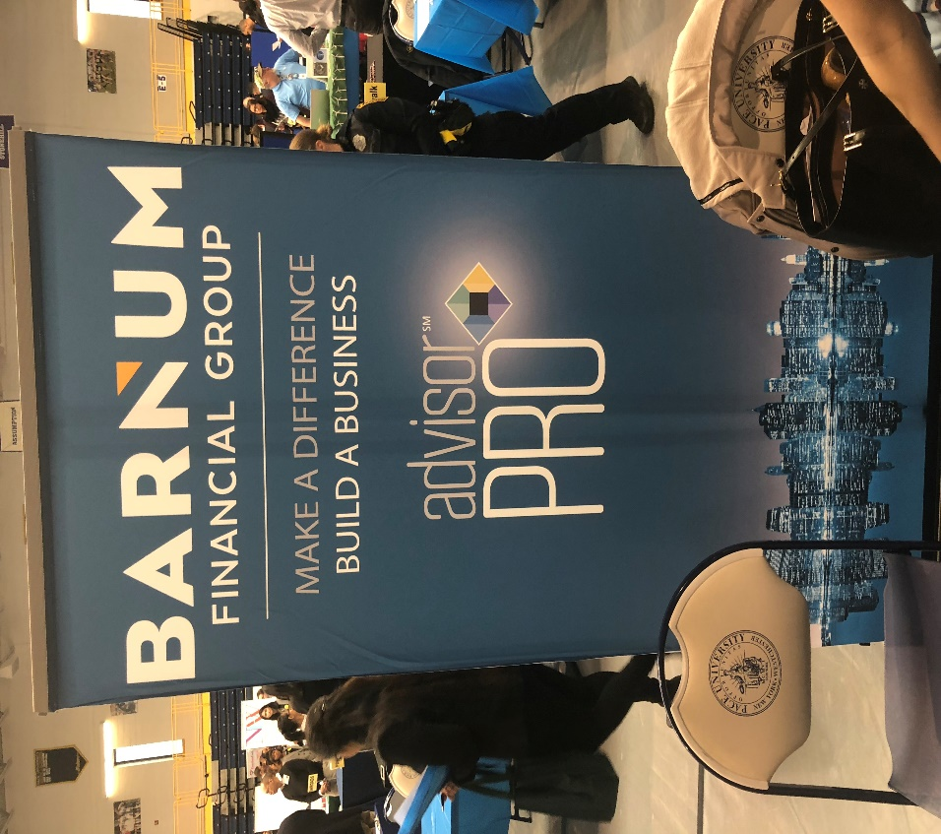
This particular organization aims to provide financial planning services to clients. The customized working domain is provided by the organizations to meet the actual financial targets of the customers.
The technique of brief business introduction is used by the company to introduce their business to the observers. Some important elements of billboard advertisement are missing that make it difficult for people to get a complete overview of the whole business.

- Capgemini America Inc.
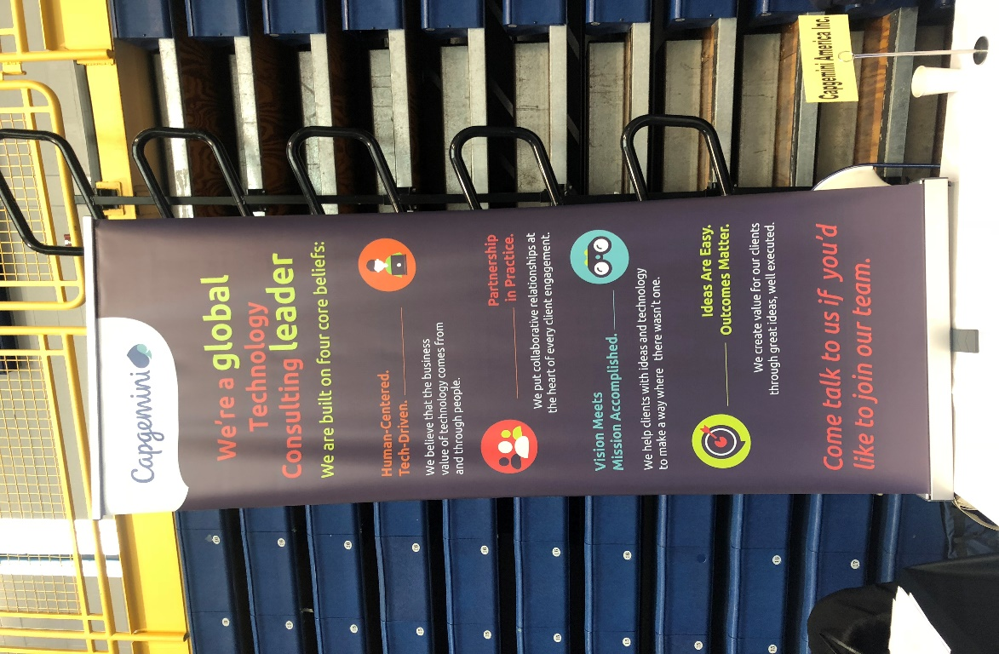
The Institute of Capgemini America Inc. is a business management consultant organization situated in New York City. It is recognized as one leading entity concerning the approaches of consulting, technology services, and the domain of digital transformation.
The billboard presented by Capgemini America Inc. is one great example of the effective use of billboard advertisement. Different organizational services are clearly explained at the billboard. Different visual effects are effectively used to grab the attention of the observers.

