Olfactory receptors
The receptors are members of the G-protein-coupled receptor family. The receptors play a critical function in identifying most of the odorant molecules in the olfactory sensory system. The spatial and temporal sequence of the olfactory receptors expression offers new intuitions in the transcriptional control of the gene family. The exceptional design of the custom array allows the attribution of the 3’ untranslated sections for the olfactory receptors which are crucial for the posttranscriptional control. The receptors are established in a patch of the olfactory epithelium that covers the medial and lateral walls of the top of cavity of the nasal. Olfactory receptors are specialized embryonic cells, bipolar neurons whose nuclei are located at the lower part of the epithelium.
On the cilia, the odorants acts on the receptors to produce the sluggish depolarizing generator potential. The interaction between the odorant and the receptor is so complex and in most cases, the process needs an odorant-linking proteins to transport the odorant via the mucus. The uniqueness of the bipolar neurons of the olfactory epithelium in which they are CNS neurons is because they experience constant nourishment and turnover from the basal stem cells in the epithelium. The human nose have approximately 400 types of scent receptors that are able to detect at least one trillion different odours.
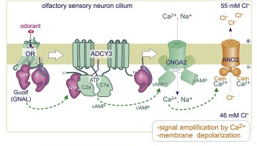
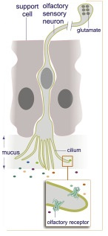 References
The olfactory receptors transmits sensory information to the brain and thus, it is accountable for the sense of the smell. In other words, it is responsible for the detection of the odorants which produces the sense of the smell. As a result, they are situated in the mucosa of the nasal cavity

Olfactory Receptors in Non-Chemosensory Organs: The Nervous System in Health and Disease. (n.d.). Retrieved from https://www.ncbi.nlm.nih.gov/pmc/articles/PMC4932117/
Olfactory receptors. - PubMed - NCBI. (n.d.). Retrieved from https://www.ncbi.nlm.nih.gov/pubmed/14999405
System-Wide Expression and Function of Olfactory Receptors in Mammals. (n.d.). Retrieved from https://www.ncbi.nlm.nih.gov/pmc/articles/PMC5903065/

