Genre: Interior
Your Name (First M. Last)
School or Institution Name (University at Place or Town, State)

.
Interior:
In art, interior could be defined as the work or the art that artist depicts for enhancing the impact of inside environment, in order to achieve a healthier and more aesthetic environment that would appeal people and would cast an impact in the visual art that would appeal like something mesmerizing for the viewer. Authenticity would be difficult to challenge in this case.
Work selected:
"Vincent's Bedroom in Arles" is one of his best works that have an unusual perspective and a kind of familiar subject matter and this piece of art is also one of his favorite works. This is a picture that depicts the interior setup of a bedroom and it showing peace her in this picture.

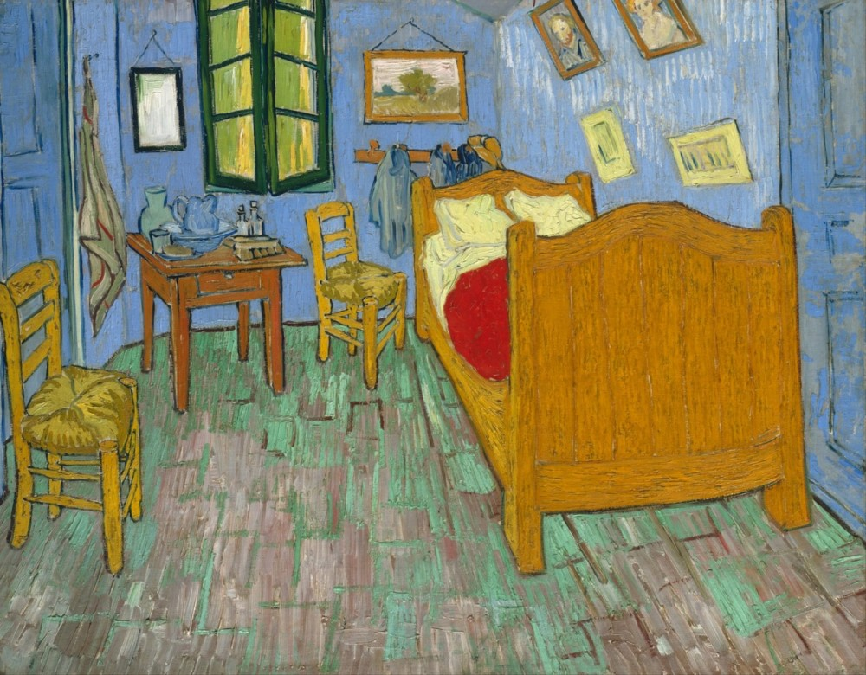

Formal characteristics:
Line:
The use of the line used by Vincent has given depth and character to this piece of art. The line that is outlining the bottom of the bed first caught the eye of the ones who have a great interest and taste for art and painting. It has been felt that there is a great distance between the bottom and the floor by taking a look at the outlining line (Kirchner,et,al,2018). Excellent use of the line is showing that bed was sitting directly on the floor. His use of the brush for lining is used in such a way that thickness varies immensely to give a depth to the painting. There could be seen depth mainly because the artist has made use of line in the floorboards that it is putting more depth into it.
Color:
Attractive colors have been used by Vincent for appealing the sight of viewers as it could be seen that the use of red and orange are catchy. Soft-hue of blue walls against the strong hue of bed frame along with the floor provides the viewers with a strong contrast that pulls the viewer into the painting. The strong hue of the table connects visual for looking at the chairs and the bed as well that are neighboring the chairs (Fonseca,et,al,2018). The color scheme that has been used by the artist for the table will force the viewer to look at other furniture that is there in this room. Brownish color of the chair and bed, used in this picture is giving a realistic touch to this piece of art. Abundant use of colors has been used for applying the style in things being depicted in the room.
Texture:
The texture of the painting gives a sense immediately of the wooden floor and frame of the bed. The texture of the painting also spots a light on the fabric that is hanging from the nail. By taking a deep eye on the painting, it could be seen that the artist has used different techniques for creating various impacts in the room. For giving it a wooden touch, floorboards are being given multiple layer coating of paint (Edwards,et,al,2018). The texture of the glass that has been used in window gives a sense of surface to the glass and Vincent has used the texture in such a skillful way that it gives the sense to the viewers that they can walk into the room. Use of squares and rectangles gives flow to this painting.
Composition:
Composition in art means putting things together, in such a way that they would make sense in all ways and the composition in this picture is perfect as it could be seen that all the things that are being placed in this room are making sense that there should be these things in a room that the artist has depicted. Bed, chairs, hanging paintings, blanket, pillow, window and other things that a bedroom usually carries (Barlow,et,al,2017). Things that are being placed in this painting are placed in a correct manner as all these things depict what a person may need while living in his bedroom. Composition gives a realistic touch to the picture.
Fitting of the work with the definition of the interior:
This work of Vincent is depicting the interior genre, as it could be seen that interior in art enhances the impact of things that are being placed inside a closed boundary. This piece of art is related to the definition and genre of the interior as it is depicting everything that is being placed inside Vincent’s room. It could also be seen that this picture is free from any external impact. This work relates to the interior genre as it is appealing to the senses of the viewers with its color scheme, color, composition, and texture that are part of interior. Interior of a picture always appeal to the senses of the viewer and catches his attention (Gould,et,al,2017). Interior is something that cast a great impact on the viewer about the things that has been used in a picture showing stronger impact of inside. This painting is also related to the definition of interior as the inner scenario of bedroom is totally being cut off from the external world and focuses on environment that is inside the room. Interior of any piece of art shows the most authentic things placed inside so this picture is quite relatable with the definition that has been given for interior and its realistic effect is appealing to the senses of people. This picture could be used as the best example when there is a need to show an artistic work which is spotting a light on the interior setup of the room.

References:
Kirchner, E., van der Lans, I., Ligterink, F., Geldof, M., Ness Proano Gaibor, A., Hendriks, E., ... & Delaney, J. (2018). Digitally reconstructing Van Gogh's Field with Irises near Arles. Part 2: Pigment concentration maps. Color Research & Application, 43(2), 158-176.
Fonseca, A. F. (2018). Representing pictures with emotions. arXiv preprint arXiv:1812.02523.
Edwards, C. (2018). Van Gogh Redux:“Loving Vincent”: From Quest to Pilgrimage, Games to Gravitas.
Gould, J. (2017). Alfred the Great (British History Makers). The School Librarian, 65(2), 114.
Barlow, R. (2017). Chronologica: The Incredible Years That Defined History. The School Librarian, 65(2), 114.

