Marketing plan
Nitika Karir (First M. Last)
School or Institution Name (University at Place or Town, State)

Introduction
A marketing plan of a company showcases its marketing strategies and guides an organization in marketing and promotion of its product or service of the brand itself. A marketing plan is an essential tool which guides the company regarding its marketing activities and the absence of an effectual plan results in the failure of a company or its product. When it comes to a global brand, the marketing plan is based on its target market from that geographical location. This report seeks to highlight the value proposition of Samsung and develops the marketing mix strategies for the Indian market.

The value proposition of Samsung
The value proposition of a company is the sum total of all the product offerings which includes the products, services, and other values that a company offers or promises to offer on customers interaction at any touch point. A value proposition makes the customers aware of the offerings of a brand which differentiates it from others. A well-crafted value proposition results are the key to the effectiveness of marketing activities and it generates superior outcomes for the company. Samsung is the well-known name in the arena of IT companies providing its segments of customers with the most innovative tech products. It is one of the largest electronic companies and according to the revenue and goodwill.
The value proposition of the company is based on three elements which remain at the heart of the company's operations. Quality, prices and design are the three pillars of the value proposition of Samsung (Čirjevskis, 2016). The company maintains the quality of its products by designing the eco-friendly manufacturing processes without compromising on the quality of products. The devices and electronics made by Samsung are known for their reliability and durability and user-friendly features manufactured using the energy efficient manufacturing designs. The second element of Samsung’s value proposition is the state of the art technology in its devices. Every new model is optimized by the increased performance, convenience to use, great designs and value for money (Čirjevskis, 2016).
Samsung targets a variety of customer segments and therefore it offers products with low prices against better quality and innovative features. This makes the company attractive to most of the customers especially in the countries having a large middle-class population such as India. The three elements of Samsung's value proposition upturns the competitiveness of Samsung (Čirjevskis, 2016). In order to offer this unique value proposition to its customers, Samsung is highly focused on the research and development and it is also the market leader in R&D, design and marketing. Analysis of customer value proposition of Samsung with the lense of PERFA Framework reveals the way by which company creates value in the form of performance, ease to use, reliability, flexibility, and the affectivity. The products made by the company are not only of good design but they are user-friendly developed on the basis of continuous innovation while keeping the aim of helping society and community (Čirjevskis, 2016).

Developing appropriate Marketing Mix Strategies
The Marketing Mix is a tool used in marketing planning and developing marketing strategies aimed at providing value to the customers of a company or a brand. The marketing mix is all about making the right combination of a company's product, price, place and promotion, also known as the 4Ps of marketing (Armstrong & Kotler, 2007). 4Ps are the factors that a company can control to influence its customers to purchase a product or a service. The marketing mix was developed in the 1960s by E. Jerome McCarthy. This model was later modified into 7Ps for service industries.
The first P in the marketing mix is referred to as the product which is the main item which satisfies the needs or wants of customers. Products are tangible while intangible products are referred to as services. The right product mix is based on certain questions such as the actual need or want of customers, the features that can satisfy those needs, the way product will be differentiated from its competitors etc. The second P is the price of the product, another very important component of the marketing mix on which the profitability of the product depends. While developing the right mix of price, the cost of the product, customer's perceived value and competitors pricing (Jain, 2013).
Place or distribution of the product is also vital for the success of the marketing strategy because the products have to be in access of customers. There are several distribution strategies, but the customer's needs must be kept in mind before adopting any placement strategy. Some of the distribution strategies are franchising, exclusive distribution, intensive distribution, and selective distribution. The last P in the marketing mix is the promotional or advertising strategy which aims at boosting the sales of products and it comprises of sales promotion, advertising, public relations and sales organizations. The promotions decision must also be based on the ways that are most effective in sending messages to consumers and communicating the value of the company’s offerings.

Product Strategies
The marketing mix of Samsung India elaborates all the marketing strategies that the company must adopt in order to deliver the value to its customers all over India. Since the value proposition of Samsung India is based on three key elements that are quality, price and design. These elements must be incorporated into the product strategies of the company in India. The increase in awareness and technological knowledge of the Indian consumers, Samsung must offer the whole range of products and services to the Indian consumers. This vast product portfolio must consist of smartphones, tablets, Television, cameras home appliances and many other accessories and products. Samsung already has a high market share in most of the product categories but it faces competition from the competing Chinese brands in terms of low prices and high quality.
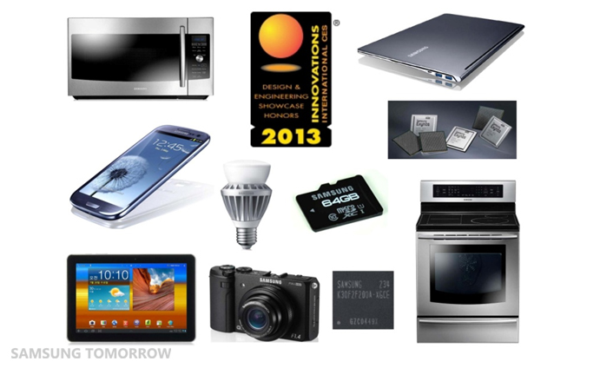
Figure 1 Samsung Products
In addition, Samsung smartphones are very popular in Indian electronics and it is the greatest sources of revenues and sales. In addition, smartphones remain at the top and are rising at a high pace. Samsung has to focus on innovation in order to differentiate the products from its competitors. The increasing Chinese mobile companies in India are giving a tough competition to Samsung smartphones, however, its smartphones are the key drivers of brand image. Samsung has to segment their products in different categories such as smartphones, home appliances, cameras, printers and peripherals, and other electronic devices. In each of the product category and the company must be focused on innovative cutting edge technologies to deliver quality and design value to its customers. At the heart of all the products the core product which is its actual use, the core product its features, and the augmented value such as after sale services must be incorporated to create value for the customers.
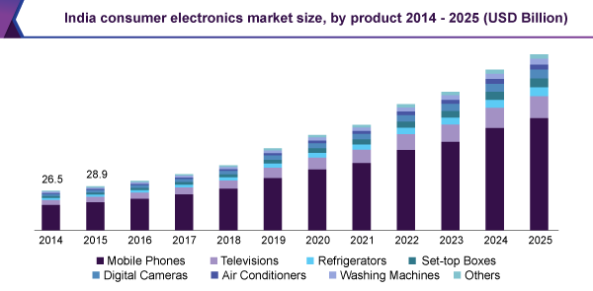
Figure 2Indian Consumer Electronics Market (“India Consumer Electronics Market Size & Share | Industry Report, 2025,” n.d.)
The company has to develop products based on extensive research and development, which has always been the key to success in the Indian market. The learning and knowledge gained from 20 years of Samsung's existence in the Indian electronic must be used and incorporated in the features and specifications of the products of the company. All the customer segments from the middle class to high-end consumers must be kept in mind while designing the products. India is well known for the largest middle-class consumer market which is the main source of revenues, therefore, it must be the key focus of the brand. The technology breakthrough can enhance Samsung's reputation as the strongest brand in the electronics market in India.

Pricing Strategy
Pricing strategy plays a key role in the success of a company. Samsung has to take care of the pricing strategies because it aims at providing excellent products to its customers at low prices. In addition, the company has a strong product portfolio serving a variety of customer segments, one pricing cannot work for all of the products and customers' segments. At the same time, the company seeks to increase its revenues and market share. Samsung has to use both the most leadership strategies and differentiation, depending on the segment that it is serving. For the middle-class segment, Samsung as to set prices that enable it to compete with the Chinese companies and for the elite class and upper-middle-class customers, it must adopt the differentiation strategies by offering cutting edge technologies.
For its smartphone market which is always changing and new models are coming up, Samsung must use the skimming price strategy like Apple. When the products will be launched in the market, they will be sold at a high price (Spann, Fischer, & Tellis, 2014). However, this type of initial price can be lowered to compete with competitors. In addition, this pricing strategy is highly useful for the innovation-driven electronic products market, especially the smartphone’s market. Another recommended strategy to Samsung is the implementation of competitive pricing strategy since the company aims at offering value to customers in terms of exceptional quality at the suitable pricing that could provide the value for money, competitive pricing is a suitable strategy.
Market competition must be taken into consideration while setting the price of products. In the smartphones market, numerous Chinese companies, Apple for high-end smartphones and others are competitors. In the home appliances market, LG is one of the greatest competitors, and in other products market, there are many players such as Panasonic, TATA, Whirlpool, Sony, and many others. Like the smartphone's market, Samsung faces tough competition from other market players in other markets, therefore, competitive pricing can assist the company is keeping up with the competition. Samsung must not consider penetration pricing strategy which is mostly adopted by the latecomers in the market, while Samsung already exists in all the notable segments related to the industry in which it operates.

Distribution Strategy
Products placement and distribution highly influence the sales of products and the growth of a product or a brand in the market. The distribution network highly impacts the availability and access of the products and services to the customers and it determines the profitability of the company. Samsung has to ensure that the distribution of the products is centred on the customers' segments and the products are easily available to the market for which it is being developed. Samsung has to use the retail chains to make its products accessible to different customers. All of its products must be available at the major retail chains of the country. The distribution network must consist of the dealers for its corporate sales.
Dealers can sell the products through the company’s showroom. Being the most reputed brand, the retail chains can keep the products of the company as the primary products. Samsung can adopt both the indirect distribution and direct distribution to offer the products. Samsung must have different distributors divided according to the geographical locations it must serve in the country. Online purchasing of electronic products in India is also very common and it’s increasing with the increase in reputed online retail stores such as Amazon which Samsung must avail to make the products accessible to its customers.
Samsung can directly sell to its customers without the involvement of any third party through its own online shop. Its stores and the customer care centres must be in all the major cities and markets of India so that customers can make a request in case of need. Service centres are very important to be in the reach of customers. Samsung must own their stores and they must also sell franchises which is an added source of revenue for the company (Gupta & Dubey, 2017). Samsung enjoys high goodwill in the market and therefore it has the opportunity to sell the franchises to some third party. The company can boost its sales by selling franchises and all it needs is to provide training to the personnel.

Promotion Strategy
The success of a company or a brand is centred on the effectiveness of its promotion strategies. Without exceptional promotion, it's not possible to communicate the value proposition to the potential customers and build a customer base. Samsung must not rely on one promotion strategy but it must diversify its advertising and promotional strategies based on its customer's segments and the product's offerings. The first promotional strategy is to offer discounts and price benefits to the customers on the products' launches and pre-booking discounts which is mort suitable for the smartphone's market. Since many new models are launched every year, Samsung must offer discounts to boost its sale.
For its other categories of products, it can offer discounts and high commission to the dealers for displaying and keeping the company’s products. This will motivate the dealers to sell Samsung’s products above its competitors, which is a push strategy. Samsung must also consider both the push and pull market strategy to promote its products. Some other push strategies that company can use consist of sales promotions, pricing discounts and offering coupons etc. in addition, the promotional strategies must be targeted at the right target market, for instance, for the promotion of home appliance, Indian households must be targeted.
The pull marketing strategy is also very effective in boosting sales of the company. These include advertising using social media, which is the most common and effectual method as the Indian market uses social media aggressively, and lastly positive word of mouth. Positive word of mouth is the most cost-effective marketing strategy which functions if the company satisfies its customers by providing them superior value, and it highly impacts the profitability of the company (East, Hammond, & Lomax, 2008). Email marketing, print media marketing, television, media coverage are some of the promotional strategies the company must adopt in order to reach the target market. The right promotional strategy is vital for successful marketing, therefore, Samsung must be focused on its target market and promote its products in the way best suitable for a certain market. In addition, fulfilling social responsibility, taking community initiatives and using its revenues for the betterment of society can enhance the reputation of business and results in positive word of mouth.

Conclusion
To sum up, the marketing mix of a company is an essential element of its marketing plan and it guides in marketing activities. The marketing mix of Samsung India, developed in the report highlights product, price, distribution and promotional strategies. The product and pricing strategies must aim at delivering the value proposition of the company. The placement strategy should make the product available to its customers while keeping the company's profitability at a priority. The promotional strategy must communicate this value to the right target audience.

References
Armstrong, G., & Kotler, P. (2007). Principles of Marketing (Principles of Marketing). Alexandria, VA: Prentice Hall.
Čirjevskis, A. (2016). Designing dynamically “signature business model” that support durable competitive advantage. Journal of Open Innovation: Technology, Market, and Complexity, 2(1), 15.
East, R., Hammond, K., & Lomax, W. (2008). Measuring the impact of positive and negative word of mouth on brand purchase probability. International Journal of Research in Marketing, 25(3), 215–224.
Gupta, P., & Dubey, A. (2017). Franchising and e-commerce a realistic business option: An analytical study of Intex Smart World. International Journal of Advanced Research in Computer Science, 8(3).
India Consumer Electronics Market Size & Share | Industry Report, 2025. (n.d.). Retrieved from https://www.grandviewresearch.com/industry-analysis/india-consumer-electronics-market
Jain, M. K. (2013). An analysis of marketing mix: 7Ps or more. Asian Journal of Multidisciplinary Studies, 1(4).
Spann, M., Fischer, M., & Tellis, G. J. (2014). Skimming or penetration? Strategic dynamic pricing for new products. Marketing Science, 34(2), 235–249.

