Exercise Activity 2
Student’s name
Institution

SPAM email
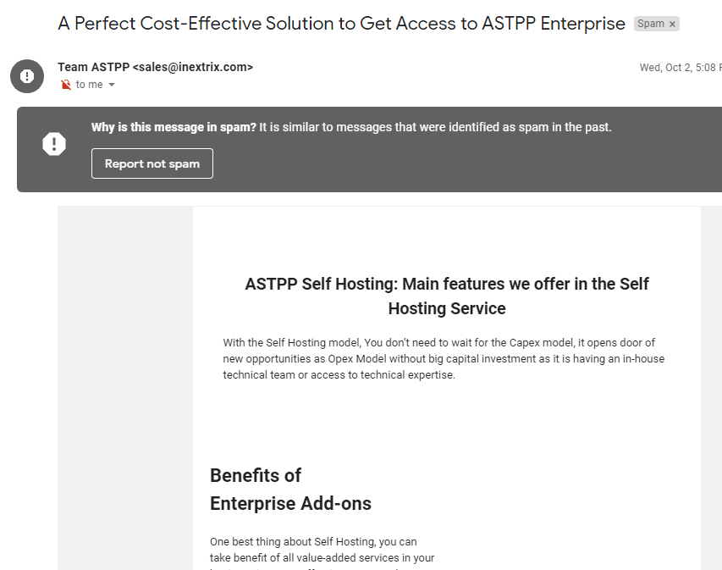

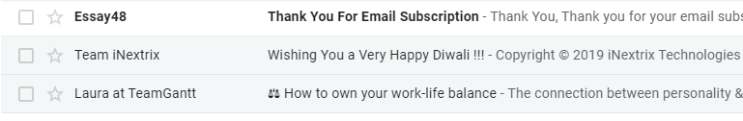
Identify whether an email is a spam or not has become very difficult. Some email accounts automatically filter all the incoming incomes and then categorized emails as spam and importance email. Gmail accounts have features, which help in filtering emails and categorize them. The filtering and categorizing emails ensures that a person does not provide importance information t0 a scammer. The email above is asking for some importance credential, which cannot be provided to any people through email or any form of media. The email was categorized as spam in the email account and therefore, it can be scam. The importance aspect, which indicates that the email is scam, is that there is no signed sender of email and therefore, nobody can take any responsibilities on damage caused as result of the email sent. The email is also categorized as spam under the emails tabs and therefore, it is evident that the email is a spam and should be avoided.
Spam or fraudster email is very risky an expose the privacy and access to the system hence exposes some critical information of the network and private information as well. The best action which should be taken is to delete the spam email and block any income emails from the said IP address or email account in the future. This will prevent any further communication from the email account identified. The scam should be deleted immediately to avoid creating any confusion. This means that the email should be removed immediately it realizes that it is spam. It is also important to scam a computer to ensure that there is no any background software or application, which is being used to monitor communication. These actions are required to be taken immediate to ensure that no further communication can occur and to avoid mistaking such emails as genuine and correct emails.

