The Pick’s Theorem
Student’s Name
Institution
Date

Introduction
Pick’s theorem is described as gems of elementary mathematics. It has the most innocent sounding hypotheses that entail a very surprising conclusion. Pick’s theorem is named after its founder George Alexander Pick. George Alexander Pick was born in 1859 in Vienna, Austria and spent a better part of his life in the academic field teaching at different universities. Pick discovered the first mathematics paper in 1875. And in 1899, he discovered theorem but it was not published until 1969 several years later. Pick has published over 70 different mathematical issues related o calculus, algebra, and geometry and therefore, he was regarded as the father of mathematical formula. The formulas he established were used and currently being used to solve various mathematical problems including calculating the area of a polygon. A lattice polygon is referred to as a simple polygon, which is fixed in or embedded on a grid, whose vertices are integer coordinates and are referred to as lattice point. However, if the lattice point of the polygon is P, then the formula, which is involved, is simply obtained by adding the points located at the boundaries of the polygon which is b, dividing by b by 2 and then adding the number of lattice points available at the interior polygon which is i and then subtracting 1 from i to get the area of the polygon.

Pick’s Theorem provides the simplest and the best method for calculating the area of a polygon. According to Schultz (2015), it is the best method, which is used to determine the area of a polygon, whose vertices are placed on a lattice. It provides a correct spaced array of point and therefore, it an important aspect in mathematics. Though polygon area can be tabulated using other methods such as using surrounding rectangular and partitioning into smaller pieces, pick’s theorem offers the best and alternative way of calculating the area of a polygon. Pick's theorem is, therefore; provide the simple and best alternative formula for calculating the area of a polygon.
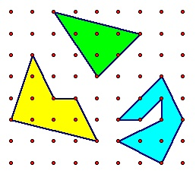
Figure 1: Polygon
The pick’s theorem illustrates that the area of a simple lattice polygon, which is S is always given as A (S) =i-¹/₂b-1= u-¹/₂b-1. In this case, i, b, and u are the number of interior lattice points. The number of boundary lattice points and the total number of lattice points of S (Varberg, 2014). However, to understand the formula of polygon it is important to look into the boundary and interior points of the polygon. The boundary point, which is B, is the lattice point of the polygon and it includes all the vertices. The interior point (i) is a point, which exists in the interior region of a polygon. As stated by Varberg (2014) pick’s theorem applies the description to highlights the area of a polygon whose vertices are lattices points. The formula of the Pick's theorem is, therefore, defined as
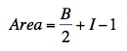
Pick's theorem is, therefore, provides the best description of a polygon and it is the true construction of polygon. The polygon is, therefore, used to construct from n and 1 triangle. Pick theorem is, therefore, an important factor for tabulation of polygon area. According to Pick's Theorem, the calculation of the area of a polygon is done simply by counting the points allocated on the interior and on the shape of the boundary (Kowalski, 2014). Without the use of Pick’s theorem, it might be difficult to tabulate the area of lattice polygon. Larsson and Lofberg (2014) pointed out that the decomposition of lattice polygon to form triangles has provided the best way to solve the problem of a polygon without pick's theorem. This could be done by tabulating the area of each triangle using the sine rule and therefore, it assumes that the area of each triangle gets the lattice polygon. It is also pointed out that the Shoelace theorem operates side by side and it is used to find the area of any figure when the coordinates are given. Larsson and Lofberg (20140 argued that pick's theorem provides the best and simple way to solve a mathematical problem which includes calculating the area of a polygon. Shoelace theorem could not provide the simple method though it is being used for the calculation. According to Larsson and Lofberg (2014), pick's theorem provides the best way of calculating the polygon a simple way compared to Shoelace and other methods used in the calculation the area of a polygon. The Pick's Theorem is, therefore, entails the use of the interesting corollaries as illustrated below:
Proof
Pick’s Theorem illustrates that, let P to be the lattice polygon and the B (P) to be referred as the number of lattice point, which is allocated at the edge of P and I(P), which is to be the number of lattice points, which lies on the interior of the P of the polygon. According to Kowalski (2014), the area of P denoted to A (P) is equal to B (P)/₂ + I (P) – 1. Studies have shown that this kind of formula allows the simplest and the best calculation by simply tabulating the area of polygon or lattice polygon with vertices lies on the integer coordinates, with just one simple question. The formula used in the theorem is simple to draw a conclusion on the concept and therefore, it is easy and simpler to use in solving polygon problems. The problem of polygon question can be solved by using only one simple question. It means that the area of a polygon is always half of the integers and therefore, it is easy to prove the lattice using rectangular. The rectangular then provide a clear illustration or the formula for calculating the area of a polygon using rectangular.
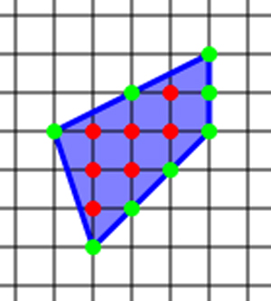
Figure 2: Rectangular with holes
The polygon above is an example of a rectangular. In the above polygon i = 7 and b = 8. According to Pick’s Theorem the area = 7+ frac (8) (2) – 1 = 10 and thus provide the correct area of polygon above. The area is calculated by the number of rectangular allocated on the polygon. The Pick’s Theorem is used even to calculate very complex a simple polygons. Some of the polygons are not intersecting themselves and do not have any holes and it can include in the holes for easy calculation. The Pick’s Theorem is used to calculate simple questions of an area of a polygon with holes.

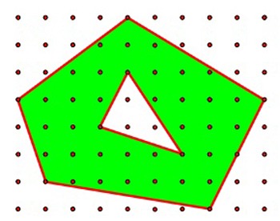
Polygons with Holes of Pick’s Theorem
The Pick’s Theorem indicated above could be solved by focusing on the green color. The theorem would then be applied on the green shape without holes and then subtracting the established area of the hole. The Area of the green shape which does not have holes applying Pick’s Theorem and the area of the rectangular of the hole using Pick's Theorem and therefore, the total area of the shape is established to be (Raman & Ohman, 2014). The approach to solving the problem can be expanded to a polygon, which has any number of holes. However, if it happens to interested in proofing the existence of Pick’s Theorem is could be too long but very hard to comprehend. And therefore, proofing the formula of Pick’s Theorem is quite challenging and it is time-consuming. It means that the Pick's Theorem formula is the best way to solve the area of a polygon and this could help to formulate the formula. It is, therefore, clear that counting holes or dots within the polygon are one of the simplest ways to establish the area of a polygon.
The Equilateral Triangles
It has also been established that Pick's Theorem can apply to indicate that it is difficult to draw an equilateral triangle to a lattice to allow each vertex to exist on a grid point. However, imagine that there is an equilateral triangle, which has a base of b, and height of h. In order to tabulate the height in terms of a base is, therefore, necessary to use Pythagoras Theorem.
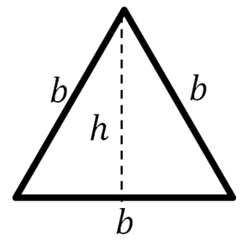

Diagram 1: Triangle used in the application of Pick’s Theorem

For instance, we must first calculate the area using the formula to get the accurate Area of the triangular. The area of an equilateral triangle is, therefore, could be obtained using Pick’s Theorem. It is, therefore; prove the importance of theorem is the calculation of the area of various objects (Conover, Marlow, Neff, & Spung, 2015). The formula being used in the calculation of triangle should, therefore, be full because a complete drawing is needed for equilateral triangles. The Pick's Theorem, therefore, holds true for any triangle, which shares its enclosing rectangular.

Conclusion

Based on several studies, it is evidence that Pick’s Theorem is an important mathematical theory, which has been used to calculate the area of several objects. It was discovered by George Alexandria Pick and since 1899 has been used to help to address several mathematical problems. The Pick's Theorem is, therefore, used for the calculation area of the polygon through small rectangular, and small colored dots or small hole to give an accurate answer. It is also important to note that the formulation or generating the Theorem formula is hard and its application is simple by using derived formulas.

References
Conover, B., Marlow, C., Neff, J., & Spung, A. (2015). Pick's Theorem.
https://sites.math.washington.edu/~julia/teaching/445_Spring2013/Project_Pick.pdf, 2-34.
Kowalski, J. M. (2014). Recurrent Theme of Pick’s Theorem.
https://arxiv.org/ftp/arxiv/papers/1707/1707.04808.pdf, 2-31.
Larsson, E., & Löfberg, H. (2014). A Proof of Pick’s Theorem. Mathematical Communication,
2-15.
Raman, M., & Ohman, L.-D. (2014). Two Beautiful Proofs Of Pick’s Theorem.
https://pdfs.semanticscholar.org/12b2/234857bc83581fe972820a4d6955b9feb322.pdf, 2-34.
Schultz, K. (2015). An Investigation of Pick's Theorem.
http://jwilson.coe.uga.edu/emat6680fa05/schultz/6690/pick/pick_main.htm, 2-34.
Varberg, D. (2014). Pick Theorem Revisited. https://faculty.math.illinois.edu/~reznick/496-2-6-
17.pdf, 2-34.

