[Your Name]
[Instructor Name]
[Course Number]
[Date]
Chirisei Kyubiki Painting
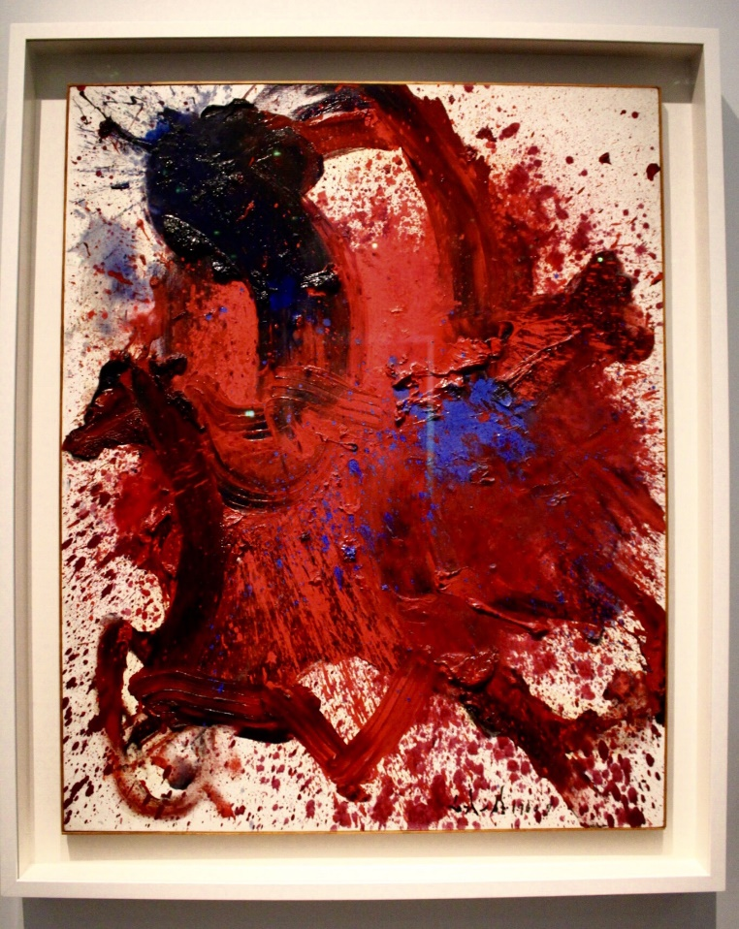
There is something intrinsically amazing and beautiful about raw emotion. OK, this could be difficult to deal with if it is directed at you but when it has used in the expression of artistic intent, then it gives the viewer and open and honest of what the artist was feeling or what were the feelings of the artist at the time of creation. Chirisei Kyubiki is the painting that left the legacy of the creator who was Shiraga after he died in 2008. This painting made by him got internationally acknowledged and recognized after his death. The paint he created is the result of the performance technique which has been sued for more than ten years. He has been pushed for such credibleness by this piece of work. For the creation of this art, the artists (Shiraga) had suspended him from the ceiling on ropes, after pilling the paint of the canvas, then pushing the paint around with his feet taking the energy of his feet and full body as well as body moments to create the arcs of patterns (WidowCranky, N.P). To me, it feels like the emotions of Shiraga are demonstrated in the shape of aerial dance which is so raw.
This art is a consistent negotiation of space, both in its creation and reception. This painting is presently in the Louvre Abu Dhabi. At the first click when I see it before reading the curator written about the paint, I felt that this is a Japanese warrior riding a horse into a battle. The very limited palette led me to the feeling of the violent battle as the red paint splattered across the perceived horse and its riding, almost indicating a tumultuous struggle, despite there being no opponent.
This work of art of the Shiraga has a very clean and clear Avant grade feel to it which pushes a movement of performance painting to new horizons at the movement he created them (WidowCranky, N.P).
This piece of work (art) has been mainly created and came to see in the year of 1960. The Shiraga has a huge range of artwork but this one is considered as the most credible one because of the hard work put to create the work. The art has been made by the creation of a mixture. There are a number of things used in almost every art, artists create (The Art Newspaper, N.P). Similarly, the common things or items used in this piece of work include oil, colors, and other materials commonly used in the artwork. According to the Shiraga, the creation of this art and the work to create this art was like a struggle between myself, the color, and the matter. Despite, Shiraga also stated that “I want and prefer to paint as though rushing around a battlefield, exerting myself to collapse from exhaustion.” Kazuo Shiraga.
I preferred to choose this painting due to a few reasons behind it. One is the painting is a credible work that shows and conveys the overall legacy of the artwork of the artist. Beyond that, the piece of work has been chosen because it has been made with almost very efforts as well as it clearly defines the hard work put by the legendary artist “Shiraga”.

Work Cited
"Chirisei Kyubiki - Kazuo Shiraga Japan 1960. Oil on Canvas. Louvre Abu Dhabi May 2018 - Pinstagram in 2019 | Kazuo Shiraga, Louvre, Art." Pinterest. N. p., 2019. Web. 5 Nov. 2019.
The Art Newspaper. "A Sample of the Louvre Abu Dhabi Collection." Theartnewspaper.com. N. p., 2019. Web. 5 Nov. 2019.
WidowCranky. "Chirisei Kyubiki – Kazuo Shiraga" Widowcranky.files.wordpress.com. N. p., 2019. Web. 5 Nov. 2019.

