Representation of ‘Muslims’ in various Media Platforms
Your Name
[Institutional Affiliation(s)]

Author Note

Culturally Relevant Social Work Practice
Social media has become a really important means of communication in the present world. A wide range of people is influenced by the tools of social media as media has the responsibility of reporting stories that catch the interest of people. Islam is the fastest growing religion in the world, especially in West. Media represents the Muslims both positively and negatively to the world. However, due to media promotion, there are many misconceptions and stereotypes about Islam and Muslims in the West. There are many factors that lead to this misconception and misinterpretation of such a peaceful religion.
Background Literature
Many media campaigns are taking place in the world against the Muslims and their religion Islam. The media is trying to show an unacceptable picture of Islam to the public. On the other hand, the Muslim groups are trying to give messages to the world through various media platforms, but as compared to the western media, the effects of Muslim campaigns is in vain. Muslims are being viewed as the extremist terrorists following a terrorist radicalized and fundamental religion. The most relevant example of the 9/11 event is used by the Western media for capitalizing its political gain. Muslims are represented as terrorists that pose a threat to the security of the western countries. The media representation of Muslims in a negative way has raised many questions for the general public as well as the policymakers, causing public panic in the Muslim communities and other communities of the world. Emergence of Islamophobia is also because of the negative representation of Muslims by media.

Data Source

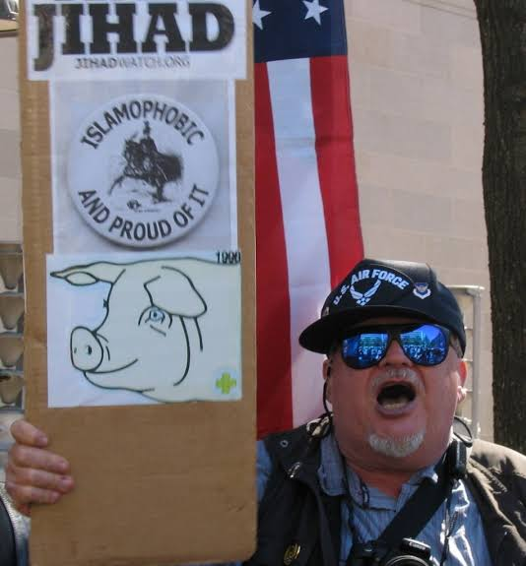
(F. Espiritu, 2018)
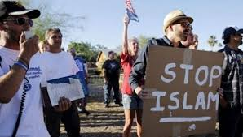
(“US Islamophobic Groups Spend $205 Million to ‘Spread Hatred,’” 2016)
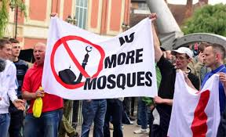
("The US hate crimes targeting Muslims up almost 70 per cent," 2016)

Themes
The following themes can be developed based on the above media representation of Muslims and Islam.
Identity
Islam has always been displayed as a violence prone religion by the global media. Various discourses, analytical writings, academic conferences, and other publications have been carried out in which the Muslim identity has been questioned. In 2007, F.A Noor presented an argument that, “Muslim identity and the concerns of Muslims are increasingly being defined in terms of an oppositional dialectic that pits Islam and Muslims against the rest of the world” as Islamophobia has become the mainstream media discourse “where images of Muslims as murderous fanatics abound in movies, videos and computer games.” The general media coverage representing Muslims as terrorists has caused them to lose their national identity and has created a feeling of hatred for Muslims all over the world (Lajevardi, 2019).
Prejudice
The poor representation of Muslims and Islam by different platforms of media has created a negative image of Muslims in the minds of people, and they have prejudices regarding the image of Muslims. According to a conducted research, the media depicts Muslims strongly and closely associated to terrorism that has evoked feelings of threat in the Western societies, and such misinterpretations have led to prejudices about the norms and practices of Islam. This prejudice can also be linked to the development of severe racism for Muslims in western countries.

Hatred and Discrimination
The media platforms cover the news about terrorism and connect Islam and Muslims to terror, war and bombing. Unfortunately, TV news and documentaries have the strongest influence on people's views of Islam and cause the non-Muslims to develop a feeling of hatred and a dark image of Islam. A major example of this hatred is the organization of “international Quran burn day” in Florida by Pastor Terry Joneson. This event was largely covered on the electronic and print media and Muslims were hardly given any opportunity to express their opinions or say something about themselves or their religion (Patil, 2015).
Discussion
The portrayal of Muslim by media is mostly negative, but there are many Muslims who have used media to express themselves and portray the acts of Muslims something other than terrorism and violence. A student at the University of Colorado Boulder named Herra Hashmi created a 712 page Google document that listed all cases where Muslims had condemned violent acts done in the name of Islam after one of her classmates asked her if there are any Muslims who condemn such acts. She even launched her website and publicized her document on Twitter and Facebook to spread awareness around the globe and create a positive image of Muslims. A campaign named “True Islam” was started with an aim to make others familiar with the Muslims and their culture and values. The campaign started a website that used to discuss 11 facts about Islam which combat the myths that are false and are displayed on media. The aim of this campaign is to teach the true concepts of Islam to people and make people aware of the wrong interpretations about the religion and the people who follow it. A journalist at Huffpost, Rowaida Abdelaziz deals with the topics related to Islamophobia and the civil rights issues in the United States. Rowaida tells that she joined the field of journalism as she experienced a negative portrayal of Muslims by media since her childhood. Through the power and techniques of storytelling, she tries to create awareness about the positive aspects of Islam in the media (Phillips, n.d.). Islamophobia, the fear (phobia) of Islam has emerged after the 9/11 bombing in New York City, causing many people in the world think negative of Islam and the Muslims. The biggest misconception existing about Muslims and Islam is the real truth about Jihad that means “struggle in the path of God.” Media has proposed a wrong definition and concept of this word that is “Killing of people unreasonable by the Muslims.” It has given an impression to the world that Muslims are extremists and terrorists. An internet survey was carried out by the Global Market Insight involving 1360 people which resulted in 40% people blaming the anti-Islamic feelings created by media about Muslims.
Summary
The western media always portrays Muslims as stereotypes and extremists, which they are not. The main reason for this distance and gap between Muslims and the West is media that plays a vital role in creating a negative image of Muslims and their religion. The minds of people are stuffed with movies, pictures, and posts against the Muslims that are not true. A moral panic has been created globally as the media reports Muslims as violent, cruel, and immoral that causes Muslims to be seen as terrorists and extremists by the world. Public awareness should be raised in every country through electronic and print media so that the general public gets a clear image of the Muslims and the ill representation of Muslims on media platforms gets changed.

References
F. Espiritu, D. B. (2018, February 14). Islamophobia and the “Negative Media Portrayal of Muslims.” Retrieved November 14, 2019, from Global Research website: https://www.globalresearch.ca/islamophobia-and-the-negative-media-portrayal-of-muslims/5440451
Lajevardi, N. (2019, May 9). The News Media and Portrayals of Muslims Foreign and Domestic. Retrieved November 14, 2019, from Maydan website: https://www.themaydan.com/2019/05/the-news-media-and-portrayals-of-muslims-foreign-and-domestic/
Patil, T. V. (2015). “You can’t have the struggle without the ugly fringe” - Publicness in Australian National Imagination: Media representations of the Muslim demonstrations in Sydney in 2012’. Continuum, 29(1), 57–69. https://doi.org/10.1080/10304312.2014.964179
Phillips, L. (n.d.). Discourse Analysis as Theory and Method. Retrieved from http://ezproxy.federation.edu.au/login?url=http://srmo.sagepub.com/view/discourse-analysis-as-theory-and-method/SAGE.xml
US hate crimes targeting Muslims up almost 70 percent. (2016). Retrieved November 14, 2019, from https://www.worldbulletin.net/ website: https://www.worldbulletin.net/islamophobia/us-hate-crimes-targeting-muslims-up-almost-70-percent-h180185.html
US Islamophobic Groups Spend $205 Million to ‘Spread Hatred.’ (2016). Retrieved November 14, 2019, from TeleSure website: https://www.telesurenglish.net/news/US-Islamophobic-Groups-Spend-205-Million-to-Spread-Hatred-20160620-0028.html

