Research methods for health sciences; Education and mortality risks
[Author Name(s), First M. Last, Omit Titles and Degrees]
[Institutional Affiliation(s)]

Author Note

Research methods for health sciences; Education and mortality risks
Mortality rates are defined as the number of deaths in a particular period. The rates vary in different parts of world, even in different parts of the same country. Such disparities have been associated with a number of factors including socioeconomic status, risk taking behaviors, gender, age, health facilities and level of education. Correlation of morbidities to the level of education have been debated for long. This document presents five research articles studying education and death rates as primary or secondary objective. The research design of choice, its components, advantages, disadvantages and risk of bias have been also discussed.

Mortality and education
The correlation of mortality and education has been studies by many researchers. Dupre, Silberberg, Willis, & Feinglos (2015) studied two factors related to mortality, diabetes and education. The survival rates were found to be low in people with lower education and suffering from diabetes. Mortality risks were also found to be higher in children with lower education leading to increasing rates of child labor (Estevan & Baland, 2007). Lower education is accompanied with lower survival rates among adult population of US (Hummer & Hernandez, 2013). Sandow, Westerlund, & Lindgren (2014) and Krueger, Tran, Hummer, & Chang (2015) also observed a decrease in death rate with increase in education.

Papers selected
Presented below is the list of titles of papers selected to study the link between education levels and morbidity rates.
- ‘Education, glucose control, and mortality risks among U.S. older adults with diabetes’ (Dupre, Silberberg, Willis, & Feinglos, 2015).
- ‘Mortality risks, education and child labor’ (Estevan & Baland, 2007).
- ‘The Effect of Educational Attainment on Adult Mortality in the United States’ (Hummer & Hernandez, 2013).
- ‘Is your commute killing you? On the mortality risks of long-distance commuting’ (Sandow et al., 2014).
- ‘Mortality attributable to low levels of education in the United States’ (Krueger et al., 2015).

Evidence table
The table given below sums up important characteristics of researches studying the relationship between number of morbidities and education level. Most of them are based on adult populations, whereas some are limited to children. It can be observed that in some studies, education is not the only variable studied. However, mortality risk has been recorded as a primary outcome in all the researches.
Citation | Study setting | Study design | Population | Intervention | Outcome
(Dupre et al., 2015) | Global | Prospective cohort | Those born between 1931 and 1941 | Diabetes mellitus and education | Mortality risks
(Estevan & Baland, 2007) | Global | Literature review | Adult populations in the US | Child labor and education | Mortality risks
(Hummer & Hernandez, 2013) | Global | Literature review | Global | Education | Adult mortality
(Sandow et al., 2014) | US | Using registry data | Population between 1985 and 2008 | Long distance commuting | Mortality
(Krueger et al., 2015) | US | Survey interview | US population in 2010 | Low education levels | Mortality
Table 1. Evidence table of studies selected

Questions to be addressed
In order to choose a study design for a research question, a few questions need to be addressed (Boland, Cherry, & Dickson, 2017). Before starting a research on a specific question, it is essential to know the amount and type of research done on the same topic. If the area has been covered already, a strong rationale must be provided to justify the need of further research (Mulrow, 1994).

Gaps in available studies
Identifying the gap refers to finding out the area in the topic of interest which has not been covered by previous researches (Boland, Cherry, & Dickson, 2017). This gap provides the rationale for conducting the research. Many researches have been published studying the correlation of mortality rates and education. However, no systematic review has been produced on this topic.

Chosen study design
The chosen study design for this study is systematic review, systematic reviews provide highest level of evidence on research questions. Systematic review is a secondary study design which uses and presents the related data form previously done researches. It follows a systematic approach of data collection, synthesis and analysis (Boland, Cherry, & Dickson, 2017). Systematic review is best chosen design to measure the correlation of morbidity to level of education as the information of number of deaths has been previously collected and analyzed in previous researches. Moreover, it will save the time of lengthy data collection procedures which will be used for analysis and interpretation.

Components
Figure 1 shows the components of a systematic review from selection of question to analysis of results. The first and foremost stage is the development of a research question. After the development of a question comes designing research criteria. The research criteria must be broad enough to cover all parts of the question and precise enough to filter out irrelevant researches. Once the inclusion/exclusion criteria have been formulated, the literature search is performed using online databases. The choice of database is based on the type of research question (Boland, Cherry, & Dickson, 2017). The keyword selection is another important step in literature search. Keywords are chosen related to population, intervention, comparison and outcome and combined with an AND. The literature search gives a list of articles including the keywords in full text, summary or title. These papers are then screened in first and selected by reading titles/abstracts and full articles, respectively. The second selection provides a final list of papers to be included in the systematic review (Boland, Cherry, & Dickson, 2017).
After the papers are obtained, they are subject to critical appraisal tools. The choice of tool purely relies on the type of study design like CASP, JBI and McMaster. Each study design has a specific appraisal tool. After the appraisal, data is extracted and synthesized from the studies (Mulrow, 1994). The extracted data is then combined using a meta-analysis approach if the results are similar enough to be combined. Otherwise, best evidence synthesis is employed to present the findings. Data can be presented in form of tables, graphs, pie charts or figures. It must be noted that all components of a systematic review are predefined and are performed in a highly precise manner that is why it is called a systematic review. Therefore, systematic review has been chosen for this study.
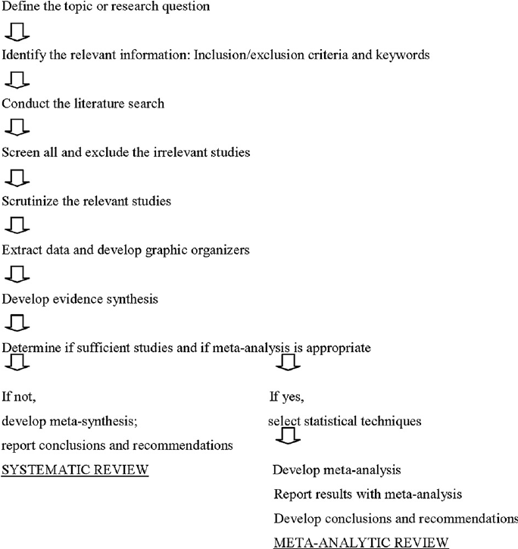
Fig. 1 Components of a systematic review

Type of study design
Two main categories of study designs are observational and experimental. Observational studies (cohort and case control studies) are those measuring the effect of a test, treatment or any other type of intervention whereas experimental studies (randomized controlled trials) introduce an intervention in a preset population and measure its effects. A systematic review including observational studies is called systematic review of observational studies. On the other hand, the one including experimental is called systematic review of experimental studies. Some systematic reviews include both experimental and observational studies. This study will include both the designs based on number and type of studies found. Additionally, limiting the type of designs can reduce the number of participants and in turn reduce population size.

Advantages and disadvantages
Systematic reviews have several advantages over other study designs. They save the time of the researcher which can be utilized on the analysis and interpretations. Other than time, systematic reviews also save resources (Mulrow, 1994). The biggest advantage is quality. They provide high quality evidence by combining a variety of researches. On contrast to all the advantages, the combination of different studies is sometimes not possible as the original studies are carried out in different study settings. Moreover, validity of the results may be affected because the published researches only contain the significant effect (Knobloch, Yoon, & Vogt, 2011).

Risk of bias
Systematic reviews are affected by various types of bias. Selection bias can harm the interpretation of findings as the researcher can report the outcome of interest. Similarly, journal editors can cause publication bias by publishing more compelling or audience drawing researches and ignoring others (Knobloch, Yoon, & Vogt, 2011). Risk of bias can be minimized by double data extraction methods and employers two reviewers who perform the data extraction independently (Boland, Cherry, & Dickson, 2017).
.

References
Boland, A., Cherry, G., & Dickson, R. (2017). Doing a systematic review: A student’s guide. Sage.
Dupre, M. E., Silberberg, M., Willis, J. M., & Feinglos, M. N. (2015). Education, glucose control, and mortality risks among US older adults with diabetes. Diabetes Research and Clinical Practice, 107(3), 392–399.
Estevan, F., & Baland, J.-M. (2007). Mortality risks, education and child labor. Journal of Development Economics, 84(1), 118–137.
Hummer, R. A., & Hernandez, E. M. (2013). The effect of educational attainment on adult mortality in the United States. Population Bulletin, 68(1), 1.
Krueger, P. M., Tran, M. K., Hummer, R. A., & Chang, V. W. (2015). Mortality attributable to low levels of education in the United States. PloS One, 10(7), e0131809.
Sandow, E., Westerlund, O., & Lindgren, U. (2014). Is your commute killing you? On the mortality risks of long-distance commuting. Environment and Planning A, 46(6), 1496–1516.
Knobloch, K., Yoon, U., & Vogt, P. M. (2011). Preferred reporting items for systematic reviews and meta-analyses (PRISMA) statement and publication bias. Journal of Cranio-Maxillofacial Surgery, 39(2), 91-92.
Mulrow, C. D. (1994). Systematic reviews: rationale for systematic reviews. Bmj, 309(6954), 597-599.

