Ventricular Assist Device
[Name of the Writer]
[Name of the Institution]

Ventricular Assist Device
Ventricular Assist Device (VAD) is a mechanical pump. People with heart diseases or those who face difficulty in pumping blood through the heart use this pump. VAD is effective for the proper function of the heart. It helps the heart to function normally by taking blood from the lower chamber of the heart and then pass it to the other body parts. Physicians use VAD usually before, and during the surgery, heart transplant and after the operation till the heart starts functioning normally (Slaughter et al., 2009). Therefore, it is also known as a heart pump.
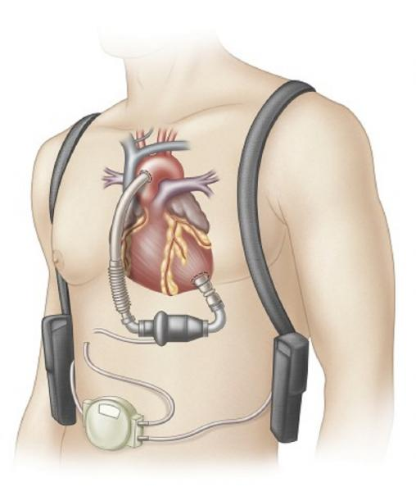
Two types of VAD are present that are right ventricular assist device (RVAD) and left ventricular assist device (LVAD). These two devices can be used at the same time as per requirement, which is known as biventricular assist device (BIVAD). RVAD is used to help the right ventricle to function for a short period, while LVAD is the commonly used device that is used during heart surgery and transplant. When the LVADs do not perform solely, then RVAD is added to support the heart (Birks et al., 2006).
VADs have two designs known as the power source and transcutaneous VAD. Power sources are located outside the body while transcutaneous has its pump, which connects to the heart by tubes through abdomen with the help of a hole. VADs are added during the examination of the patient when physicians do a heart transplant. It can also be used as the long term solution for heart patients who are not candidates of a heart transplant.
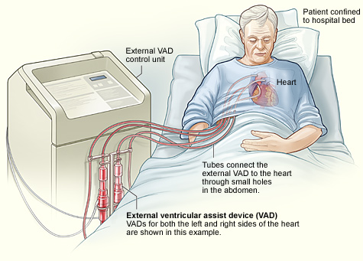
Besides two types of VAD, it is also be considered on the basis of long-term and short-term use. When a patient is having more than one heart issue like cardiogenic shock, ventricular arrhythmia, and heart failure in that case, physicians prefer VAD for short-term use. In addition, before heart surgery when patients are under observation, VADs are applied to them.
Long-term use of the VADs is recommended by the physician when heart failure medicines are not effective for the patient, and it is necessary to improve the heart function to increase the life quality. In addition, while waiting for heart transplant, VADs are used as long-term ventricular assist devices (Rose et al., 2001).
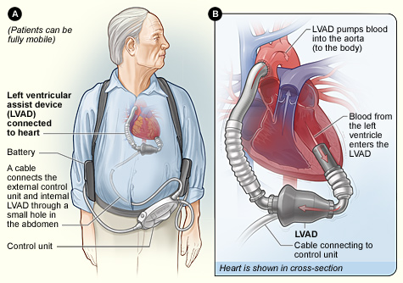
The patient and his family should know the basic knowledge of VAD because it is applied to the body. They should know about how it works, its safety precautions, wash, and shower, warnings, affect and care in case of an emergency.
Physicians may insert an extra tube in the body with VAD. This is because sometimes the patient is not healthy enough that the physician can do heart surgery. Therefore, they recommend different tests like Echocardiography (echo), Chest X-ray, blood tests, and EKG (electrocardiogram). In addition, a nutrition tube is inserted with VAD to provide extra patient nutrition to make him able for heart surgery.
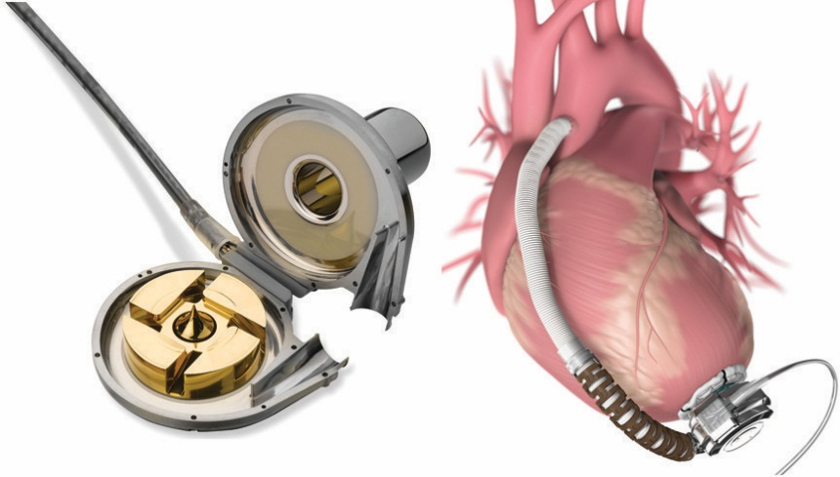
Initially, VAD size was a big problem for the physicians as well as the patient. This is because VAD could be fit only who had a large chest and therefore, women were unable to use VAD in an emergency. However, the size of the device is now small so that it can easily be used for women and children, but it still cannot be used for newborns to young children.
VAD is the lifesaver for many patients with heart failure, but it still has some risks like blood clots, device malfunctions, infection, bleeding, and right heart failure. Therefore, it is important to notice pain or change in the body due to VAD so that the patient can identify the problem and preventions can be made on time.

References
Birks, E. J., Tansley, P. D., Hardy, J., George, R. S., Bowles, C. T., Burke, M., … Yacoub, M. H. (2006). Left Ventricular Assist Device and Drug Therapy for the Reversal of Heart Failure. New England Journal of Medicine, 355(18), 1873–1884. https://doi.org/10.1056/NEJMoa053063
Rose, E. A., Gelijns, A. C., Moskowitz, A. J., Heitjan, D. F., Stevenson, L. W., Dembitsky, W., … Meier, P. (2001). Long-Term Use of a Left Ventricular Assist Device for End-Stage Heart Failure. New England Journal of Medicine, 345(20), 1435–1443. https://doi.org/10.1056/NEJMoa012175
Slaughter, M. S., Rogers, J. G., Milano, C. A., Russell, S. D., Conte, J. V., Feldman, D., … Frazier, O. H. (2009). Advanced Heart Failure Treated with Continuous-Flow Left Ventricular Assist Device. New England Journal of Medicine, 361(23), 2241–2251. https://doi.org/10.1056/NEJMoa0909938

