Genogram

[Name of the Writer]

[Name of the Institution]

Genogram
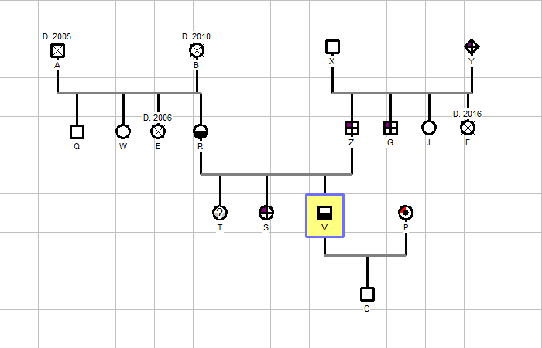
The index person in this narration of genogram is V who lives in my neighborhood. He is a 27 years old male who got married to P 3 years ago. The identities of these people have not been revealed due to privacy concerns. This family genogram represents four generations of a family. V is a suffering from intense alcohol and drug abuse while his wife is a carrier of cardiovascular disease. They have a son who is one years old and he is a normal healthy baby.
V has 2 sisters, T and S. S is diagnosed with diabetes while T is likely to be affected with diabetes and is also a suspected drug and alcohol abuser. Their mother R is in recovery from a kidney transplant and also mental illness as she had quite depressing period in the past 2 years because of her health conditions. Moreover, she also has an alcohol and drug abuse problem.
V’s father is affected with diabetes and he had 3 siblings of which one sister is dead while the other is a normal healthy person. However, his brother is also suffering from diabetes. V’s paternal grandfather is healthy and alive while his paternal grandmother is dead and she also had diabetes.
V’s maternal family does not have any genetic illness and all are healthy individuals except for his mother. His one maternal aunt is dead while other aunt and an uncle are living a normal life. V’s maternal grandparents are dead due to natural illness.
By analyzing the genogram, it is evident that V’s paternal family have a genetic disorder of diabetes prevalent in all generations. However, his maternal family is genetically healthy but have an issue of substance abuse but it seems they have shorter life expectancies as the number of deaths in that family are quite high.

