Lab Report
[Name]
[Institution]
[Date]

Lab Report
Abstract
The study observed the reaction time towards body stimuli, given by body images. The aim of this experiment is to identify the reaction time towards different body stimuli. The test was taken by the help of Matlab programming and the Psych toolbox. The stimuli were further divided into two types. The primary stimuli sources were the lines placed next to the bodies and the secondary stimuli were the body images. The computer screen generated an imaginary circle along with ten vertical and horizontal lines. The position of the target line was changed frequently during the trail.
All the bodies were same and one underweight body was included in the congruent trail and that body was displayed along with a target line. For the Incongruent trail, all the bodies were of the same weight except on underweight and that was placed parallel to a distractor line. For the neutral trail, all bodies were of average weight.
The relationship between the target line location and the unique body images is the independent variable and the dependent variable is the reaction time to the body stimuli.
The task was to press the right key in the computer to identify the vertical and horizontal target line. The left shift was used for horizontal target and right was for the vertical target. 160 subjects were being tested and 60 of those were neutral, 40 incongruent and 60 congruent. The conclusion drawn from the test is the participant who was involved in the trail of the neutral condition had slower reaction time as compared to the trail of the congruent group but the time for the incongruent was the slowest. Due to the unique location of the secondary stimuli in the incongruent target made the participant made slow reactions.

Introduction
The aim of this study is to know the fact that whether a human being is able to use the variation in body fat in order to guide the visual search. The study also wants to know whether the underweight bodies get most of the attention or not.
This study was conducted because body size generate misperception and there is a general belief that one body is larger than the other but that is not what happens in reality. Several body perceptions were made based on visual observation and the public have set criteria for a good body just on the bases of the fact that the specific body gives a beautiful look to the eyes.
The body stimuli could divert the point of normality of the subject and due to visual adaptation, the body size misperception occurs. The particular question that this study focused was to identify the reaction time to the body stimuli received by a group of a participant who was involved in a trail. For that purpose, two different types of bodies were created, one was designed to create an underweight body stimulus and the other was a normal body. The facial features of the bodies were hidden so that stimuli can only be received from the bodies.
The body stimulus had a height of 6 cm and their widths were 3 cm. There were ten bodies include in the experiment and each of them was placed inside a small circle with a radius of 9.5 cm. the trial was of three types, congruent trial, neutral trial, and incongruent trail. The congruent trail included bodies with similar body mass and one underweight was coupled with the target line. In case of the neutral trial group all the bodies were having similar mass and in the group of incongruent trials the underweight was placed along with the distractor line. The expected findings would be that the location of the distractor lines will delay the reaction time and the incongruent group will have the slowest reaction time.

Theoretical Framework:
The dependent variable in the study is the reaction time and the independent variable is the relationship between the body images and the target lines. The dependent variables were represented with X. A T-test was run in order to identify the effect of independent variables on the dependent variable. The relationship between body images and targets lines were further classified as congruent condition, neutral condition, and incongruent condition
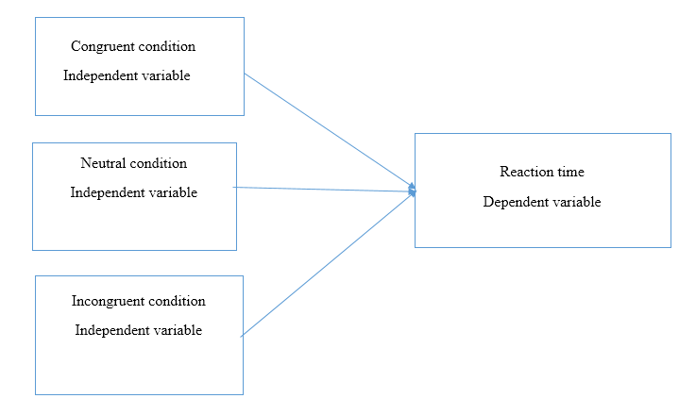
As has been discussed early, the research question focusses on the reaction time a participant will take in order to observe the given group and based on the reaction time a conclusion will be drawn.
Previous research
Jiang and Vartanian (2012) examined the memory and attention generated by body-related images and they have examined it through a group of restrained and unrestrained people. They have tested the memories of the participant and find out that unrestrained and restrained eater gave more attention to the images that were revealing bodies than to a group of control images.
However, another study was conducted that identify the biases to shape and weight that have developed in women who have eating concerns. The used the method of dot probe task to analyze the question whether the dissatisfaction related to the attention bias towards the bodies of women and the study concludes that women have always an attention bias towards thin bodies and which appears naturally. This bias was not present in women with body dissatisfaction and high BMI. Thus, the attention towards a thin body is related to body dissatisfaction. (Glauert, Rhodes, Fink, & Grammer, 2010).
The fatness and thinness of a body are differently processed by the individual with eating disorders and the one who has pre-occupied by the weight and the nature of such an attentional bias is not yet clear. Another study used the bias of the eye moment tracking assessment to identify the visual attention related to the body stimuli. The study compares the visual attention to the body stimuli given by weight dissatisfied and satisfied young women. The study revealed that a speed dictation was seen towards the bodies with high weight and thin bodies are avoided (Gao et al., 2011).
However, the properties of visual attention are used to control the disposition of attention. The visual stimuli are not just the processes of visual processing but they are abstraction drawn from the visual input (Wolfe & Horowitz, 2004).
Well, study also conducted to identify the relationship between body dissatisfaction, eating disorder and the attention to the male body images. The study found a negative relationship between them (Talbot, Cass, & Smith, 2019).
However, the aim of this study is to know the fact that whether a human being is able to use the variation in body fat in order to guide the visual search. The study also wants to know whether the underweight bodies get most of the attention or not?
Thus, the hypothesis could be that if the body fact information is used to guide visual search then the search time in neutral condition will be slower than the search time incongruent condition. The search time for the incongruent condition will be faster than that of the congruent condition.
Discussion
The result shows that the correct reaction time for Neutral condition is higher than the congruent group and the reaction time for the incongruent time was the highest. This result means that the unique secondary stimuli were the center of attraction for the participant. The neutral condition has no secondary stimuli so there was no focus of attraction and it took longer for the participant to get the bod stimuli but in the Congruent there was one underweight image that attracted the visual concentration of the participant. But in case of incongruent condition, the secondary stimuli were paired with a distracting line that is why the participant was unable to recognize the unique entity and it took the longest for them to concentrate.
The study needs more in-depth research and should include another factor that might affect the visual concentration of human being towards body stimuli.

Reference

Gao, X., Wang, Q., Jackson, T., Zhao, G., Liang, Y., & Chen, H. (2011). Biases in orienting and maintenance of attention among weight dissatisfied women: An eye-movement study. Behaviour Research and Therapy, 49(4), 252–259.
Glauert, R., Rhodes, G., Fink, B., & Grammer, K. (2010). Body dissatisfaction and attentional bias to thin bodies. International Journal of Eating Disorders, 43(1), 42–49.
Jiang, M. Y., & Vartanian, L. R. (2012). Attention and memory biases toward body-related images among restrained eaters. Body Image, 9(4), 503–509.
Talbot, D., Cass, J., & Smith, E. (2019). Visual Body Scale for Men (VBSM): Validation of a new figural rating scale to measure perceived‐desired body discrepancy in men. Journal of Clinical Psychology, 75(3), 462–480.
Wolfe, J. M., & Horowitz, T. S. (2004). What attributes guide the deployment of visual attention and how do they do it? Nature Reviews Neuroscience, 5(6), 495.

