PROJECT PROPOSAL

SENSITIVITY OF COMPACTION PROPERTIES OF LOW TO HIGH PLASTIC CLAYS TO BIOPOLYMERS

SUBMITTED BY
AJAY VARMA BUDDHARAJU
STUDENT ID – 12073259
Date of submission- 5/4/2019

SUPERVISOR – DR MEHDI MIRZABABAEI
UNIT CO-ORDINATOR – DR ABDUL MAZID

School of Engineering and Technology
Central Queensland University

Contents
Introduction and Background 3
Objectives 4
Scope and Description on Project 5
Required Resources 6
Methodology 6
Stakeholders 8
Conclusion 8
Recommendation 9
References 10

Introduction and Background
Clays play a significant role in geotechnical engineering practice. It is also used in many of the construction activities and waste landfills. These soils have some complications such as high compressibility, high level of volume changes and low strength. The study suggest that these soils should have improvements like workability, increase in strength and reduction in plasticity and swelling potential properties before application (Mehdi Mirzababaei, 2017). There are many studies on soils in geotechnical engineering which helps in studying and understanding the problems in the past and precautions that should be taken into notice before planning and constructing structures where these kinds of soils are found in place. Clay is formed by the primary weathering of rocks and separated particles from silt, sand and gravel particles. This study provides all the information about the clay soils and its properties which impacts on the geological engineering (ural, 2018).
Plastic nature of clay is defined when the water content in the clay ranges from low to high and the water mixture in the clay also defines the properties in common. Plastic deformation is witnessed when the material is subjected to the stress greater than its yield point. So, in order to yield a continuous nature of the clay below the yielding point, the force must be high enough (Guo, 2014).
Clays which show high plastic nature absorbs a large amount of water when compared to its weight. Due to plastic nature clay liners observe some changes like high permeability and instability based on the swelling nature of the land. Clay liners have an advantage of low-permeability with fluids and affected by weak properties like high shrinkage and expansive potential which causes instability. Clays show different compaction properties such as shrinkage, swell-pressures, stress-deformation characteristics, un-drained strength, pore-water pressures, and effective strength characteristics.
Compaction of soils is a most important humiliation syndrome which outlines the issue of soil management around the world. Soils are compacted by various means like vehicles, forest harvesting and natural human activities (Batey, 2009). This exercise intends to identify the magnification of mechanical behavior of collapsible soil by taking chance on using biopolymers (Fang, 2008).
The studies cited above show that the test data of lateral earth pressure which is applied on a retaining wall mainly due to vibratory compaction and soil filling applied. Air-dry Ottawa sand was filled with 0.3 m thick and compacted and continued for 5 layers to obtain a relative density of 75%. After repeated compaction on the backfill of the soil shear failure is observed at the topmost layer of the land fill.

Objectives
The main objective of this project is,
- Compaction properties of low to high plastic clays when stabilized with biopolymers.
- Develop a predictive model to show a relationship between the maximum dry unit weight and optimum moisture content by using the database obtained from compaction.
- Creating a database obtained from the compaction tests.

Scope and Description on Project
This is an estimate used to identify and explore the compaction properties of low plastic clays to high plastic clays by using miniature Harvard compaction test with addition of two biopolymers. Compaction test applied on soils of different proportions to identify the strength and settlement of the soils. We will observe the properties of clay soils due to the addition of biopolymers and produce results. These results are then compared to draw a relationship between the optimum moisture content and dry unit weight. By testing the soils at different proportions, we will obtain a large amount of database. This results also shows the variations in optimum moisture content and dry unit weight. By using this database, we can plot the graphs which help to study the variations of soil nature under compaction. The study will appraise the impacts of biopolymer and monomer adjustment on the shear quality and stress-strain conduct of loess and sand (Lytton, 2002). The study will also reflect on the shear quality of biopolymer-altered sand was essentially expanded by expansion of the polymer. The study will also reflect on the Polymer adjustment expanded the shear quality of the sand. The biopolymer utilized in this examination along these lines may give a progressively manageable option in contrast to customary adjustment techniques while offering ecological and monetary advantages (Guo, 2014).
The assessment of the biopolymer adjustment for shear quality of clay was directed
utilizing compaction. The gainful impacts of polymer maturing ought to be considered further by playing out an increasingly exhaustive arrangement of tests at relieving times of 28 days what's more, past. Rheological tests on the polymer itself ought to likewise be performed to describe its thickness and shear quality as an element of the distinctive polymer mixes and polymer age. Measurable demonstrating utilizing conditions or diagrams ought to be created to foresee the impacts of different fixations and sorts of polymer on soil quality. Moreover, computational multi-material science demonstrating ought to be performed utilizing a limited component investigation of the coupled mechanical and compound wonders, to create prescient models for a more extensive scope of soil types and proposed biopolymer types (Guo, 2014).
The response of soil and polymer can be seen through infinitesimal approaches to decide potential components of holding for any polymer under examination and the subsequent quality of corrected soil. The waterproofing capacities of different polymers ought to likewise be analyzed by testing the static quality of dry and immersed polymer-corrected examples. At that point, cyclic triaxial or cyclic basic shear tests with pore weight estimation ought to be performed to assess the capability of the bio-polymers for improving liquefaction obstruction of sands and sediments. Extra applications and soil types could be analyzed, for example, solidify/defrost conduct, or on the other hand adjustment of dirts as far as shear quality, decrease of combination settlements, and improvement in therapist/swell conduct.

Required Resources
By using the clay soils (kaolinite & Bentonite) and biopolymers that are available in the university laboratory and Miniature Harvard compaction test apparatus.

Methodology
An aggregation of fake soil blends was utilized in shifting extents so as to better watch the attributes. These blends comprised of inadequately reviewed clay with an explicit gravity of 2.65, kaolinite containing a particular gravity of 2.623 and bentonite containing a particular gravity of 2.89. Grain estimate circulation of soil tests was decided utilizing sifter examination for sand and Hydrometer tests (ASTM D 422-63) for kaolinite and bentonite. For the sand, coefficient of consistency (Cu) and coefficient of ebb and flow (Cc) are 3.15 and 1.15 separately for the sand. The Cu and Cc esteems show that the ASTM C-33 sand is inadequately reviewed and named SP. The tests performed included compaction test, unconfined pressure, fluid point of confinement, and plastic farthest point by utilizing various blends of kaolinite and sand, bentonite and sand and bentonite, kaolinite and sand (Krystal Wilbourn, 2007).
Equipment Required
- Specimen ejector
- Collar remover
- Spacer plate
- Mold holder
- Volume mold and collar
- Compaction tamper (9.07 kg, 17 kg, 18.2 kg)
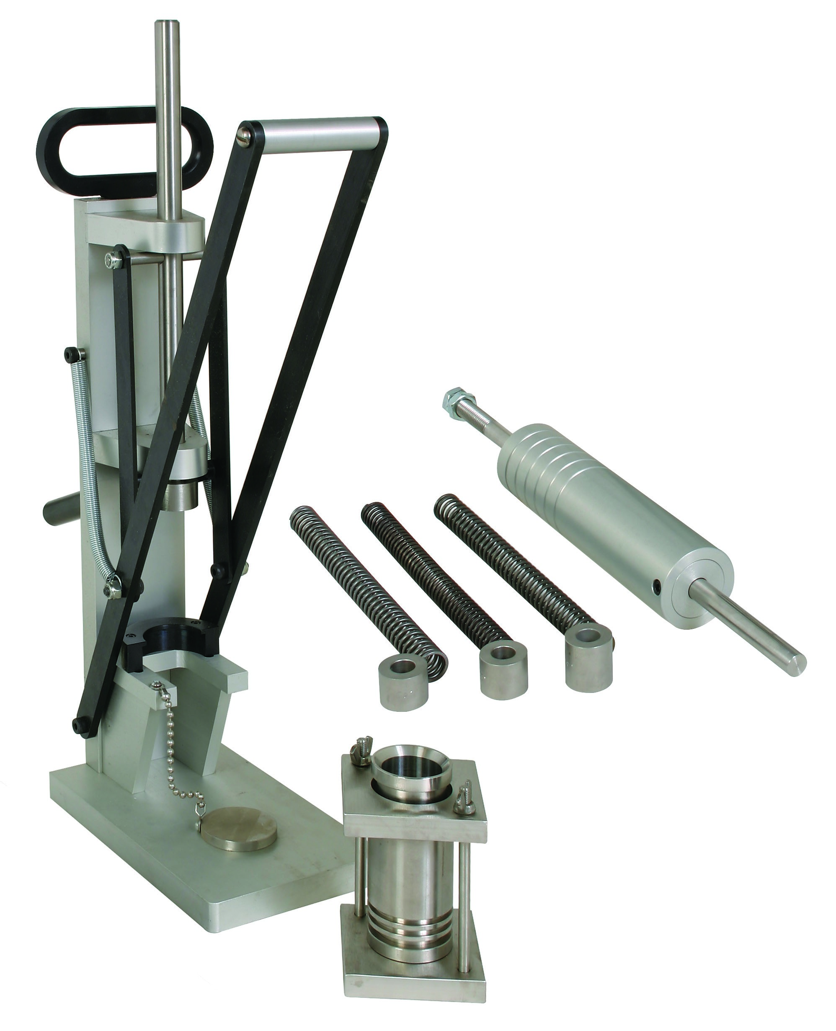

Stakeholders
- State government of Victoria.
- Local community groups.

Conclusion
The ultimate aim of this project is to obtain knowledge on properties of clays and its behavior on the addition of biopolymers using miniature Harvard compaction test apparatus. We are going to conduct a large number of compaction test and the results obtained from these tests are saved in a database. This database is analyzed and used to show the relationship between the optimum moisture content and dry unit weight of all samples. These results and study can be applied to find compaction effects on clays.
Unconfined compressive quality will be carried out on the examples arranged from the Harvard smaller than predictable form for numerous mugginess substance. Unconfined compressive quality rises with intensification of dampness content and subsequent to achieving ideal dampness esteem the quality declines. The quality of strength of the strength indicate a comparative pattern for every one of the blends of clay. The high strength value rises with intensification in dirt substance aside from the kaolinite and sand blend which demonstrates more quality. In the bentonite, kaolinite and sand blend B10K40S50 appears more quality.

Recommendation
It is likewise prescribed to lead monetary investigations to evaluate the presentation of biopolymers with respect to conventional adjustment techniques as far as a cost/advantage proportion, and supportability examinations to look at the general advantages of polymer adjustment conventional stabilizers, for example, concrete and fly-slag, as far as the potential funds of limited normal assets and decrease of nursery gasses. At last, the exhibition and field-execution of biopolymer adjustment ought to be examined further by directing field look into studies (Nazmul H.Mondo, 2007).
The response of clay and polymer can be seen through infinitesimal approaches to decide potential components of holding for any polymer under examination and the subsequent quality of corrected clay. The waterproofing capacities of different polymers ought to likewise be analyzed by testing the static quality of dry and immersed polymer-corrected examples. At that point, cyclic triaxial or cyclic basic shear tests with pore weight estimation ought to be performed to assess the capability of the bio-polymers for improving liquefaction obstruction of sands and sediments. Extra applications and clay types could be analyzed, for example, solidify/defrost conduct, or on the other hand adjustment of dirts as far as shear quality, decrease of combination settlements, and improvement in therapist/swell conduct.

References
Batey, T., 2009. Soil compaction and soil management. volume 24 ed. s.l.:s.n.
Fang, T.-J. C. a. Y.-S., 2008. Earth Pressure due to Vibratory Compaction. pp. 437-444.
Guo, L., 2014. Investigation of soil stabilization using biopolymers. Iowa State University Capstones, Theses and, p. 97.
Krystal Wilbourn, K. V., 2007. Index Properties and Strength of Artificial Soil Using the, s.l.: National Science Foundation.
Lytton, C. A. a. R., 2002. PROPERTIES OF HIGH-PLASTICITY CLAYS, texas: Texas Department of Transportation.
Mehdi Mirzababaei, M. O., 2017. Polymers for stabilizatiion of soft clays, s.l.: Procedia Engineerin.
Nazmul H.Mondo, K. J. K., 2007. Experimental mechanical compaction of clay mineral aggregates—Changes in physical properties of mudstones during burial, Oslo: s.n.
Tarantino, A., 2009. Discussion: Compaction behaviour of clay. Géotechnique.
ural, N., 2018. The importance of clay in geotechnical engineering. chapter 5 ed. s.l.:s.n.

