Assessment Findings
[Author’s name]
[Institute’s name]

Assessment Findings
Development of Genogram and Ecomap
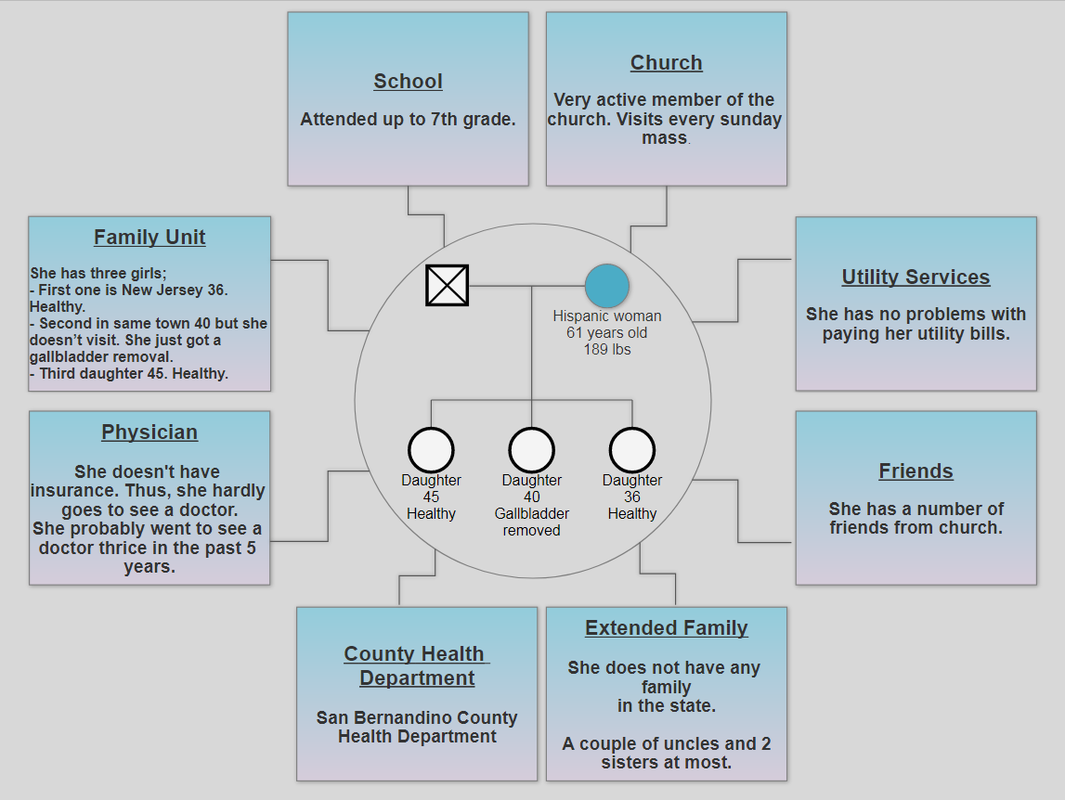
Summary of Family and Community Assessment Data
Comprehensive understanding of the health concerns at family and community levels is essential to accomplish some particular objectives in an effective manner. Consideration of the specific Leading Health Indicator (LHI) according to the actual approach of the specific community is an essential step to identify the actual health issues of the people of that community. The approach of LHI can be used to determine actual influence of a particular health concern and how it can be minimized through necessary practical measures. Here, the main focus is to select the suitable LHI according to the healthcare requirement of the Hispanic community that regionally belongs to San Bernardino County.
Case study of a sixty-one years old Hispanic female is one of the specific cases that can be used to critically examine the healthcare domain in the context of community and family assessment. It is vital to critically examine the overall daily routine of her life to make better inferences about her health condition. This form of observation further assists to identify the most suitable healthcare approach in the form of Leading Health Indicator (LHI). The framework of LHI is of utmost importance as it provides valuable data to figure out the health condition of an individual. This certain paradigm is assistive to define the areas that require necessary and immediate improvement.
In the first step of the detailed assessment of the community and family health, it is important to examine the overall lifestyle of the Hispanic female. Interview is a practical approach in this case to closely examine her way of life and figure out how it negatively influencing her health. It is observed that the old Hispanic female of 189 Ibs is suffering from the chronic issue of hypertension. This specific concern prevails for her due to different inter-connected reasons. It is critical to examine all relevant aspects to ensure the significant form of proper healthcare assessment at the family and community level. Examination of her routine perspectives reveals that she is not greatly connecting with her immediate family members. Her kids hardly visit her place where she lives alone and manages all things by herself. It is a complex situation as these aspects eventually impact her mental health condition. The issue of hypertension is going to be adverse for her with time and it appears that she requires immediate community healthcare needs to tackle the concern. Her main health issue in the form of hypertension can determine through the specific Leading Healthcare Indicator.
The health issue in case of the Hispanic community can also better understand through the consideration of other critical details about the life of an old Hispanic female. The objective of extensive information about the considered lady can be achieved through the proper development of the tools of genogram and ecomap. The aim of these two forms of visual representation is to examine the crucial information of the considered individual. She is a financially strong woman as she never has any issue to pay her utility bills. Furthermore, she never had great social interaction with her family and community as she only had some friends in Church where she plays her role very actively.
Selection of Theories
Self-Care Deficit Nursing Theory
The self-care deficit nursing theory is recognized as a theory that closely linked with the domain of community health. It is the direction for nursing staff to ensure the provision of better healthcare assistance to the patients at community level. The focus of this theoretical framework is to assist people to better handle the approach of self-care by embracing the requirements of the environment (Smith & Parker, 2015). It is comprised of the concept to consider humans being able to flexibly adjust with their environment. This specific theory contains some forms of strengths and limitations that need to be considered when it comes to application. Consideration of different intellectual and practical phases is the major strength of this theoretical approach, whereas the limitation is that it never fully covers each aspect of the nursing paradigm. There is a need for more clarity when it comes to defining the role of the family to assist the patient. The implications of this theory in the form of nursing practice can better examine in case of community healthcare service. The role of nursing staff is immensely critical to ensure the overall well-being of the Hispanic female who is going through with different physical damages and the major concern of hypertension.
Human Needs Theory
Human needs theory established as one significant form of non-nursing theories that can be applied at the social level to ensure better approach of individual behavior. Maslow provides the direction in case of basic human needs through the approach of the pyramid. This kind of realization further helps to examine the actual necessities prevails in case of social framework. Hierarchy of needs plays a vital role to determine the importance of each need for human beings in the social set-up. The theoretical framework of human needs theory is linked with the approach of family/community healthcare. Consideration of the basic needs is the crucial step to promote better healthcare domain in people by aligning their behavioral domains. Identification of advantages and restrictions of this specific theory is also primitive to ensure the proper application according to the requirement of the situation. The main advantage of this theoretical spectrum is that is comprised of the domain of nature of human beings (Moreno, Zidarov, Raju, Boruff, & Ahmed, 2017). On the other hand, the limitation of this theory is that it is closely linked with the cultural paradigms and differently apply in different cultural environments. The paradigm of human needs theory can be assistive for the nursing staff to examine the actual psychological position of the patient in the form of a particular behavior.

References
Moreno, A., Zidarov, D., Raju, C., Boruff, J., & Ahmed, S. (2017). Integrating the perspectives of individuals with spinal cord injuries, their family caregivers and healthcare professionals from the time of rehabilitation admission to community reintegration: Protocol for a scoping study on SCI needs. BMJ Open, 7(8), e014331.
Smith, M. C., & Parker, M. E. (2015). Nursing theories and nursing practice. FA Davis.

