Strategy Formulation
[Author Name(s), First M. Last, Omit Titles and Degrees]
[Institutional Affiliation(s)]

Establish Long-term goals and objectives
Cisco Systems Inc., is a networking system designer, operating successfully in the IT industry. It is operating internationally and has headquarters situated in California. The company is skilled in scheming, engineering, and selling Internet Protocol (IP)-based networking as well as supplementary products associated with communications and information technology (IT) industry. Moreover, the company is a tech leader and has a high brand worth. In addition, it has a huge market share in the routers as well as LAN market.
Strategy Formulation
Cisco can further achieve success through effective strategic planning. It can establish different long term goals and objectives. The organization in the past had gone for different acquisitions and minimized the risk (Nakamura, 2017). It can further pursue this strategy and gain a competitive advantage. It will then has a strong financial position in the industry. Furthermore, to increase sales and have long term relationships with the client, the company is required to have developed an efficient supply chain. For this, it must have an objective to have associations with reliable suppliers so it can avoid any component shortages and delay in order processing (Nakamura, 2017). Lastly, it must further expand in the international market, and for this, is it needed to make huge investments.
Potential markets
Cisco Systems Inc currently has its presence in many geographic segments such as Europe and the Middle East. It can further explore new makers such as Japan and China.
Unique value by the company
Offering new products and services is a useful strategy for the organization to gain the attention of new customers. It will serve the market with new innovative products. Moreover, it will also maintain its new product quality, and this will go for huge investments. For example, the company will also be providing post-purchase backing for network arrangements. Similarly, the products will be offered at reasonable and market competitive prices to gain the economies of scale.
Required resources and capabilities
A huge amount of research is required for the development of any new product as well as introducing it in any new market (Nakamura, 2017). Moreover, the company must have an association with the local people to have an idea about their needs and requirements.
Gaining competitive advantage
By offering new products, the company can gain a competitive advantage. This will not only assist the company in establishing the brand worth in a new market, but it will also increase the number of customers and sales. Moreover, by maintaining the quality of products, the company can have a long term presence in new areas and can earn profits easily.
Business Management Strategy
Cisco Systems Inc., as a part of strategic management, must establish different business management strategies.
Cost and differentiation advantages
Cisco Systems Inc. will have its presence in new geographic areas and for the need to use the cost leadership pricing strategy. This will allow the company to gain a competitive market as with the new price, it will be able to sell more. The company already has an established brand worth and can easily pursue this strategy.
Moreover, it can also go for differentiation, such as product or cost. With product differentiation, customers will have the required utility with the new product, according to their needs. Similarly, the company can also go for increasing the performance of its current products. Likewise, the price can also be set for any product depending upon the features of the product as well as the purchasing power of the customer.
Corporate Strategy
Cisco Systems will recognize, categorize, and invest in new markets that are customer-driven. This will increase the worth of the company by providing its competitive advantage with the introduction of new products and features (Newton, Gilinsky Jr, & Jordan, 2015). This innovation will provide an opportunity for the company to go for different partnerships and acquisitions to enhance its productivity and quality. Moreover, the differentiation approach will also be there to gain accesses to the new markets (Newton et al., 2015). To provide value-added services and serve different customers, cross-functional teams will serve the purpose.
Vertical Integration
It is the process of expanding company operations either in a backward direction; acquiring suppliers or in a forward direction; acquiring the distributors. This will allow Cisco Systems Inc to have more control and get the capacity to respond to customers' needs promptly. For this, the company can go for both directions to gain a competitive advantage. It can have an acquisition with small and fast-growing firms as a part of its growth strategy.
Strategic Alliances
It is partnering and collaboration with other companies in the industry. Cisco is a risk-embracing company that has always shown likeness towards strategic alliances. Likewise, there is also a collaborative internal environment inside the company that encourages peo9pel to accept the change readily. Thus, Cisco already has strategic alliances with Accenture, Microsoft, and IBM. Moreover, it also went for a partnership with Motorola and Ericson, although these had not been very successful.
Company competitive advantage
Cisco has always believed in collaboration with other companies in the industry. This not only increases the resources and capacity of the company to go for additional strategies but also provide it a competitive advantage (Harrigan, 2017). With different alliances, the company can increase the quality and sales of its products. Different partnerships will allow it to gain access and have market penetration in new markets.
Organizational Chart
Cisco has a functional organizational structure, and employees are organized in a cluster according to their specific skills and acquaintance. Each department, such as production, marketing, and finance, is responsible for its required function.

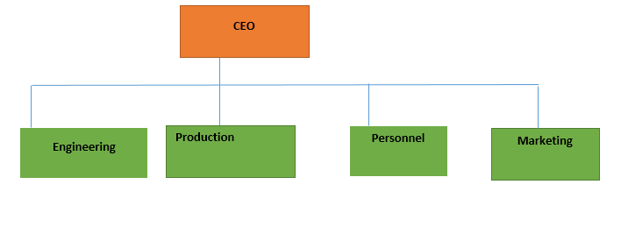

References

Harrigan, K. R. (2017). Strategic alliances as agents of competitive change. In Collaborative Strategy. Edward Elgar Publishing.
Nakamura, H. (2017). Partner Selection in International Strategic Alliances: The Case of the Information Industry. International Journal of Economics and Management Engineering, 11(9), 2282–2286.
Newton, S. K., Gilinsky Jr, A., & Jordan, D. (2015). Differentiation strategies and winery financial performance: An empirical investigation. Wine Economics and Policy, 4(2), 88–97.

