Elasticity
[Name of the Writer]
[Name of the Institution]

Elasticity
- Consumer surplus = 0.5 (21-13)*80
Consumer surplus = 320$
 | Comparative Equilibrium | At 13$ price
Consumer surplus | 240$ | 160$
Product surplus | 400$ | 720$
Deadweight loss | none | 40

- a. Initial price = 1.25 dollars
price after tax= 2.50 dollars
Government tax on each pack = 2.50 - 1.25
= 1.25 dollars
b. Tax paid by consumer = 2.50 – 1.50
= 1.00 dollar
c. Tax paid by producers = 1.50- 1.25
= 0.25 dollar
d. Quantity sold after tax= 18 billion
e. After-tax revenue received by producers = 1.25 dollar
f. tax revenue collected by the government = 1.25* 18
=22.5 billion dollar
g. deadweight loss = (1/2*1.25*2)
= 1.25 billion dollars

Determine the market clearing price, market clearing quantity and total clearing economic surplus when marketing clearing is changed.
QD = 5000-100p
QS = -1000+50P
Therefore, = 5000-100p =-1000+50p
=5000+1000 =100p+50p
= 6000 = 150p
P = 6000/150
P= 40.
However, QD = 5000-100p
= 5000-(100*40)
= 5000-4000
QD = 1000.
QS = -1000+50p
= -1000+ (50*40)
= -1000 +2000
= 1000
QS = 1000

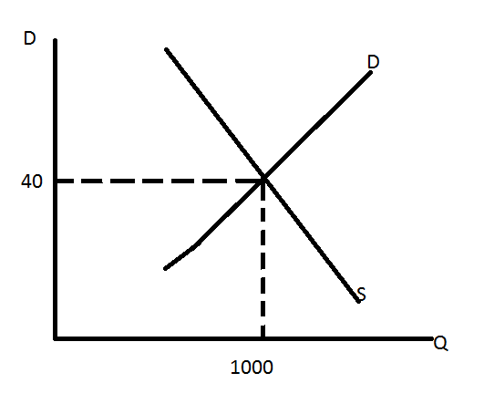
The market clearing for is $40, the quantity is 6000 and the economic when the market price charged would be 90.

