# Executive Summary

Looking at the financial prospects of Qantas, one thing that stands out is that the financial ratios and all the information has to be looked into the context of the aviation industries. But even if this fact is being accounted for, it can be seen that the financial prospects of the organization are far from ideal at the moment. The lowering profit margin as well as the global recession has played a major part when it comes to creating difficult conditions for Qantas in terms of the financial. The good thing is that they have managed their liquidity constraints in quite an effective manner.

Running Head: FINANCE

Qantas Financial Analysis

[Name of the Writer]

[Name of the Institution]

# Profitability Ratios

One of the most important determinants of the financial health of the organization is the profit-making ability of the entity. The profitability ratios go to show what is the extent to which the organization is earning profit at the given point of time (Teker et al, 2018, p.603). The main premise of the idea of the profitability is that it shows what are some of the aspects of the profit making of the organization and what are some of the particulars of the profits that they must take care to ensure better business sustainability (McDonald and Millett, 2017, p.21).

# Liquidity Ratios

The liquidity ratios are the class of ratios and metrics that are used to determine the ability of the organization with regards to how they are going to be able to repay their current debt obligations without having this need to opt for external financing (McDonald and Millett, 2017, p.21). It considers the ability to pay both the long term and short-term liabilities that are witnessed at the end of the organization (Teker et al, 2018, p.603). The other thing that they tend to indicate is that whether the current assets that are at the disposal of the company are going to be enough when it comes to making sure that the financial obligations of the organization are being taken care off (Lee and Yang, 2017, p.410).

# Financial Stability Ratios

The stability ratios show the long-term sustainability and the prospects of the organization at the given point of time (Teker et al, 2018, p.603). What it tends to show is that how much debt any organization can accumulate at the given point as well as showing what is the balance between debt and equity in an organization at a certain point of time. It also goes to show some of the risks that are faced by the organization at the given point of time and the future prospect of the organization (McDonald and Millett, 2017, p.21).

# Profitability Ratios

## Return on Assets

Return on asset is the financial ratio that goes to show the percentage of the profit an organization is earning with relation to its resources (Teker et al, 2018, p.603). For an industry like aviation and airline, it is very crucial for them to make sure that they are utilizing their assets in the appropriate manner. At the same time, the other crucial aspect that is needed to be looked at is that how well they are performing as compared to their competition at the given point of time and what are some of the prospects of the organization in terms of its competitors when looking at their utilization of assets (McDonald and Millett, 2017, p.21).

One of the key things that is witnessed in terms of the return on asset is that they have decreased their asset utilization in the past few years. There is a slight progress during the early years, but the ratio is dropped again. It goes to shows that as compared to some of the other competitors that are available in the market, Qantas is doing a good job when it comes to make sure that they are utilizing their assets to generate more sales and ultimately creating more profit margin (Lee and Yang, 2017, p.410).

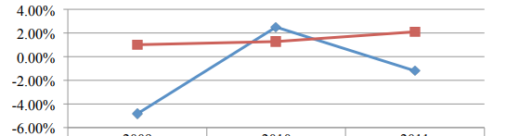



## Profit Margin Ratio

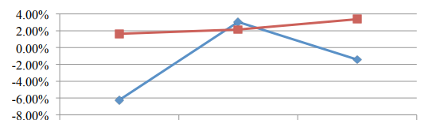



The international Civil Aviation bodies have stated that the average profit margin for the aviation industry has been about 5 % for last five years (McDonald and Millett, 2017, p.21). Keeping that aspect in mind, the average profit for Qantas has increased but still they need to do a lot more to make sure that they are able to increase their profit margin in the coming years (McDonald and Millett, 2017, p.21). In the long run, to sustain such low profit margins are determinantal to the success of the organization. Overall, the aviation industry operates in the lower margin, but effort must be made to make sure that they are at least operating in the breakeven region (Lee and Yang, 2017, p.410).

## Asset Turnover Ratio

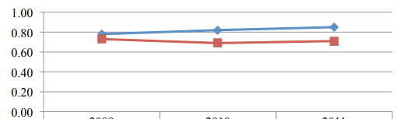



For an organization that is a part of the aviation industry, it is quite important to make sure that they can take care of their assets in an appropriate manner (Lee and Yang, 2017, p.410). The idea at the end of the Qantas is that they must utilize the assets in the manner that brings about long-term benefit to the organization (McDonald and Millett, 2017, p.21). Looking at things in this regard, there has been gradual improvement in their asset utilization in the given time period (Tan, 2018, p.111). Despite this fact though, there is a need to bring about considerable improvement to make sure that the prospects of the business can be improved about in the long run (Lee and Yang, 2017, p.410).

# Liquidity Ratios

## Current Ratio

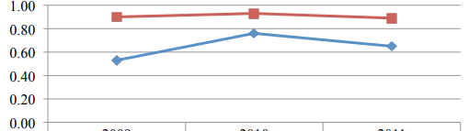



For the aviation industry, the acceptable quick ratio is going to be around 1:1 or 2:1. Looking closely at the ratios of Qantas, keeping mind the financial prospect of the organization, they have managed their liquidity constraints quite effectively (Lee and Yang, 2017, p.410). The other thing that works out well for them is that how they are far ahead as compared to some of the other competitors in the same industry (Lee and Yang, 2017, p.410).

## Quick Asset Ratio

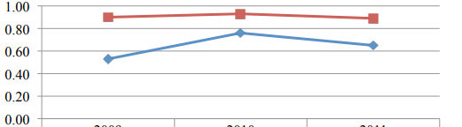



Looking at the industry average, which is hovering around the range of 1:1. It is safe to assume that the Qantas is falling way below the acceptable industry standard (McDonald and Millett, 2017, p.21). One of the reasons that their performance has been far from ideal is since the profit-making ability and the prospects of the business are on the lower side (Vasigh et al, 2017, p.45). Other thing that is a huge handicap for them is that how they are not able to bring about the ideal mix in terms of the asset and debt financing (Anaman et al, 2018, p.103).

## Liquidity Constraints for Qantas

Whenever analysis of the financial ratios is supposed to be carried out, the key thing is to make sure that there must be some context behind the way numbers are racking up (Tan, 2018, p.111). The same thing is needed to be looked at when looking at the financial figures and the liquidity numbers for Qantas. Looking at the recent financial statements, one thing that has stood out about the organization is that how the debt coverage ratio of Qantas has constantly increased in last few years. As a matter of fact, the debt coverage ratio has declined from 658 % to about 475 % in the coming years (Lee and Yang, 2017, p.410). What it means is that there is a deliberate attempt on their part to make sure that sort out their liquidity issues and one of the ways through which it is being done is by making sure that they are in the position to cover up their debt at least by their operational earnings (Lee and Yang, 2017, p.410). The same depiction is being witnessed in terms of the way cash flow ratios are reflected during the given period (Anaman et al, 2018, p.103). The cash flow for the Qantas was supposed to be around 20 % at the given point of time. This level is not going to be enough when it comes to making sure that some of the short-term obligations and liabilities of the organization are going to be paid off. There is still hope for Qantas due to the fact how these figures are increasingly showing a positive trend at that point of time (Tan, 2018, p.111). The cash flow constraints and other things are going to be discussed later (Teker et al, 2018, p.603). SO, all these things play an important role in terms of the continuity of the operations of the organization at the given time period (Teker et al, 2018, p.603). In the hindsight, it can be said that even though they are facing some changes in terms of the way they are going to be managing their liquidity problems, it is quite normal in the industry for the aviation companies to face this issue (Anaman et al, 2018, p.103).

# Financial Stability Ratios

## Debt Ratio

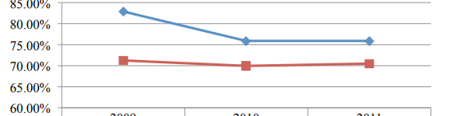



Looking at the debt ratio across three years, Qantas has average of about 70 % debt in the last three years and thus it implies that the organization is operating under a debt (Teker et al, 2018, p.603). That does not mean that they are debt ridden as simple comparison against the competitors goes to show that they have declined significant debt during the last few years and there is a deliberate attempt on their part to make sure that they bring about an element of control in their debt (Anaman et al, 2018, p.103).

## Equity Ratio

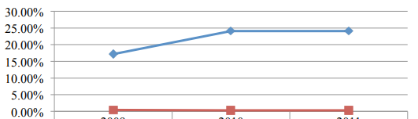



Qantas has been relying on much less equity as compared to some of the other players that are the part of the industry (Vasigh et al, 2017, p.45). What it implies is that there is an expectation on the part of Qantas where they are not expecting their shareholders to bring about additional funds. There is a modest growth but still if one talks about the scale and the extent of the organization that is as large as Qantas, it is paramount that they bring about certain degree of control as far as the way they are operating (Anaman et al, 2018, p.103).

## Times Interest Earned Ratio

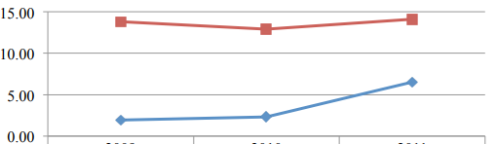



The trend in terms of the Times Interest ratio, it is one of the areas where Qantas is working closely now (Anaman et al, 2018, p.103). The idea on their part is to make sure that they manage their debts in a smart manner so that whatever the accumulated debt that is being faced by them is lower than the inventory and accounts receivables at the given point of time (Vasigh et al, 2017, p.45). The other major aspect that has to be kept in mind is that for an organization like Qantas, the majority of the cash flows went towards the operational and investment activities as compared to the financing activities. This is specially important for Qantas keeping in mind their financials for last few years (Vasigh et al, 2017, p.45).

# Analysis of the Cash flow

There are two things that are of utmost importance when one talks about the way cash flows of the entity are supposed to work out. The first one is the free cash flow and the other is the way cash and asset management is being done at the level of the organization. Looking at Qantas, there free cash flow has been declining for considerable time period now and what it is going to do is that it is going to affect some of the immediate capital investment that is going to be happening in the organization at the given time in the time period. Looking further into the cash flow statement, there are numerous instances when it is mentioned that how the inflow from the operating activities and the eventual cash flow from the investment activities has receded in the last few years. There is a significant decline in the financing cash flow needs of the organization (Anaman et al, 2018, p.103). In the long run, such an initiative is being done to make sure that the element of control is brought towards the cash flow in the organization.

# Why Advanced Revenue is not a Major Issue for Qantas

It must be noted for the organization and business-like Qantas, there is a vast portion of their transactions that are carried out based on the advanced revenue. The major premise is that the stakeholders with whom they are working with have their own set of priorities as far as the way they would like to manage their cash flows. The same advanced payment system is being implements when payments and receipts are being provided to the vendors. Thus, for an organization that is part of aviation, these practices are quite normal. The ideal thing for them though is to make sure that they manage their cash flows appropriately.

References

Anaman, K.A., Lellyett, S.C., Drake, L., Leigh, R.J., Henderson-Sellers, A., Noar, P.F., Sullivan, P.J. and Thampapillai, D.J., 2018. Benefits of meteorological services: evidence from recent research in Australia. *Meteorological Applications*, *5*(2), pp.103-115.

Lee, V.C. and Yang, X., 2017, August. Development and test of an artificial-immune-abnormal-trading-detection system for financial markets. In *International Conference on Intelligent Computing* (pp. 410-419). Springer, Berlin, Heidelberg.

McDonald, J. and Millett, B., 2017. A case study of the role of collective bargaining in corporate change-Qantas Airways Limited. *Business research paper series*, pp.1-21.

Tan, A.K.J., 2018. Airline Agreements and Competition Law: Qantas Airways' Operations in Singapore. *Annals Air & Space L.*, *33*, p.111.

Teker, S., Teker, D. and Güner, A., 2018. Financial performance of top 20 airlines. *Procedia-Social and Behavioral Sciences*, *235*, pp.603-610.

Vasigh, B., Fleming, K. and Humphreys, B., 2017. *Foundations of airline finance: Methodology and practice*. Routledge.