Amazon
[Author Name(s), First M. Last, Omit Titles and Degrees]
[Institutional Affiliation(s)]

Author Note
[Include any grant/funding information and a complete correspondence address.]

Amazon
The balance sheet is a rich source of information about company’s assets, equity and liabilities for investors, creditors, and analysts. It is an indicator of cash flows that may be generated from inventories and receivables, and earnings capacity of a company’s assets in future.

Assets
Resources that are controlled by the company from past proceedings and future economic profits that are probable in the flow of entity are called assets. Assets are goods that add future value to the company. To measure the value of company, assets must be calculated accurately.

Current assets
According to quarterly report on 1st Nov 2019 of Amazon total assets are of $199,099,000, consisting of current assets of $79,054,000 and non-current assets of $120,045,000 (Amazon.Com Inc (AMZN), 2019).

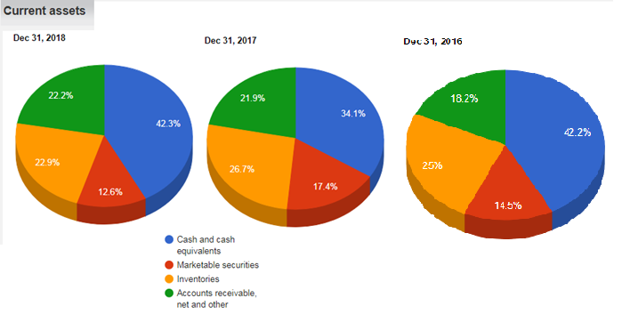
Figure 1: Shows pie charts of Amazon’s current assets in year 2018, 2017 and 2016 are $75101000, $60197000, $45781000 respectively.
It shows that current assets are increased from 2017 to 2018. Cash and cash equivalents are increased approximate 8% from last year, which shows that liquidity is higher which is healthier sign of growth. Market securities are changed negligibly small i.e. 0.3% increase in 2018. Moreover, pie graph shows that inventories has decreased in 2018 approximately by 4% and it shows company has sold more goods as compared to purchased, which has a positive effect on cash. According to chart accounts receivable, net and others are decreased by 4.8%, means working capital Amazon is increased in 2018 (Staff, 2019).
Moreover, inventory of a company characteristically includes goods in three phases of production i.e. raw goods, in-development goods, and complete goods that are prepared for sale. By accounting inventory, it will allocate values to the objects in each of these three phases and measure them as company assets. Inventories, consisting of final product for sale, are valued at the lower of cost and net attainable value, counted by the first-in, first-out method. This estimation needs Amazon.com to make decisions, based on presently obtainable material, about likely technique of disposition, through sales to separate customers, revenues to product retailers, or liquidations, and predictable recoverable amounts of each disposition type.

Long-term Assets
According to quarterly report on 1st Nov 2019 of Amazon property, plant and equipment, net (PPE) is $67,662,000 and in Dec 2018 it was $61,797,000 and in Dec 2017 is $48,866,000. It concludes that more than 8% increase is observed in current year means additional new equipment’s are parched by company. In year 2018 PPE increased by 21% from 2017 which shows a remarkable increase in tangible fixed assets of the Amazon which may be in form of land, equipment, machinery, vehicles, buildings, office equipment, furnishings, and other things.

Figure 2: Shows long-term assets of Amazon during years 2016-2019.
It shows that property, plant and equipment, net (PPE) is increased by 0.3% means that company has increased investments. Moreover, Figure 2 explains that goodwill is decreased by 2.2% so a noncash charge for the impairment of goodwill should be logged. Goodwill is extra money paid above its actual book value by company at the time of purchase. Moreover, other assets are also increased by 2% in 2018.

Total assets
In Sep 2019, total assets of Amazon are of $199,099,000, in Dec 2017 it was $162648000 in 2018, $131310000 in Dec 2017, and $83402000 in Dec 2016.

Figure 3: Shows percentage increase of total assets per year.

Asset turnover ratio
Measure of a company’s ability to generate net sales from total assets is called asset turnover ratio. It can also be defined as efficiency of a company using its assets to generate sales. Therefore, if turnover ratio is higher its favorable for company as it is using assets more efficiently.

Asset turnover for year 2018 and 2017
= Sales/Average Total Assets
= Revenue (Annual: Dec. 2018)/((Total Assets (Annual: Dec. 2017)+ Total Assets (Annual: Dec. 2018))/2
=232887 million / ((131310 million+162648 million)/2)
=1.58

Asset turnover for year 2018 and 2017
= Sales/Average Total Assets
= Revenue (Quarterly: Sep. 2019)/((Total Assets (Quarterly: Dec. 2017)+ Total Assets (Quarterly: Sep. 2019))/2
= 69981 million / ((191351 million+ 191351 million)/2)
=0.36
Companies having low profit margins have high asset turnover tendency, while high profit limitations have asset turnover low. In retail industry, companies have a tendency for larger turnover ratio (Amazon.com Asset Turnover: 0.36 (As of Sep. 2019), 2019).

References
Amazon.com Asset Turnover: 0.36 (As of Sep. 2019). (2019). Retrieved from www.gurufocus.com: https://www.gurufocus.com/term/turnover/AMZN/Asset%252BTurnover/Amazon.com%2BInc
Amazon.Com Inc (AMZN). (2019, November 1). Retrieved from www.barchart.com: https://www.barchart.com/stocks/quotes/AMZN/balance-sheet/quarterly
Last Name, F. M. (Year). Article Title. Journal Title, Pages From - To.
Last Name, F. M. (Year). Book Title. City Name: Publisher Name.
Staff. (2019). Balance Sheet: Assets. Retrieved from www.stock-analysis-on.net: https://www.stock-analysis-on.net/NASDAQ/Company/Amazoncom-Inc/Financial-Statement/Assets

