RUNNING HEAD: FASHION PHOTOGRAPHY

The effects of fashion photography and advertisement on the society
Author
[Name of the Institution]

The effects of fashion photography and advertisement on the society
Introduction
There has been criticism on advertising for changes which were not required by the people. It also creates a world of consumption that does not take into account the social problems. Advertising can create non-communication by communicating various aspects of products. It can be seen as a mirror that serves interests of companies only (Sandikci, n.d.). Consumption is seen as being the only solution to social and personal problems. An undemocratic social order has been developed where power is confined in the hands of small number of corporations. Many of the advertisements do depict a world that does not exist in reality and is built around product consumption. Some companies produced advertisements which had very clear messages regarding politics and society. Benetton made advertisements which included pictures of people affected by AIDS and other similar social and natural disasters (Macleod, 2007). There were mixed reviews regarding these advertisements with some people bashing the company to use already distressed people for its advertisements and some people encouraged the company for bringing major social issues to forefront. This debate was accompanied by banning of many advertisement campaigns of company in various countries. There are different opinions about these advertisement campaigns, some people saw it as commercialization of serious social issues (Ganesan, 2002).
Controversy advertising is a form of advertising that started to come t scene in the 1970’s. Some other branches like social marketing can be mistakenly treated as controversy advertising but it is the way marketing is used to resolve any issues faced by the society. Controversy advertising deals with the issues which have more than on facets. In advocacy advertising, a problem is presented and a suggested solution is also given for it. Controversy advertisement only presents a problem but does not provide any action. This form of advertising presents a question but does not limit the number of views which can be given as responses (Timeea, 2011). This form of advertising had a sharp increase in adoption around 1973 when a number of advertisers experimented new things in their fields based on political and social issues. Benetton was the most famous company that used controversy advertisement to its benefit. If the major aim of company is to maximize profits, it is difficult to ascertain the sincerity of advertising campaign but in the view of advertisers, they contribute positively towards the society (Kuan, 2018).
Shock advertising is a part of advertisement that aims to get attention by giving jolts to its customers. It has become difficult for companies to attract consumers on the basis of creativity only because people have become more advertising literate and savvy (D.Pickton & A.Broderick, 2005). Some advertisers deliberately use such labels which show misery and suffering to distress the audience. Shock appeals tend to improve on brand recall by customers. Some experts see shock advertisements as opposed to advertising laws and standards. Attempts to change the norms of advertising made the advertising industry ambiguous. Traditionally, advertisement was meant to show experiences like happiness and pleasure connected to a product. If ever a problem was presented in an advertisement, it was resolved by the miraculous power of product advertised. Advertising was historically seen as a representation of fiction and unreality (Andersson, et al., 2004).
Body
In many advertisements of Benetton, images of fantasy are replaced by images of distress and realities. Major part of these advertisements came from the third-world misery especially in North Korea. A company named diesel was also involved in many happenings where advertising was used to show weird themes (Barela, 2003).
It all started when Luciano Benetton started making colorful sweaters for people who were wearing dull colors. The company was successful in managing its operations by postponing the dyeing of sweater to the last moment so that they can reflect latest trends in society. There were a large number of suppliers working with the company where Benetton worked as a franchisor sold its products through agents who were all responsible for developing their own markets. There are no stores for company but it enters into licensing agreements with agents (A.Tinic, 1997).
Toscani joined the company in 1982 and his photos in the quarterly magazine have brought certain issues to light. Themes followed are reality, peace and war, AIDS and safe sex. Despite their controversial nature, these pictures continue to grasp attention of the general public. These ideas are unique in a way that they deny the traditional approach to marketing by educating people about issues which are common across all continents. In the lines below, we will take a look at three different campaigns undertaken by Benetton.
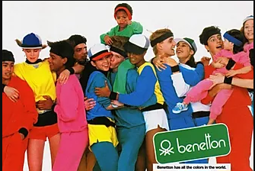

The above picture shows a number of colors to depict the monogram of company united colors of Bennington. The company started launching its campaigns in 1984. Toscani was the chief executive of company at that time. The company felt that its brand should suit to a majority of people around the world so they focused on topics like peace and racial equity. There was considerable criticism received by the company regarding these campaigns. The company generated mission statements according to different topics which were relevant to that particular time. The company started its uniting the countries campaign at a time when USA was at war with the Soviet Union. Benetton started this campaign to bring more peace to this world. Until the 1980’s advertisements of Benetton were traditional focusing on company products and logo. There was a need of new stance in advertisements used by the company both with reference to competition and normal practice of the industry. After the unity theme shown by promoting peace, the company wanted to unite people across continents. There were youngsters and kids clothed in different colored clothes of Benetton. Another campaign was named “all the colors in the world” showing youngsters and kids from different countries and races wearing Benetton clothing. The company name means colors by definition so it showed various people having different skin colors. Another advertisement showed two boys kissing each other having the USA and USSR flags painted in their hair. England and Argentine also had clashes with each other and these themed advertisements were used there as well. Uniting cultures was aimed at creating peace and harmony among different cultures. The company did not promote itself on television for some time and did so only on specific networks like MTV in USA. It would have cost the company much higher if it had tried to change product and marketing strategies for different countries it as catering, so it decided to come up with something that will be global in nature. Another part of the unity campaign showed unity across countries (Kubacka, 2012).

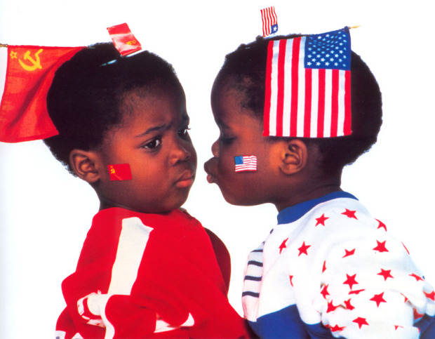
The above picture shows two children having USA and USSR flags and representing the need for peace between the two super powers. This advertisement was also according to an event taking place at that time.
Advertisers can impact an individual consumer and many firms will want to know if their spending has been effective. Some critics said that advertising was an evil which initiated unreal and almost mechanical responses to messages (Warnick, 2005). The major impact of Benetton advertising was to bring a drastic change in conventional advertising. It breaks the rules used to make traditional advertisements. Normally advertising was seen as a way to show some product which can be used to fulfill some need or want. Benetton never showed its products in its advertisements and there were images which symbolized certain issues faced by the society such as aids, natural disasters etc. The campaign has resulted in a global recognition for company. There have been severe criticisms on the campaigns run by Benetton showing controversy that now surrounds company philosophy of communication. The connection of social problems to a designer clothing brand was not seen as ideal by various critics. The company mixed the terrains of news and public service announcements with designer clothing sales. This case provides a very good example of how advertisement is not allowed to interfere in social issues in a developed societies guided by capitalism (Kraidy, 2003).
The black and white campaign was launched against racial differences perceived between white and black people. There were many posters developed by the company to show this issue. There were black and white people handcuffed to each other. These advertisements were provided by company in 1989 and 1990. Equality between white and black was the major theme of these advertisements. There should be no discrimination on the basis of color of any human being. These campaigns also had various reactions from different parts of the world. Nations with white majority argued that they can promote racism instead of culminating it. Countries with black majority argued that these advertisements brought racism issues to the knowledge of general public. With the passage of time, there has been a change in these campaigns run by company. The black and white is still shown but by showing white dog and black cat (Incze, et al., 2018).
Ebony and Ivory campaign was just another form of black and white campaign but it included two different things to show that there is no difference based on race between humans. Ebony refers to a tree found in the tropical areas and ivory refers to the tusks of an elephant. Both these things are used to make ornaments and decoration pieces. The campaign included two people with contrasting skin colors but with very similar clothing. This campaign makes us realize that things may mean differently when seen across different societies. The campaign was named “we on death row” and was launched on 31st January 2000. The campaign had a wide reach across the USA. The campaign was against the fact that some nations or social groups were dominated by others. It is not easy to identify such dominance because there are number of people with different backgrounds at any particular place. Communicating or advertising to these people is a costly matter because they will have different needs and wants. These costs force the companies to ally the economic and political forces to make a public thought through debate or communication. In the USA, politicians need the support of donations to run their campaigns so the decisive power stays in the hands of economic elites to decide how public communication will be done (Riggs, 2006). There should be equal representation of all groups living in the society when some public communication is undertaken. This also includes the fact that the content of such communications should be such that is equally acceptable for all these groups. There is a considerable difference between the political elite and general public of the United States. The company implied that there are people living in America who were neither democrats nor conservatives because traditionally a false notion had been developed that there are only these two groups prevailing in the USA. The economic aspects are more important because they form the opinions of candidates by financing their campaigns. This means that there is a clear influence of financial backers over candidates. The system does not allow the insertion of outside ideas and develops a system that supports certain dominant interests (Crosier, et al., 2010).
All campaigns implied unity and racial equality but initially company products were the major focus of these advertisements. In 1985, the united colors of Benetton was used for the first time and visual aspects were also added to these advertisements. With the passage of time, company products got disappeared from these advertisements and there were themes of world peace and harmony shown by company. Especially in the USA, there was a political history regarding slavery and racism. Public debate started about the strategy of Benetton to bring issues to light. In most countries, there were bans on various advertisements made by company because advertisers were not ready to show human pain, distress and death. The perspective of all these campaigns was to communicate with people regarding these social issues. The company now symbolizes world peace, equality and racial harmony. The company opinion on these campaigns was very clear because it all came out of long term discussions between company president and photographer. Benetton was elected to the Italian senate in 1992 and it also affected the way company acted in the business world. Toscani had complete control over advertising campaign of company and he was off the opinion that advertising industry weighs people on the basis of what they consume and possess. The major aim of Toscani was to depict social issues rather to increase sales. People were forced to think about these issues by separating image from the product. There is very little difference between product advertisements and an effort to change someone’s political beliefs, raising doubts about intentions of the company. The campaigns were aimed at accomplishing something more useful than selling a product. There have been economic benefits for the company generated from these campaigns. The company wants to communicate with its customers in a way that is understandable to all people in its target markets. There are major differences in markets that company serves in seasons at different times of the year so it becomes almost impossible for it to satisfy the needs of its customers across markets. The present mode of advertising allows company to create brand awareness through non-product advertising. There is a minimal amount of money which is spent on advertising by company from its annual profits. The company has benefitted by targeting needs and wants of groups which are different in terms of social and cultural affiliations. The company has also been aware of the needs, wants and interests of particular target market which is 18 to 34 year olds (A.Tinic, 1997).
Conclusion
The advertising campaigns by Benetton can be seen as a struggle of ideology between the US and Europe. There have been many aspects of these campaigns ranging from commerce, advocacy and controversy. A campaign based on AIDS was banned in several countries but at the same time, respective associations working on AIDS awareness saw them as a positive sign. In a society like the USA, these campaigns were opposed because some social groups were considered superior as compared to others. The politicizing of advertisements was also seen from both angles, groups of people who were traditionally undone by social injustice saw them as a positive development whereas the rulers or those forming the public opinion saw it as a negative development. Dealing with the social issues as commodities also poses a question whether public is actually discussing the issue or advertisement only. People speaking against these campaigns argue that company is trying to communicate and save its own interests. There is no hint of actual social issues discussed during the debate. All these campaigns triggered some kind of debate in the US society regarding highlighted issues. The company has changed the way advertising was traditionally seen by most people. There has been some considerable change in the approach of company today (Horovitz, 1990). The company adopts a way that does not shock the audience in order to compel them buying a product. There are many common aspects between the company and markets it addresses, these common aspects are now explored more than the differences which exist. The company understood difference between relational capital and reputation. Reputation shows an image of the company whereas relational capital is more about changes. If the company wants to be successful, it has to look beyond the tactical or limited relationships. There was a sense of deeper relationship between Benetton and its stakeholders after these campaigns were completed. There were many incidents which should have prompted campaigns from the company but actual fact is that they were all meant to show colorful blazers with zero addition in terms of charitable funds. The company has been able to stand out among a large number of companies showing that concept ised for its advertising was clearly practical and useful.

Introduction
Fashion world is influenced by many social, political and environmental aspects and immigration is one of them. Due to instabilities in many parts of the world, the number of immigrants is increasing in the United States and European nations where people leave their countries and regions and settle in a new cultural environment. People tend to select such places and countries as an option of survival or to find better opportunities to enhance the standard of living. The effects of immigration are observed to influence the fashion of the hosting country and also pose some threats related to the identity of the immigrants. Immigration is no doubt an important factor in the growth and development in the fashion industry. In every society, there are contrasting views of people regarding immigrants where some sections of the society consider immigrants as important catalysts that bring diversity and innovation in fashion trends of society. The other section especially right-wing populist consider them a symbolic or economic threat to their political agendas and advertisements and make a discriminatory divide between ordinary people (good) and immigrants (bad). Many scholars of cultural studies have studied the impact of acculturation on the fashion and cultural norms of the immigrants and the residents of the selected area. In the recent past, it has been observed that there are many campaigns and movements in support of immigrants in many western countries appreciating their role in the fashion industry and regarding many other cultural aspects. In this chapter, we will analyze the impact of immigration and acculturation on the lives of people and on the culture of a country or region by undertaking many examples of different campaigns in support of cultural diversity and innovation due to such experiences.

Body
There is a notion that fashion contributes to understand the idea that immigration is an important aspect of contemporary society. Is it really a strong notion and has practical implementable options or is there already existing examples supporting this idea? Is it the right time to ask such questions nowadays when in the United States and across the majority of the European nations as the proponents of right-wing conservatives associate immigration with economic and cultural threats. Their ideology revolves around the concept of applying constrictions on the borders to stop the ‘infiltration’ of people from other regions for asylum and secure residence. Many of these parties have got success in the polls in 2016 and 2017 which suggests that their maxim is supported by a majority of the masses as well. One main and important example is the Brexit campaign which Britain's decision to separate itself from the European Union. Brexiteers invoke the protection of their economy from a number of threats posed by their membership in the European Union and systematically convert modern racism to imperial old fantasies of political and economic sovereignty(Tillmans, 2016).

Considering the role of fashion regarding the multicultural nature of American European societies and immigration, there are many epistemological questions that are necessary to address. These questions are how the concepts of identity and tradition can be unraveled and how this contemporary theory of fashion can conceptualize the immigrant figure and understand displacement? The studies regarding the impact of immigration on culture and fashion should engage deeper findings and conversation with post-colonial and philosophical aspects as it is denounced by the Agency of The United Nations at the end of 2017. According to the statistics, around 68.5 million people were forced to displace from their homelands due to persecution, violence, conflict and the violation of basic human rights(Refugees, n.d.). As the shift in the political ideology in European countries is towards right-wing, the discrimination and hatred towards immigrants and people going through the process of acculturation is in full swing. The protectionism and nationalistic tendencies are cultivating an approach of demonizing the immigrants and reinforcement of the borders. Fashion studies need to focus on how these nationalistic sentiments against the immigrants can be addressed and reduced and develop a novel understanding in this regard.

The representatives of 10 Downing Street gathered in London in 2018 and the Chair of the British fashion Council discussed this issue in her detail address. She said that the increased anti-immigration sentiments are dangerous as they threaten the basis of what renders London capital for global fashion. Business is not the main factor in making the city a world center of fashion rather it is the manufacturing and the availability of the best talent from across the globe which makes it a suitable place for representing global fashion (“Broeke”, n.d.). These statements indicate the importance of the participation of the international community to highlight the important role of immigration and diversity in the fashion industry and the positive and progressive impacts in the society. Fashion expresses itself as an important field for re-imaging radically our relationship to the place, challenging institutions, nations and borders and place and to one another (Balibar, 2015). In this article, it is argued that it is possible to address the category of the ontology of the immigrants beyond the restrictions of nationality.

Nationalism supports discriminatory arguments against the immigrants and this results in many problems related to the representation of foreign candidates in the fashion industry. The underrepresentation can also be understood by the issues related to visa and identity papers. Many candidates get rejections and have to face obstacles because they are either not legal or their case is in progress. Laricks (2017) studies the impact on American fashion by the non-native and new settlers. The experiment for the study was conducted in the month of April at the university of fashion and highlights the contribution and impact of the immigrants in the American fashion industry. Local and non-native students participated in the experiment and the report published in the end pointed out many concerns and suggestions regarding how to minimize the travel bans, deportations and the issues related to border security. About 7- percent of the participants pointed out that the foreign candidates are absolutely essential to the success and growth of the industry. Their work ethic and designs exhibit novel approaches and diversity of the overall fashion sense. 43 percent of the candidates reported that they find difficulties and sometimes cannot hire the best person for dedicated work because of visa complications (Laricks, 2017). 0-1 visas are very difficult to qualify and for that reason, about 64 percent of the participants indicated that there are many uncertainties in the immigration system and it impacts negatively on the ability of the business owners and recruiters to hire best foreign students.
The report presented many recommendations to enable business owners hire the best candidates from foreign lands. The recommendations include easy qualification of visas and adequate extension in the duration, make paths to legalize them and offer citizenship to the undocumented garment workers, tailors and seamstresses.

Jigsaw Campaign
Jigsaw is one of the popular campaigns in support of migrants and new settlers regarding their impact and contribution in incorporating cultural diversity in the fashion markets. The campaign was launched in 2017 by the former chief of Jigsaw Peter Ruis. The campaign conducted many shows and arranged programs in Britain and other cities of the world as well to show solidarity with the immigrants and promote them as a potential cultural asset of the country. The supporters and participants in this movement featured the pictures of foreign citizen migrants on the shop windows and billboards with the
statement “♥ immigration”.

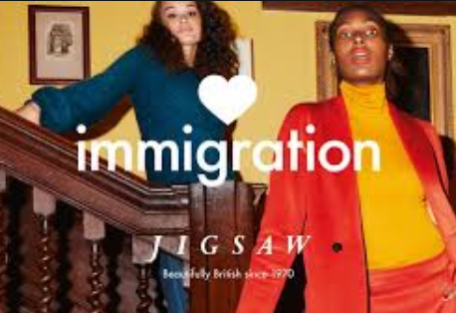

The famous poster of the jigsaw campaign features two women from different ethnic backgrounds with some statements about the British fashion. It states that the British fashion is not comprised of 100 percent British culture and norms neither the culture of the US, France, Germany or any other nation is one hundred percent pure. The campaigns and movements like Jigsaw are actually compensation to the debt that is owed to the immigrants by a British multi-ethnic and multi-cultural society. It promotes the issue in a different way rather than making it an issue for the culture and heritage of the country. There is no doubt that the new Britain is influenced by the protectionist approaches to the culture where the EU is considered as an encroaching entity and the cultural difference is increased in number at home (Hall, 1993). Despite these facts, Jigsaw is focused on bringing a shift in the overall perception of the masses towards immigrants and new settlers. There were voices against the ♥ immigration campaign of Jigsaw suggesting that the movement is against the British culture and poses threats to the identity and uniqueness of the culture. The Jigsaw authorities confronted with this allegation by the manifesto that British style and fashion is nor one hundred percent British. In the organization, candidates and participants from almost 45 different countries are included which shows the practical implementation of ‘love immigration’. The former chief executive Mr. Ruis said that fashion is comparatively a broader psyche and does not just operate in a bubble. Statistics revealed that the Jigsaw fashion brand evolved as the most famous and successful market in the year 2017 ( Emma, 2017). The efforts were applauded and supported on an international level and also was backed by the government machinery as the Mayor of London Sadiq Khan praised this movement in a tweet.

Jigsaw is one example of such a campaign but there are many concerns and issues related to immigrants and the related aspects of the fashion industry. In January 2017, the British government outlined a green paper related to the industrial strategy. The British Fashion Council had many reservations on this and they prepared a proper detailed reply to the government. In this response, they addressed many key issues that are summarized as.
· The fashion industry of the country greatly relies upon the trade from foreign countries especially from European countries for a skilled workforce, transporting collections, different aspects of supply chain and sourcing materials. The government must understand the importance of trade with the European Union as they possess the largest export market and is a source of quality production skills and business talent.
· The fashion industry is dependent on talent from international backgrounds across all disciplines and levels including business matters, production, and design.
· The fashion landscape in the country is also dependent on the graduates from the world renowned-universities where immigrants often establish their business in the city after their education.
· The skill gap and inefficiencies identified in the industry is due to visa regulations and authorities must take adequate measures in order to minimize such shortages and shortcomings.
All these suggestions and recommendations by the British Fashion Council revolve around entertaining and facilitating the immigrants and talent from foreign countries so that diversity and novel approaches are included in the business.

Other Campaigns
Another campaign in this regard supporting the immigrants and their importance in the culture and fashion of the country was launched in Spain. The exhibition was named ‘fashion mix’ and artists and creative designers were invited from different parts of the world. In the exhibition, a huge map was displayed that was showing with the trajectories of the arrows the places and regions from which major skilled and professional designers belong and participate in the development of the fashion industry. Saillard and colleagues (2014) discusses the importance of skill and explains that the only passport of numerous immigrants whom he knew was competence, imagination, and creativity. These migrants had a huge contribution to the progress of the Paris Fashion market (Saillard et.al, 2014). The exhibition ‘fashion mix’ has one great aspect that it reflected the national identity while projecting and promoting the national items and cultures in the form of artifacts, designs and dresses according to the local heritage. The national touch of the displayed items and pieces of art was unique and it portrayed a border-less sense because it also included items that were culturally diverse and were adapted from other cultures. This is mainly possible due to the influence of the cultural exchange and harmony among the fashions and representatives of the fashion industries of two or more regions (Menkes, 2015).

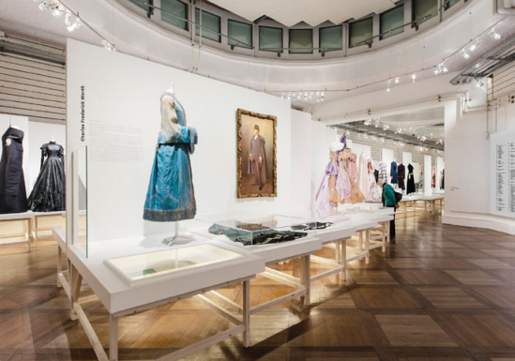

Considering the example of London which is famous for its dynamic and international education, is not only a place for training fashion professionals/workers but also it is a creative laboratory (McRobbie, 1998). Professionals, students, and workers from different parts of the world take part in the city’s fashion in a number of ways. These ways include fostering the job circulation, enriching creativity and creating opportunities for business and investment. Many workers and designers are settled in the country while bringing their inspiration and elements of their cultural heritage and have become an important and integral part of the British fashion. An important and notable example is Casely-Hayford who is an immigrant designer from Ghana and started working in Britain. He narrated his story about how he was treated in the fashion markets. He said that he had many struggles while working as he was named as a ‘black designer’. At the start, he never introduced any of his African cultures in his designs but later with the passage of time a mixture of British, Bedouin and African styles were introduced (Frank, 2011).

Talking about the role of immigrants in American fashion, many researchers have pointed out that it is necessary for the industry to support immigrants and stand up for them. The historic fabric of the United States is, in fact, the history of immigrants. Parabal Gurung is a designer from Singapore and works in the United States. He is so proud of his work and was is satisfied with the supportive environment for the immigrants and foreign workers. His dream was to become a successful designer of the United States and made a name by making a dress for the Duchess of Cambridge and also for the first lady of the United States. (RODULFO, 2017). Fashion Innovation alliance is the concerning department in the United States and is chief executive and founder Kenya discusses the importance of nurturing and promoting foreign workers in the United States. In her opinion, both the tech industry and the fashion industry in the United States are produced and built by immigrant entrepreneurs. This inclusiveness is one of the reasons for the economic growth and financial stability of not only the fashion industry but also of the country. So, it becomes exclusively important to review the immigration policies made by the new government which is based on nationalistic and conservative ideas. The policies are needed to be reviewed as we want to keep the American dream alive and continue working towards making innovation and progress (Stefanyshyn, 2015).

Conclusion
According to studies and literature reviews covered above, it has been observed that immigration has an undeniable impact on fashion. The rise of nationalistic and conservative political tendencies are a threat to the cause of immigrants. However, in the United States, the United Kingdom and in many other European countries, fashion industry representatives are launching campaigns to promote awareness regarding this issue. Fashion is one of the very important and obvious entity of a culture because of its visual implications and appearance-based characteristics. The leaders in the fashion industry expect to observe the reforms in the immigration system in order to address two main concerns. The first is to provide feasible ways to ensure easy access of top talent to the top fashions markets and also to ensure their retention. The second reform is about the reduction in the costs and bringing concessions in the immigration system for skilled immigrants and foreign talent. The fashion industry is dependent on talent from international backgrounds across all disciplines and levels including business matters, production, and design. The culture is a blend of many civilizations before getting a final shape and also keeps on varying with time as artifacts and fashions from other backgrounds adds. Immigration has enabled the inclusion of beautiful minds with innovative ideas into the market and without this, we would be dealing with the business of potatoes (Woods, 2017). To make a beautiful world and we need to give way to collaboration, love, and openness and to give up intolerance, isolation, and fear.

Women Empowerment and Fashion Industry
Certain devastating upshots and criticisms have been posted on platforms of media for undermining women by representing in unrealistic and traditional ways. Conservatively, females were portrayed as dependent-on, inane, inferior to men, passive, and they are frequently symbolized and sexualized to appeal to spectators. In recent years, women have been encouraged to get an education and higher educational opportunities have been provided to support them. Combined factors such as educational opportunities and better societal roles have promoted women in the advertising industries. It has been observed that women have been economically well-off due to technological improvement and higher education possibilities. Female’s community roles and capabilities of purchasing have been significantly increased in recent years in the global spectrum (Qiao and Wang, 2019). Additionally, more women have taken the arguments raised by discriminating them from societies through protests and campaigns (“Empowering Women & Girls – Self-Help International,” n.d.).
Certain promotion campaigns have supported women in industries particularly in photography and advertising. As women of recent years have realized that they have to compete and strive hard to stand beside men in these industries. Education, awareness and economic strength have supported and encouraged women to accept the challenges of these industries to compete in the media (Qiao and Wang, 2019). The previous diminished and weak image of women has been replaced with a strong and capable woman (“Empowering Women & Girls – Self-Help International,” n.d.). These radical changes have taken years to portray the image of women as robust and proficient in photographic industries.

In the board, clichéd traditions through which females were oft-depicted were outstretched. Stereotypes 2 comprise of female’s physical characteristics such as body size and personality traits. The roles and occupations of women were portrayed to empower them (Sternadori and Abitbol, 2019). These campaigns and advertising promotions have highlighted the physical characteristics of women not to deny their delicate nature, however, it was meant to display their traits, roles and body figures as an empowering feature. They have utilized the body sizes of the females to show societies that women are not weak in any aspect (Sternadori and Abitbol, 2019). Their physical traits cannot be denied as a resilient message was conveyed through these promotional and advertising campaigns (“Empowering Women & Girls – Self-Help International,” n.d.).
Women are not weak and should not be considered weak because of their delicate body, however, they are an equal member of this society sharing the same environment with the same opportunities (Qiao and Wang, 2019). The educational and economic development of women has empowered them as an important member of the advertising industry. Media and broadcasting companies have changed their views and opinions regarding women's physical traits though there are several agencies that still work to degrade women in these platforms (Sternadori and Abitbol, 2019). Nevertheless, women have been remarkably introduced themselves in such media and advertising platforms with robust personalities being portrayed and has significantly convinced societies that women are not an object to be treated as less than men.
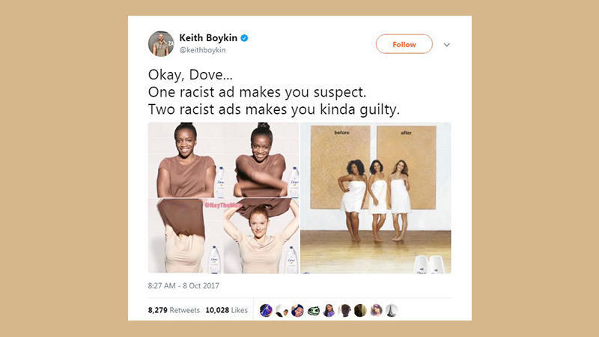

Femvertising Campaigns
Femvertising is a phenomenon that was introduced for the empowerment of women in the advertising industries. This termed was coined in 2014 by SheKnows Broadcasting in its Promotion Week board (“Empowering Women & Girls – Self-Help International,” n.d.). These advertising campaigns were specifically designed to raise women in such industries with a robust and strong image in front of the public (Sternadori and Abitbol, 2019). The message of these advertising campaigns was to employ the pro-female and rights of women and girls. Significant femivertisements including Under Armour: Rule Yourself, always: think like a girl, “Organic Balance” and We Are #WomenNotObjects with renowned fame. All of these advertising campaigns were related to women's rights in these industries. These advertising campaigns have introduced women with a different image representing them as glorifying and strong personalities who are not objects and who are not less than men (Qiao and Wang, 2019). Such advertising campaigns have been promoting women in the industries of graphic design, marketing, and photography.

Several women-empowerment advertising campaigns have received blame and criticism more than praise but were meant to promote products and services (“Empowering Women & Girls – Self-Help International,” n.d.). These advertising campaigns have been observed that it focuses on marketing their products and services rather than female empowerment. Such campaigns have been evaluated as breaking the norms of the societies and utilizing women for the production and advertisements purpose (Sternadori and Abitbol, 2019). For example, the Dove campaign has been promoted but was meant to break down the “status quos of beauty” and have highlighted the aspects of similar stereotypes. The videos were assessed and analyzed by the researchers and have evaluated that these videos were narrowing the critique of the outdated beauty models (Sternadori and Abitbol, 2019). Such advertising campaigns though encourage women and girls in the advertising agencies and companies but they promote their products through empowering women.
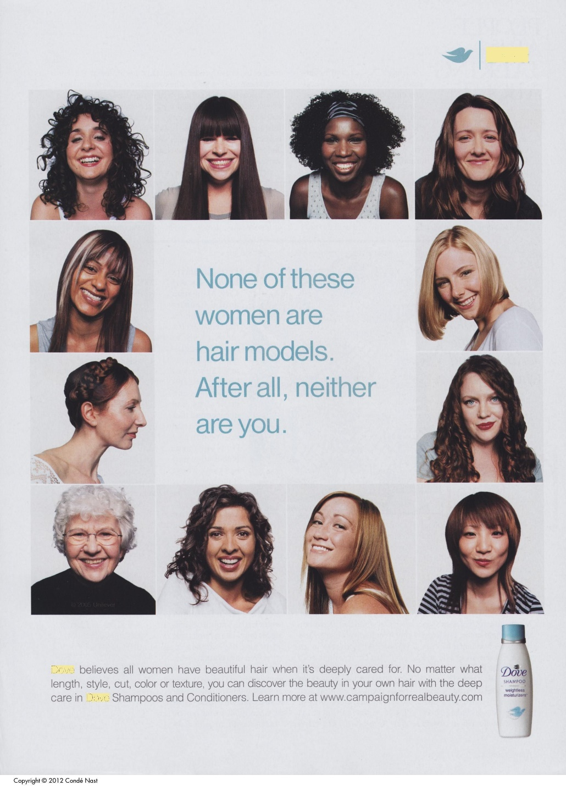
Consequently, it supports a post-feminist entrepreneurial program that essentially strengthens what Naomi Wolf titled ‘the beauty myth’”. However, beauty contests and campaigns are also meant to promote and empower women. Women empowerment is an important segment of society (Sternadori and Abitbol, 2019). Therefore, it should be promoted and highlighted through advertising campaigns and promotional activities on different media platforms.
Female’s public roles and competencies of purchasing have been significantly augmented in recent years worldwide (Qiao and Wang, 2019). Moreover, more women have taken the statements raised by discriminating females from communities through protests and movements such as gender discrimination among societies (“Empowering Women & Girls – Self-Help International,” n.d.).
Rendering to the studies that have raised criticism against advertising advertisements, these campaigns cannot be designated as purely femvertising because of the marketing strategies to sell their products and services (“Empowering Women & Girls – Self-Help International,” n.d.). The changes in such advertisements have been analyzed in different studies that methods used were ineffective and superficial. The studies have shown that femvertisements have successfully promoted the image of females among communities. The results of the studies were assessed and led the analysis that it was critically and visually examined (“Empowering Women & Girls – Self-Help International,” n.d.). Different studies have varying results regarding advertising campaigns as the analysis and methods to approach these studies were different. There are several studies that support femvertisements as effective campaigns and various studies were in contradiction to these results.
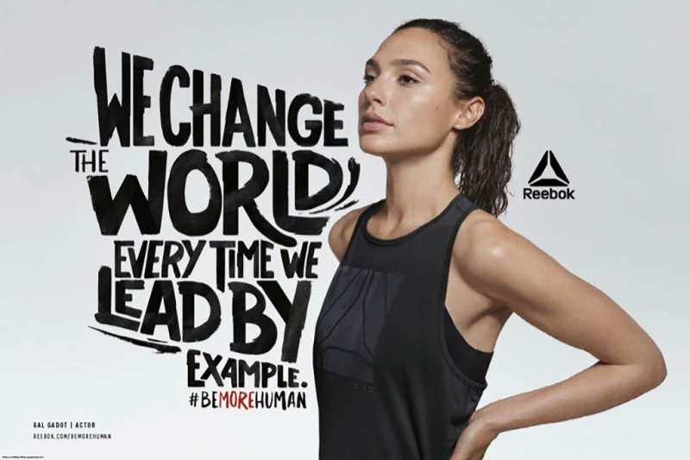

Analysis of Femvertising Campaigns
Many movements have inconsistent views towards femvertising campaigns that led the scholars to conduct and evaluate these studies. Therefore, various studies have been identified having supportive and favoring results towards post-feminist programs being raised by these advertisements promoting the empowerment of women in the societies (Sternadori and Abitbol, 2019). Since many companies have utilized online forums to encourage such femvertising campaigns. These online forums are used to encourage, support and favor females and to get feedback from communities. these platforms have played an important role in advertising and promoting femvertising campaigns (Sternadori and Abitbol, 2019). Women empowerment can be raised more aggressively through these platforms such as social media (“Empowering Women & Girls – Self-Help International,” n.d.).
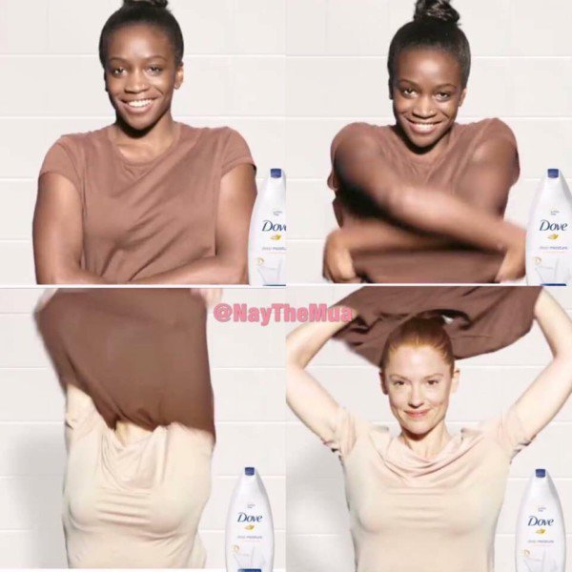

Taking the opportunity to raise awareness among communities can effectively deliver the message of the promotion of women empowerment (Sternadori and Abitbol, 2019). These videos and advertising boards have been effectively promoted in online forums. Enchanting into deliberation that social media has massive influence to distribute evidence, the movement videos can thus grasp a great number of spectators irrespective of gender (Sternadori and Abitbol, 2019). The incentive for accompanying the study is in orientation to the numerous unpredictable sentiments to femvertising movements apprehended by numerous researchers. Though few studies propose the ingenuities and innovations completed by these movements, many discourage the post-feminist program strengthened by those probable women-empowering commercials.

Evaluation of Femvertisement Campaigns
Since the women empowerment advertising campaigns have raised a concept to portray a positive image of girls and females in advertising. However, it may have a negative influence on young girls by making them overactive to adapt to inappropriate behaviors. The campaigns and fashion industries have raised a positive image of femvertising though inappropriate criticism has also been received. Portraying a positive image of females have created awareness among them to adopt the most suitable behaviors to become successful in communities. Creating awareness among women was the first message that was effectively delivered through these women empowering movements and campaigns. Education, awareness and economic power have reinforced and encouraged women to accept the contests of these industries to compete in the media (Qiao and Wang, 2019). The previous weakened and feeble image of women has been substituted with a strong and capable woman (“Empowering Women & Girls – Self-Help International,” n.d.). These radical variations have taken years to portray the image of women as healthy and proficient in photographic businesses.
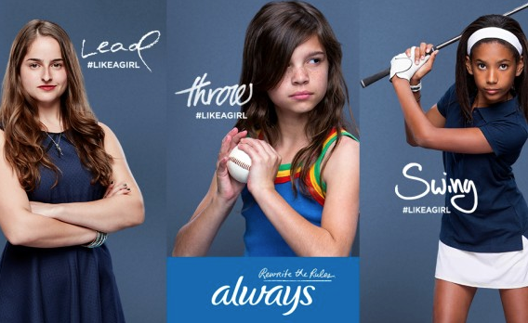
It is also important to analyze that femvertising videos and campaigns are being delivered effectively and have raised the message constructively. The message delivered through these videos is related to women's empowerment not discouraging them and not in contradiction to the education of females. Therefore, analyzing the videos and campaigns is equally important to see that the meaning is destructive or constructive (Hsu, 2018). The studies have shown that various kinds of researches have been performed visualizing different results. Certain studies were favoring advertisements and several were portraying the destructive image of these campaigns.
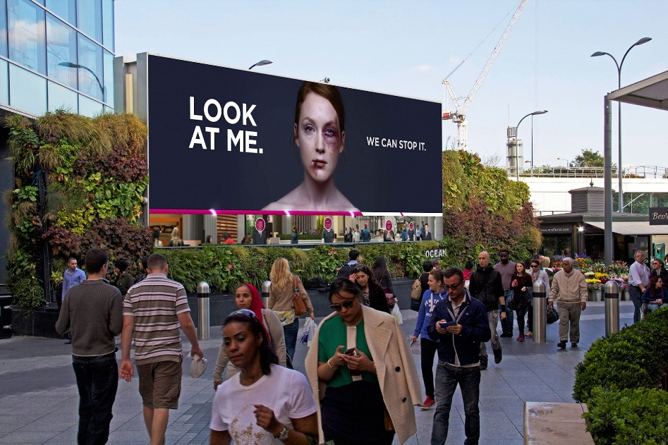
Another significant part of these advertisements is that from where the promotional expenditure would be collected to promote these campaigns? It was analyzed that such campaigns were promoting women empowerment through femvertising and were utilizing financial benefits by promoting men’s ads using women as an object (Sternadori and Abitbol, 2019). For example, the dove campaign was sponsoring Axe Men’s campaigns of deodorants that were using females as an object to represent them for sensual appealing. This also represent that how many advertising companies are playing with the minds of people. Many companies have been involved in portraying an femvertising image in communities and simultaneously these companies were engaged in promoting men’s products through discouraging women (Sternadori and Abitbol, 2019).
Therefore, advertising media have been using companies where they are favoring women empowerment in one side and strengthening built-in typecast on the other side. The dual perspective of such advertising companies are actually portraying that they favor women empowerment but are promoting typical stereotypes in the societies too. Women empowerment is not an easy task and is not achievable through media only. Building societies with education and awareness is equally important to promote women empowerment in fashion and photography industry (“Empowering Women & Girls – Self-Help International,” n.d.). Developing and changing mindsets with education and awareness is equally significant to encourage women empowerment in fashion and photography (“Empowering Women & Girls – Self-Help International,” n.d.). Building women empowerment is achievable through promoting equality and discouraging disparities regarding gender. Discouraging and evaluating these advertising agencies who promote women empowerment just to build their products and services in communities would be helpful in identifying the hidden typical stereotypes (“Feminist advertising by Dove, Always, and CoverGirl, explained - Vox,” n.d.). Promoting femvertising campaigns through utilizing all platforms such as social media, paper media and print media can promote women in fashion and photographic industry.

Viewpoints Towards Femvertisements
Different studies have shown that femvertising campaigns would never be justifying the effectiveness of such advertisements to empower women. Several arguments have been raised among various researchers assessing that femvertisements will not be able to agree on progressiveness in influencing females (Rodrigues, 2016). Several types of research have been conducted to change the image of the women in advertisements such as body shape, size, and self-esteem of females. Representation of respect of women in the societies and communities through femvertising campaigns have been completely changed in recent years (Becker-Herby, 2016). Consequently, encouraging stereotypes as well as women empowerment and not deteriorating and breaking the notions of old clichés. Therefore, advertising media have been using businesses where they are preferring women empowerment on one side and establishing typecast on the other side. The dual viewpoint of such publicity is just portraying that they favor women empowerment but are promoting stereotypes in the communities too.

Though some respect has been promoted through these campaigns among communities by empowering women (Qiao and Wang, 2019). Several studies have been conducted to test and examine the perspective of these advertisements. Some initiatives such as “the movement of change” have contributed a positive image of women among communities (“Axe Tackles ‘Toxic Masculinity’ by Revealing How Deeply Young Men Struggle With It – Adweek,” n.d.). respect of women and self-esteem was promoted among societies utilizing these movements (Mamuric, 2019). These campaigns have raised a positive image of females in the views of scholars and societies.
Dove’s Onslaught video was analyzed by several researchers and scholars and almost more than 20 themes were assessed. The majority of the researchers have been agreed to the comments that they support women empowerment through these messages and all of the videos were prepared and declared positive (Sobande, 2019). Women empowerment through these messages and videos is positively distributed among communities utilizing femvertising campaigns. For example, a little girl smiles and several images of women are being displayed outlining the positive image of females through these campaigns. The sponsors and individuals promoting women empowerment in the fashion industry has favored these videos with positive responses.
Various studies have been conducted to analyze and evaluate the messages delivered through these campaigns and the results of the studies were positive and favoring women empowerment (Abitbol and Sternadori, 2019). Therefore, these femvertsing companies have been declared as delivering a positive image of females in societies and supporting women empowerment.
Femvertising campaigns have been appraised as breaking the standards of the cultures and utilizing women for the fabrication and advertisement resolution (Hunt, 2017). For instance, as the study has analyzed the Dove campaign has been promoted to break down the “status quos of beauty” and it was true (Drake, 2017). The videos were evaluated and investigated by the researchers and have appraised that these videos were tapering the assessment of the outdated beauty models (Rodrigues, 2016). Femvertising campaigns though encourage women and girls in the advertising agencies and companies but they promote their products through empowering women as well (Sternadori and Abitbol, 2019). However, the message of such campaigns is being delivered positively as it discourages typical stereotypes.
The prevalence of opposing voices is also increasing among communities. it was assessed through various studies that campaigns supporting women empowerment are also supporting typical stereotypes (Åkestam et al., 2017). It was analyzed that the views of the communities were positive and also the sponsors were effectively delivering the women empowering messages in the societies but were not deleting the image of typical stereotypes (Wang, 2019). They were promoting the mindsets of stereotypes as well. The culture of stereotypical mindsets was also prevailing but through the same platforms (Wang, 2018). As the study discussed that the same platform and forum was used for the promotion of women empowerment and also for displaying women as sexual object. On one side women were displayed as an unstoppable and independent character and a respectable personality of the society (Wang, 2018). On the other side, the same forum was depicting women as an object (Sternadori and Abitbol, 2019).
The forum was not only meant for the promotion of stereotypical mindsets and women empowerment but also encouraging and persuading women to purchase those products (Sharma and Das, 2019). Therefore, promoting stereotypes as well as women empowerment and not declining and breaking the concepts of old clichés. Therefore, advertising media have been using companies where they are favoring women empowerment on one side and strengthening built-in typecast on the other side. The dual perspective of such advertising companies is actually portraying that they favor women empowerment but are promoting typical stereotypes in the societies too. Women's empowerment is not an easy task and is not achievable through media only. Developing civilizations with education and awareness is equally important to encourage women empowerment in the fashion and photography industry (“Empowering Women & Girls – Self-Help International,” n.d.). Building females empowerment is attainable through equality and unpromising disparities such as gender discrimination.

Bibliography
A.Tinic, S., 1997. United Colors and Untied Meanings: Benetton and the Commodification of Social Issues. Journal of Communication, pp. 1-24.
Andersson, S., Hedelin, A., Nilsson, A. & Welander, C., 2004. Violent advertising in fashion marketing. Journal of Fashion Marketing and Management: An International Journal, 8(1), pp. 96-112.
Barela, M. J., 2003. United Colors of Benetton: From Sweaters to Success: An Examination of the Triumphs and Controversies of a Multinational Clothing Company. Journal of International Marketing, 11(4), pp. 113-128.
Crosier, K., Hernandez, T., Mohabir-collins, S. & Erdogan, Z., 2010. The Risk of Collateral Damage in Advertising Campaigns. Journal of Marketing Management, 15(8), pp. 837-855.
D.Pickton & A.Broderick, 2005. Integrated Marketing Communication. 2nd ed. s.l.:Prentice Hall.
Ganesan, S., 2002. Benetton group: Unconventional advertising, s.l.: Global CEO.
Horovitz, B., 1990. https://www.latimes.com/archives/la-xpm-1990-03-07-fi-2022-story.html. [Online]
Available at: https://www.latimes.com/archives/la-xpm-1990-03-07-fi-2022-story.html
[Accessed 30 December 2019].
Incze, C. B., Pocovnicu, A., Vasilache, S. & Zain, N. L. A., 2018. Marketing communication analysis of benetton PR campaigns. Sciendo, 12(1), pp. 457-465.
Kraidy, M. M., 2003. Transnational Advertising and International Relations: US Press Discourses on the Benetton "We on Death Row" Campaign, s.l.: University of Pennsylvania.
Kuan, A., 2018. Controversy Advertising: An Exploratory Study on Controversy Advertising and Its Effects, s.l.: Portland State University.
Kubacka, N., 2012. https://www.theseus.fi/bitstream/handle/10024/48098/Kubacka_Natalia.pdf. [Online]
Available at: https://www.theseus.fi/bitstream/handle/10024/48098/Kubacka_Natalia.pdf
[Accessed 30 December 2019].
Laricks, K., 2017. THE IMPACT OF IMMIGRANTS ON AMERICAN FASHION. University of Fashion, 5 7, pp. https://www.universityoffashion.com/blog/impact-immigrants-american-fashion/.
Macleod, D., 2007. http://theinspirationroom.com/daily/2007/benetton-pieta-in-aids-campaign. [Online]
Available at: http://theinspirationroom.com/daily/2007/benetton-pieta-in-aids-campaign
[Accessed 30 December 2019].
Riggs, T., 2006. Encyclopedia of major marketing campaigns. s.l.:Amazon.
RODULFO, K., 2017. Four Fashion Designers On Why the Industry Should Stand Up for Immigrants. [Online]
Available at: https://www.elle.com/fashion/a43740/immigrant-designers-why-fashion-should-stand-up-for-immigrants/
[Accessed 15 3 2017].
Sandikci, O., n.d. Shock Tactics in Advertising and Implications for Citizen-Consumer. International Journal of Humanities and Implications fo Citizen-Consumer, 1(18), pp. 42-50.
Stefanyshyn, D., 2015. Immigrants and the Garment Industry. [Online]
Available at: https://eportfolios.macaulay.cuny.edu/whatwewear/new-yorker/
Timeea, 2011. https://www.toptenz.net/top-10-controversial-print-ads.php. [Online]
Available at: https://www.toptenz.net/top-10-controversial-print-ads.php
[Accessed 30 December 2019].
Warnick, B., 2005. Rhetoric Online: Persuasion and politics on the World Wide Web. New York: Amazon.

Abitbol, A., Sternadori, M., 2019. Championing Women’s Empowerment as a Catalyst for Purchase Intentions: Testing the Mediating Roles of OPRs and Brand Loyalty in the Context of Femvertising. Int. J. Strateg. Commun. 13, 22–41.
Åkestam, N., Rosengren, S., Dahlen, M., 2017. Advertising “like a girl”: Toward a better understanding of “femvertising” and its effects. Psychol. Mark. 34, 795–806.
Axe Tackles ‘Toxic Masculinity’ by Revealing How Deeply Young Men Struggle With It – Adweek [WWW Document], n.d. URL https://www.adweek.com/brand-marketing/axe-tackles-toxic-masculinity-by-revealing-how-deeply-young-men-struggle-with-it/ (accessed 12.30.19).
Becker-Herby, E., 2016. The Rise of Femvertising: Authentically Reaching Female Consumers.
Drake, V.E., 2017. The impact of female empowerment in advertising (femvertising). J. Res. Mark. 7, 593–599.
Empowering Women & Girls – Self-Help International [WWW Document], n.d. URL https://www.selfhelpinternational.org/empowering-women-girls/?gclid=EAIaIQobChMIjuWUsPXd5gIVkkDTCh1L3QF4EAAYASAAEgIuP_D_BwE (accessed 12.30.19).
Hsu, C.-K.J., 2018. Femvertising: State of the art. J. Brand Strategy 7, 28–47.
Hunt, A.R., 2017. Selling Empowerment: A critical analysis of Femvertising. Boston College. College of Arts and Sciences.
Qiao, F., Wang, Y., 2019. The myths of beauty, age, and marriage: femvertising by masstige cosmetic brands in the Chinese market. Soc. Semiot. 1–23.
Rodrigues, R.A., 2016. Femvertising: empowering women through the hashtag? A comparative analysis of consumers’ reaction to feminist advertising on twitter. Instituto Superior de Economia e Gestão.
Sharma, S., Das, M., 2019. Women Empowerment Through Advertising. Eur. J. Soc. Sci.
Sobande, F., 2019. Woke-washing:“Intersectional” femvertising and branding “woke” bravery. Eur. J. Mark.
Sternadori, M., Abitbol, A., 2019. Support for women’s rights and feminist self-identification as antecedents of attitude toward femvertising. J. Consum. Mark.
Wang, S., 2019. Leftover women in China: Empowering through “femvertising”?
Wang, S., 2018. EMPOWERING WOMEN THROUGH ADVERTISING: A CONTENT ANALYSIS ON’FEMVERTISING’CAMPAIGNS.

Laricks, K., 2017. THE IMPACT OF IMMIGRANTS ON AMERICAN FASHION. University of Fashion, 5 7, pp. https://www.universityoffashion.com/blog/impact-immigrants-american-fashion/.

Hall, S., 1993. Culture, community, nation. Cultural studies, 7(3), pp.349-363.

How London became fashion’s capital city [WWW Document], n.d. . British GQ. URL https://www.gq-magazine.co.uk/fashion/article/how-london-became-fashions-capital (accessed 12.30.19).

Jigsaw just released an ad celebrating immigration after the Brexit-vote [WWW Document], 2017. . The Independent. URL http://www.independent.co.uk/news/business/news/jigsaw-immigration-new-campaign-celebration-british-values-style-high-street-fashion-brand-a7999256.html (accessed 12.30.19).

Refugees, U.N.H.C. for, n.d. Forced displacement above 68m in 2017, new global deal on refugees critical [WWW Document]. UNHCR. URL https://www.unhcr.org/news/press/2018/6/5b27c2434/forced-displacement-above-68m-2017-new-global-deal-refugees-critical.html (accessed 12.30.19).

Saillard, O., Blackman, C., Rigaux, E., Renard, I., Gandon, E., Frisa, M.L., Arzalluz, M., Pessey-Lux, A., Tsujita, K., Diatkine, A. and Arnauld, M., 2014. Fashion Mix. Mode d'ici. Createurs d'ailleurs. Flammarion.

McRobbie, A., 2003. British fashion design: Rag trade or image industry?. Routledge.

Frank, A. 2011. “Casely-Hayford’s Inherited Resistance.” The Fader, March

Laricks, K., 2017. THE IMPACT OF IMMIGRANTS ON AMERICAN FASHION. University of Fashion, 5 7, pp. https://www.universityoffashion.com/blog/impact-immigrants-american-fashion/.

RODULFO, K., 2017. Four Fashion Designers On Why the Industry Should Stand Up for Immigrants. [Online]
Available at: https://www.elle.com/fashion/a43740/immigrant-designers-why-fashion-should-stand-up-for-immigrants/
[Accessed 15 3 2017].

Stefanyshyn, D., 2015. Immigrants and the Garment Industry. [Online]
Available at: https://eportfolios.macaulay.cuny.edu/whatwewear/new-yorker/
Hill, A. 2017. “Hostile Environment’: The Hardline Home Office Policy Tearing Families apart.” The Guardian, November 28

Menkes, S. 2015. “Fashion Mix - The Immigration Game.” Vogue, January

Woods, Z. 2017. “The Fashion World Speaks Out: ‘Without Immigration, We’d be Selling Potato Sacks.’” The Guardian, October

Weir, L. 2018. “Riccardo Tisci on reinventing Burberry - and who his dream muse would be.” Evening Standard, September 27

Tillmans. 2016. “Anti-Brexit Campaign.” Tillmans. Accessed May 28, 2017

