Material Culture
[Name of the Writer]
[Name of the Institution]

Material Culture

Symbolic interaction theory is considered to be a foundation stone among sociologists. In symbolic interaction, individuals interact with different objects of everyday life and assign different meanings to them (Yeager, 2016). An individual when came across to an object, the meaning of that object to the individual depends upon how the interaction between those two went (Yeager, 2016). For instance, an individual was strolling in a park when he decides to take a rest under a giant tree. As, the tree provided shade, that individual may assign the meaning of shade to the symbol of the tree. However, another individual that had a relatively bad experience with a tree might associate bad meaning to it. Both the individuals have associated meanings with a certain object after interacting with it. An interesting thing to consider is that the meanings associated with the object are not constant or absolute (Yeager, 2016). These meanings might change over the period of time depending upon the nature of interaction with the object. This interaction with the objects and association of meanings to them has fascinated sociologists over the time and new aspects of sociology are produced. That the tangible objects related to any culture and the beliefs associated with those objects are interconnected. Associating meanings gave rise to two sociological terms. Material culture and non-material culture. As defined by many sociologists, culture is shared norms and beliefs of individuals collectively (Wang et.al, 2018). The term material culture is defined as physical objects that people refer to as their culture (Wang et.al, 2018). Material culture may include homes, schools, temples, mosques, and synagogues (Wang et.al, 2018). The interaction with these objects shapes the opinion of an individual about them. Non-material culture includes just the ideas that individuals may have associated with something (Wang et.al, 2018). Non-material culture is completely opposite to material culture in theoretical perspective. However, they are deeply interlinked with each other (Wang et.al, 2018).
Three things that are selected as the material culture for this paper are school, museums, and a church. The first object that comprises of material culture is the school. A school is an important object in the collective culture because it equips the students with the knowledge that is required to thrive in this modern world. Besides academics, extracurricular activities provide ample opportunities for students to develop many skills. These skills might help students to interact with other students more sociably. Winning a trophy might give them a sense of achievement and motivates them to do more. Schools offer much more than any other material culture around us today.
The next object that comprises our material culture is a museum. Museum provides an opportunity for dialogue, cooperation, and interaction for the people sharing the same ideas. Additionally, the museum is a great source of knowledge for students like me. Museums portray history that provides an opportunity to reflect upon humanity has evolved. Furthermore, museums contain things created by man in the most adverse of times. For instance, a bow and arrow might seem redundant in today's world, but for people living a couple of centuries back, it was an important tool to acquire food for their sustenance.
The last thing that comprises of the material culture is the church. The role of the church is important because, besides being a platform to practice one's beliefs, they help to mobilize local communities. Church also help the poor and homeless individuals. Most of the time church offers shelter to people displaced through uncalled for circumstances. Moving further, churches always instruct the people attending them to behave in a socially acceptable way. Church also provides the believers to create a sense of harmony and fraternity among the community. This is an important aspect of the material culture related to the church given the fact that we are living in a multicultural and multireligious society.
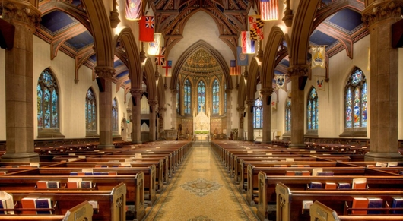

References

Yeager, E. O. (2016). Symbolic Interaction Theory. Encyclopedia of Family Studies, 1-6.
Wang, Y., Deng, X., Zhang, K., & Lang, Y. (2018, June). The Intangible Cultural Heritage Show Mode Based on AR Technology in Museums-Take the Li Nationality Non-Material Cultural Heritage as an Example. In 2018 IEEE 3rd International Conference on Image, Vision and Computing (ICIVC) (pp. 936-940). IEEE.

