Object Response
Student’s Name
Institution
Date

Quote “The middle class life was viewed as a spectator sport”
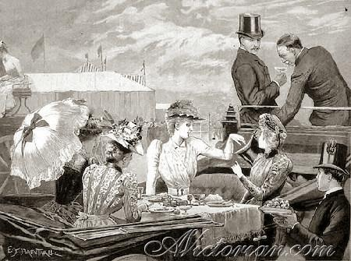
Figure1: Victorian Era Leisure
The quote “The middle class life was viewed as a spectator sport” is used to illustrate the live of many people in London during the early days. It is portrays the kind of new gentleman life where people strolling the streets for window shopping, meeting friends and having coffee together. This kind of life emerged during the early 1900s. It was the beginning of modern industrialization and revolution, which created many middle class and rich people who could afford entertainment and therefore, the author used the quote to inform the readers of the emerging lifestyle of the nineteenth century.
However, in the image above in figure 1 “Victoria Era Leisure” is group of people who are having fun, eating and connecting, which symbolizes the life of middle class in the early days. The middle class are regarded as individuals with mean and can afford entertainment, which include good life and therefore, the image depict the kind of life many middle class have in the current and old society. The spectator sport could mean having less to do except entertainment and leisure. In this regard, it could mean that middle class had much time for entertainment, which is clearly illustrated in the image in figure 1 above. The quote therefore, connects with the image because the people in the image are having more leisure time in the restaurant, which symbolizes the life of middle class in the nineteenth century.

