Research Paper
[Author’s name]
[Institute’s name]

Research Paper
Introduction
Undoubtedly, the trend of using sustainable products is immensely growing as many corporation organizations are interested to launch different products with various sustainable features. Sustainable products are recognized as the specific products that are used to deliver environmental, social, and economic benefits concerning the overall idea of the environment (Maxwell & Van der Vorst, 2003). It is noteworthy to mention that currently, customers are highly keen to buy and use eco-friendly friends in the form of sustainable products. This paper focuses to identify and critically analyze customers’ reviews on some of the sustainable products to understand the suitability and effectiveness of these specific products.
Discussion
In recent times, there are plenty of business products characterized as sustainable products in order to save the entire environmental prospect. The LARQ Bottle and the Final Straw are characterized as two prominent types of sustainable products that are immensely popular in a large portion of potential consumers. It is interesting to examine how these specific products are reviewed by some of the customers. This form of consideration is important to identify specific factors that encourage customers to use these sustainable products.
The LARQ bottle is characterized as the one popular sustainable product that can be used as the reusable bottle alternative. One of the active users of this product shared her reviews about this product on the social media platform of YouTube. It is interesting to examine what are the significant features of this product that encourage her to use the LARQ bottle as compared to other water bottles. She preferred a LARQ bottle due to its significant feature of the self-cleaning approach of bottle and water. According to her, one of the primary reasons for preferring this product on other alternative products is that it considers the beneficial domain of UV light. She shared her review that the LARQ bottle has its effectiveness because the approach of UV light is helpful to clean water inside the bottle and the entire surface of this sustainable bottle. The customer of a LARQ bottle also shared her opinion that the entire design of the bottle that ensure the successful application of UV light as the basic sustainable feature of this product (terradrift., n.d.). The slash manual of this bottle is useful that made it easy for consumers to use this sustainable product.
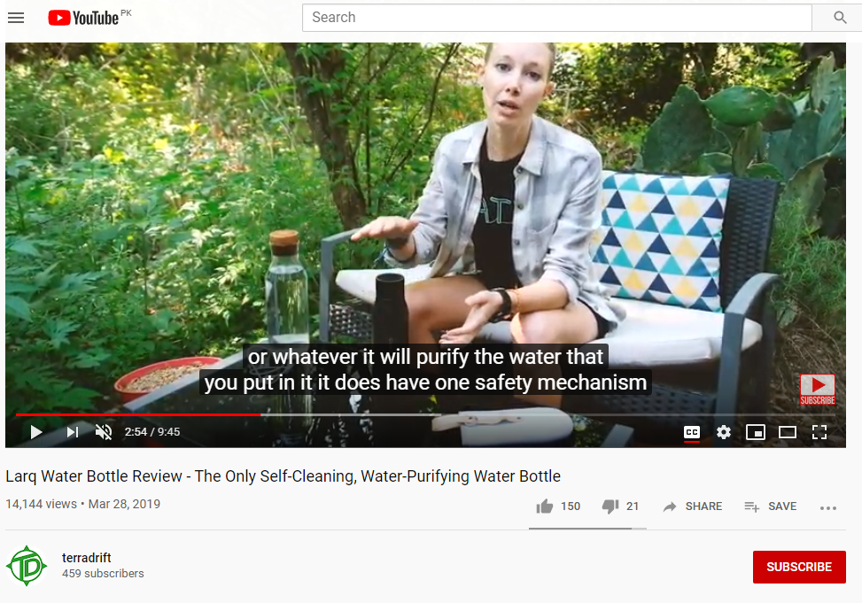
Moreover, the consideration of different cycles of purifying water ensures the smooth application of the entire process of cleanliness in a sustainable manner. The review of this product successfully conveys her opinion about the safety mechanism adopted by the manufacturers to meet the standards of sustainable products.
Currently, the Final Straw is another suitable example of sustainable products in the market that gains immense attention from potential users. The effectiveness of this item as a sustainable product is comprehensively reviewed by the user through the platform of YouTube. The reviewer shared his positive opinion about the product that the Final Straw is a successful substitute in the market to minimize the environmental costs of plastic straws. He reviewed this product as a useful item to use considering the feature of reusable metallic straw that can be easily stored on a keychain ( ReviewOnAnything, n.d.). This specific product is favored by the reviewer because it contained a great approach when it comes to source this product. He further explained that the particular features of drying rack and focused squeegee helped users to easily keep the product clean.
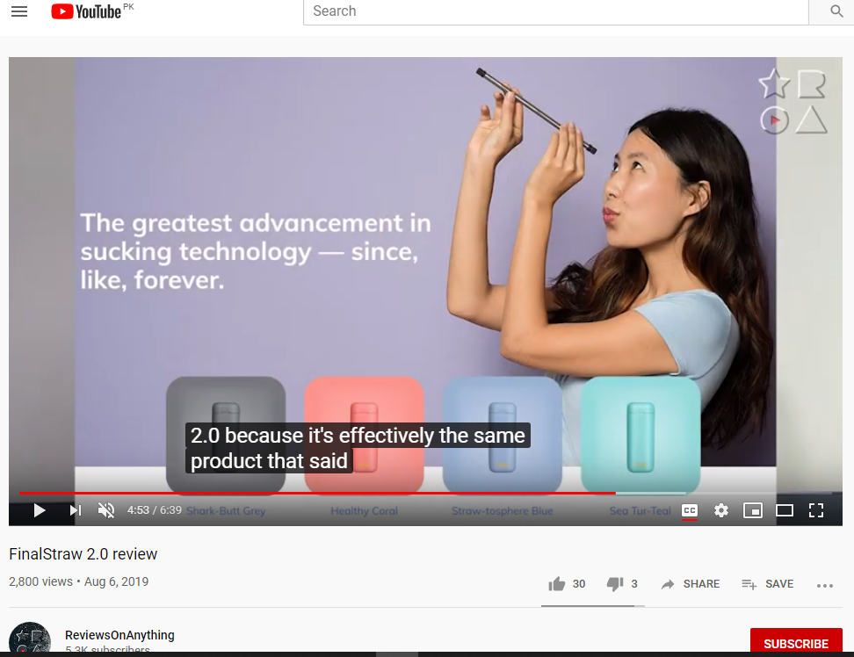
Conclusion
To conclude the discussion about the effectiveness of sustainable products, it is important to indicate that the trend of using sustainable products is growing to provide better protection to the environment. Consumers are more interested to use sustainable items because they are environment-friendly and easy to carry by considering the simple aspects of production.

References
ReviewOnAnything., (n.d.). FinalStraw 2.0 review. Retrieved from https://www.youtube.com/watch?v=lwxQP2MFqQk
terradrift., (n.d.) Larq Water Bottle Review—The Only Self-Cleaning, Water-Purifying Water Bottle. Retrieved from https://www.youtube.com/watch?v=T9R0GSFgZSk
Maxwell, D., & Van der Vorst, R. (2003). Developing sustainable products and services. Journal of Cleaner Production, 11(8), 883–895.

