Baby Boomers in Middle Adulthood
[Author Name(s), First M. Last, Omit Titles and Degrees]
[Institutional Affiliation(s)]

Author Note

Baby Boomers in Middle Adulthood
Baby boomers are one generation that may not know what it means to ‘clap back’ or even use a vape pen or an airpod. However, they were the generation who used VCRs and knew how important it was for their entertainment. They saw the age of floppy drive and were able to bear witness to most of the technological advancements that we take for granted today. Defined as those born between 1946 and 1964, baby boomers are one generation that has been target by marketing executives for decades now (Hilt & Lipschultz, 2016). Most of them are entering middle adulthood, while some are even becoming grandparents themselves. This makes them one of the very few still under the microscope of the advertising profession.
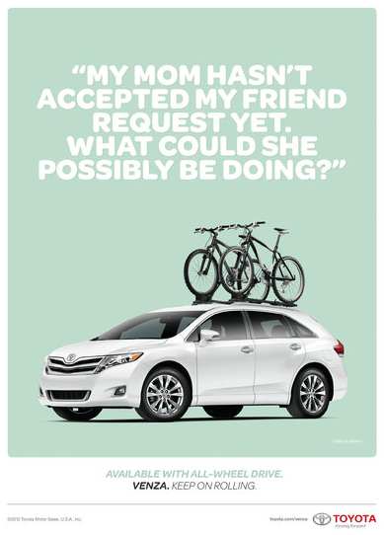
Turbulent times were written into the fates of the millennials. However, baby boomers were lucky enough to enjoy peace for most of their childhood and early adulthood. Thus, they remained in that idealistic bubble of peaceful times even when times got turbulent. According to an estimate, baby boomers have a tendency to spend more on traveling on an average than any generation that followed them. They account for more than 294.5 million trips taken in the US alone and favor living in a hotel or a model, fly for business and even spend some pretty penny on renting cars. Furthermore, they had no qualms about crossing a $1000 spending limit on a trip (Patterson & Pegg, 2009). This is the very tendency that was targeted by Toyota in the advertisement shown here.
Their propensity to invest in luxurious items is ruthlessly exploited by most advertisement executives. Add in the idea that they are getting old and they not only tend to invest in luxury, but they also work towards continuing to try new things (D’Arpizio & Levato, 2014). In the following advertisements, this idea is reinstated. The first ad is by coca cola where a baby boomer explores all the things he missed out on in life while being cared for in a senior care facility. The second one is by Chevy, which aims at making baby boomers feel young all over again, all courtesy of a luxurious ride.
Image Courtesy: Toyota
https://www.youtube.com/watch?v=9j9KWEGmq9Y
https://www.youtube.com/watch?v=EuLOCSMS-3k
Another keen aspect observed among the baby boomers is the attention they give to self-improvement. They love to look their best and wouldn’t mind investing in it to be the very best versions of themselves (De Gregorio & Sung, 2010). They were the ones who were primarily responsible for giving the beauty industry a boom as well and made them look into skincare products. Although millennials have taken this belief to obsessive levels, it was baby boomers that first started it.
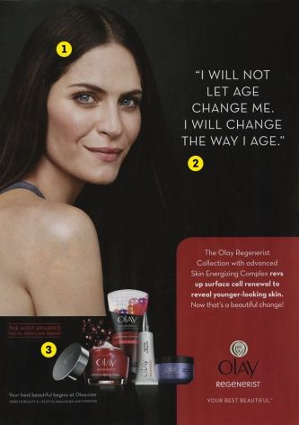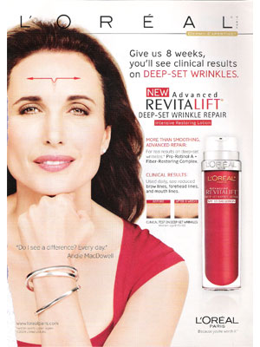
Image Courtesy: Olay and L’Oreal
Stated here as an example is an advertisement from Olay and L’Oreal that banked on this tendency and brought a revolution with anti-aging products, all as a result of effective marketing plans (Lehu & Bressoud, 2008).
With regard to individual change and stable cognitive function, the intelligence quotient in baby boomers peaks during middle adulthood, especially with regard to their intellectual skills (Chiao, 2017). However, their cognitive abilities go through a stark decline by the time they hit their 60s. Despite that, they are at a stable point in life, economically. This makes them a target for high-end retailers. In this way, their efforts more often than not bear fruits.
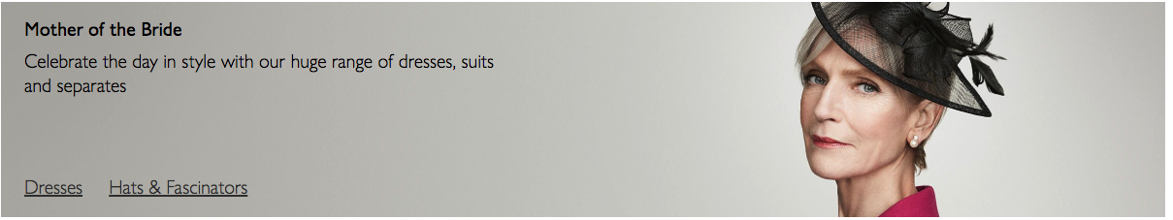Clothing section on John Lewis & Partners website

In conclusion, baby boomers have been one generation that has been a pioneer on a number of fronts and everything about them, their habits and tendencies tend to show them all. They changed the perspective of those that followed them and have ingrained and promoted a different set of values and ideals.
References
Chiao, C. (2017). General cognitive status among Baby boomers and pre-boomers in Taiwan: the interplay between mid-life socioeconomic status and city residence. BMC Geriatrics, 17(1), 113.
D’Arpizio, C., & Levato, F. (2014). Lens on the worldwide luxury consumer. Milan: Bain & Company.
De Gregorio, F., & Sung, Y. (2010). Understanding attitudes toward and behaviors in response to product placement. Journal of Advertising, 39(1), 83–96.
Hilt, M. L., & Lipschultz, J. H. (2016). Mass media, an aging population, and the baby boomers. Routledge.
Lehu, J.-M., & Bressoud, E. (2008). Effectiveness of brand placement: New insights about viewers. Journal of Business Research, 61(10), 1083–1090.
Patterson, I., & Pegg, S. (2009). Marketing the leisure experience to baby boomers and older tourists. Journal of Hospitality Marketing & Management, 18(2–3), 254–272.

