Nigeria vs Ghana Economy
[Name of the Writer]
[Name of the Institution]

Nigeria vs Ghana Economy
Nigeria and Ghana are some of the more stable economies in the African region, and both the economies have adopted different approach when it comes finding the right balance between sustained growth and making sure that they keep the inflation in check at the given point of time. for instance, when one talks about Ghana, this is an economy that has been strengthened by the sound management and efficient allocation of the resources. With the help of the fiscal management and poverty alleviation strategy, they have made sure that they have kept poverty level in check. On the other hand, Nigerian economy is fortunate in a sense that it is an economy that is relatively rich in resources specially when one compares them with some of the other economies in the African region. The instability, corruption and the lack of infrastructure are some of the major reasons behind the lack of sustained economic success by these economies. The economic and political structure in both the countries is quite different as Ghana is known to be more democratic republic while on the other hand, Nigeria has been controlled by military regimes during the course of its history. Thus, it is going to be interesting when the comparison and the contrast of both these economies is going to be carried out.

Business Prospect in Ghana and Nigeria
It has to be noted that due to the much larger population as well as the greater pool of resources, the market size of the Nigeria is quite on the higher side. On the other hand, effective policy making, and the stable economy of the region is one of the prime reasons due to which Ghana has been able emerge as one of the biggest economies of the African region. There is also difference in terms of the areas in which work is being carried out. White Ghana is an economy that is more focused on the natural resources and the agriculture, industrial manufacturing and the export-oriented industry is one of the keys defining feature of the Nigeria. The market size of the Nigeria is one of the thing that makes it much better economy as compared to the Ghana but that one thing is offset by the fact that how the performance of the long term indictors, law and order situation and the stable political regime of the country means that the scope of expansion is on the higher side in Ghana.
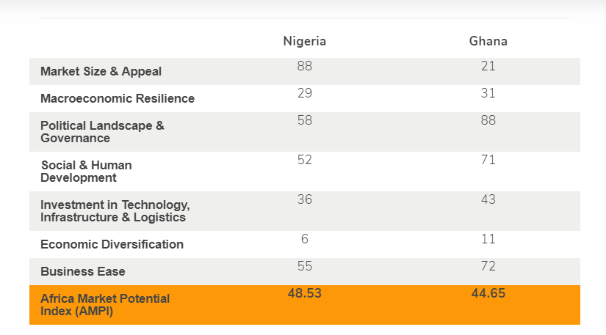

Performance of the Macroeconomic Indicators
The performance of the macroeconomic indicators is one of the things that has to be kept in mind when looking at the broader trends among both these economies. It has to be noted that the different macroeconomics landscape means that there is going to be much more pressure on the Nigeria to make sure that they are able to sustain the production that is not only going to be able to meet the external demand, but also make sure that the external disturbances are supposed taken care off. On the other hand, the unemployment rate that has been witnessed in the Nigeria is one major economic indicator that is needed to be sorted out. The huge population pool has made it one of the largest economics in the region but on the downside, it is quite hard to make sure that the economic and employment opportunities are there among the stakeholders at the given point of time.

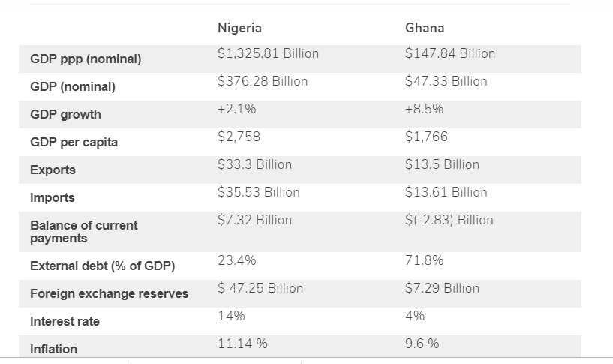
On the other hand, Ghana has its own share of issues. The problem for them is that how the current account deficit is going to be taken care off, The lack of trade, the weak currency and the closed economic system means that they have a hard time making sure that they bring about greeter number of people to their economic landscape. So, both these economies have their own set of challenges that they have to look after to make sure that they are able to sustain greater economic growth with the passage of time. The positive thing for them is that they have made sure that the employment conditions are always ideal among the populace. One of the reasons is that how the structure of both these economies tend to pan out. White Nigerian economy is more inclined towards the capital-intensive system, the labour market system that prevails in Ghana along with the much-limited population pool means that they are able to take care of their economy in a much more appropriate manner to say the least.

Social and Human Development
At times it is quite important to make sure that some insight is being developed about the development index as well as the human development to ensure much greater insight is developed about the economy at the particular point of time. Looking closely at some of the numbers in this regard, it becomes clear that Ghana is much better in this regard as well.

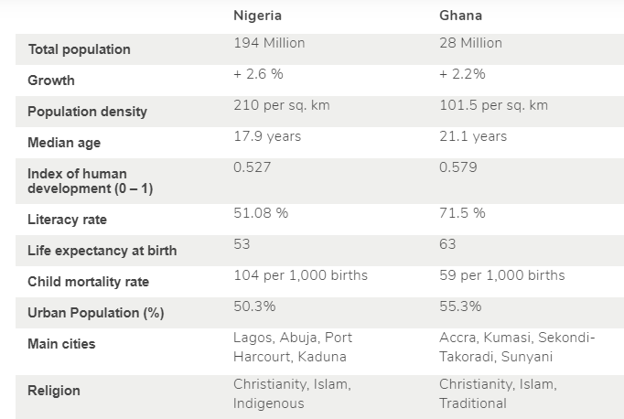
Looking at these numbers, one of the reasons that Ghana has been able to perform well six dues to the fact is that they are the economy that have developed much greater control as far as the way allocation of the resources is supposed to be controlled. There is greater degree of stability in terms of how the government and regimes have changed during the course of the last decade along with the fact that the again much lower population pool implies that it is much easier for them to work towards human development.

Investment Opportunities
The great measure of the success of the economy is that what sort of investment opportunities are located over there and what are some of the ways through which it can be made sure. Both these countries have relatively same investment environment in a sense that the product development is there and the emphasis of both the countries is towards making sure that how the foreign investment is increased in the country.
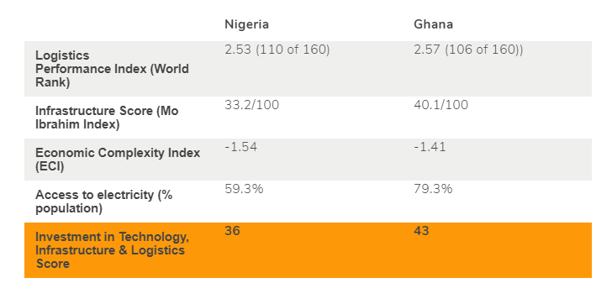
Nigeria has certain degree of edge when such decisions are being made due to the fact that they have much greater capital structure that makes them much more prone to heavy investment.

Conclusion
In the hindsight, it can be said that both the countries have considerably different economic environment. Whereas Nigeria is more inclined towards making sure that how they develop more capital structure in the country, the focus of Ghana is to make sure that how work is supposed to be done in the field of the human development. The other major challenge for both the economies though is that how the allocation of the resources is going to be done. Nigeria does better because of short-term advantages such as its current market size and appeal. Ghana fares better in long-term pillars such as business ease, social development, and most especially in good governance. Lack of infrastructure and slow implementation of reforms are key impediments to growth. The government is working toward developing stronger public-private partnerships for roads, agriculture, and power. Nigeria's financial sector was hurt by the global financial and economic crises, but the Central Bank governor has taken measures to restructure and strengthen the sector to include imposing mandatory higher minim um capital requirements. On the other hand, Ghana had Sound macro-economic management along with higher prices for oil, gold and, cocoa helped sustain high GDP growth in 2008-12, despite the general slowdown in the global economy during that same time period.

References

Kraus, J. (2016). Capital, power and business associations in the African political economy: a tale of two countries, Ghana and Nigeria. The Journal of Modern African Studies, 40(3), 395-436.
Hawkins, E. K. (2018). The growth of a money economy in Nigeria and Ghana. Oxford Economic Papers, 10(3), 339-354.
Decker, S. (2018). Building up goodwill: British business, development and economic nationalism in Ghana and Nigeria, 1945–1977. Enterprise & Society, 9(4), 602-613.
Hackett, R. I. (2017). Charismatic/Pentecostal appropriation of media technologies in Nigeria and Ghana. Journal of Religion in Africa/Religion en Afrique, 28(3), 258.
Aliyu, S. U. R. (2017). Does inflation have an impact on stock returns and volatility? Evidence from Nigeria and Ghana. Applied financial economics, 22(6), 427-435.

