Student’s Name:
Instructor’s Name:
Class Name:
Date when Due:
Works Cited
Lab Report #3
Aim
To use electric meters to establish the relationship between resistance, current, and voltage
Part A: Verification of the validity of Ohm’s Law
Introduction
According to the Ohms Law V=IR (1)
I=Current measured by Ammeter A= [I] =Amps
V=Voltage as measured by Voltmeter V= [V] =Volts
R= Resistance of the decade-resistance box Ω=[R] = Ohms
Method
Dc circuit is set up as shown in the figure below, and the current and voltage are measured using voltmeter and ammeter
Circuit Diagram
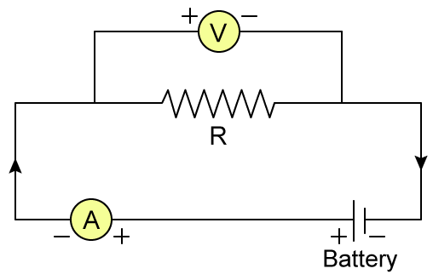
Procedure
- The circuit is set up as shown above. By using the cables required, connection to the power supply using the DC range B is made. The connection is made to the convenient range while maximizing needle deflection in the needle in both the ammeter and voltmeter
- Resistance is kept constant at 100Ω while voltage is varied as shown in the table and each time measurement of the current is filled in the table.
R constant =100Ω

V | V | 1.0 | 2.0 | 3.0 | 4.0 | 5.0
I | mA | 0.01 | 0.02 | 0.03 | 0.04 | 0.05

- Graph of V versus I is drawn with V along the y-axis. The best fitting line is drawn, and the slope is established
- Step 2 is repeated while keeping the current constant at 10mA. Resistance is changed and adjust the voltage and the current by turning the black knob of the power supply
Current constant 10 mA

R | Ω | 100 | 200 | 300 | 400 | 500
V | V | 1.0 | 2.0 | 3.0 | 4.0 | 5.0
- Draw a graph of V against R with R along the x-axis. The best fitting line is drawn and find the slope
Results

The gradient is Resistance ΔV/ΔA=R =100Ω

Gradient of the graph is Current ΔV/ΔR=I= 0.01A= 10mA

Part B: Measurement of the resistance of the two resistors that are connected in series n and also parallel.
Introduction
When the two resistors are R_{2,} and R₁ are connected in series, the equivalent resistance is given by:
R_{s}=R₁+R₂ (2)
When the resistors are connected in parallels, the equivalent resistance is provided by
$\frac{1}{R_{p}}=\frac{1}{R_{1}}+\frac{1}{R_{2}}$ (3)
Procedure
- Connect two resistors of 100Ω in series as shown in the diagram. Voltage is set at 1.0v. The current is then measured I=0.005mA
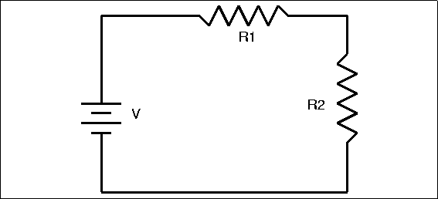
Using equation 1 find the equivalent resistance
R_{s}=V/I 200Ω
- Using equation 2 found the theoretical value of R_{s} and compute the percent disparency D
Theoretical value of R_{s}=100+100 =200Ω
{(200-200)/200}*100=0% disparency
- Connect the two 100Ω resistors in parallel as illustrated in the diagram. Voltage is set at 1.0V. The parallel current is measured I_{p}=0.02mA
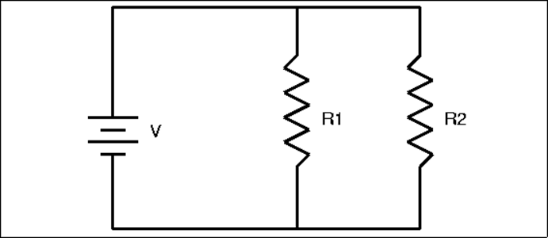
Using the equation 1 establish the equivalent resistance
R=V/I=50Ω
- Using the equation 3 find the theoretical value for R_{p} and compute the disparency D
Theoretical value of R_{p}=50
{(50-50)/50}*100= 0% disparency
Errors
There were no sources of errors since there were 0% disparency
Conclusion
In conclusion electric meters were used to establish the relationship between resistance, current, and voltage.

