Reflective Portfolio-Cultural Disruption
[Author’s name]
[Institute’s name]

Reflective Portfolio-Cultural Disruption
As a citizen of Pakistan, one has to witness the type of image given below almost daily. Unfortunately, it is the reality of public health of the country. Keen observation of improper public health facilities and services compels me to figure out the actual causes of poor health conditions. As a responsible citizen, this type of image always grabs my attention in some disturbing manner. The prevalence of improper healthcare settings and services eventually motivates me to do something practical to play my role as a responsible citizen for my country.
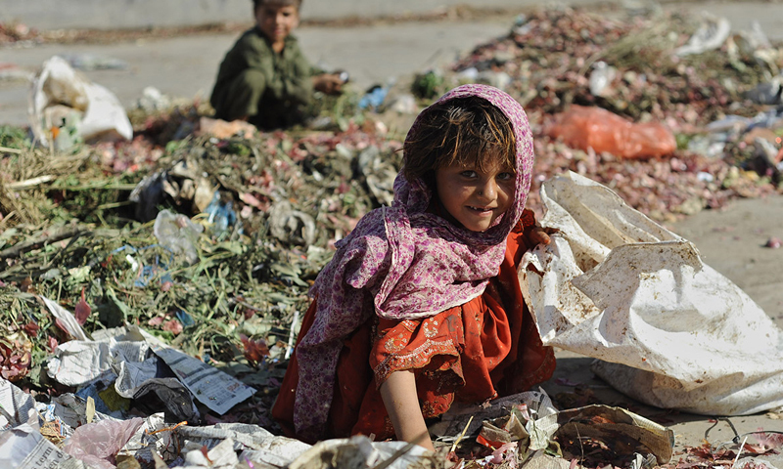
Image 1: Improper Health Conditions in Pakistan
This particular image is the representation of overall improper and unsafe health conditions for the masses of Pakistan. National statistics of the country explicitly indicate that the healthcare environment is alarmingly unsafe for poor people. The severity of this problem is cruel because it even causes severe health problems for the children (Schieppati & Remuzzi, 2005). As a sensitive individual, observing this type of sanitary conditions for children of my country is immensely disturbing for me. On the other hand, the exploration of improper health conditions and services also encourages me to take some practical measures to play my role. I always tried my best to never become the reason of health hazard for any condition. With time, I perceived that this participation is not enough from my side and I am capable of doing something more to address this issue as a public concern.
Improper health conditions of the country motivated me to learn more about the prospect of public health. My interest in the discipline of public health eventually enhances to identify the role of healthcare providers and community to ensure better healthcare services for everyone. I started reading different literature on various domains and components of public health to enhance my understanding of concerns of public health. Enhancing my knowledge about the subject of public health guides me about the immense importance of proper healthcare services for the citizens. It is noteworthy to consider that organized efforts of the whole society are crucial to measure the rampant occurrence of different health problems and propose better solutions to these issues. Furthermore, my interest in the subject of public health drives me to select this subject for my degree of masters. Poor health conditions of my country and my growing interest in the community work are two main indicators of choosing the discipline of public health.
I wanted to attain the best of knowledge about this subject so, I preferred to avail the opportunity of foreign education. Completing my masters from Australia is suitable for me because unfortunately, the education sector of my native country is also not up to the mark as required in the healthcare sector. I perceived my admission in Australian university as a great opportunity for me to better understand the practical and theoretical approaches to public health. Staying in a foreign country is also gives me a chance to compare the health facilities of my country with the rest of the world. Gaining education from the students of other countries helps me to figure out the potential differences that prevail between my native country and the other societies. Shifting and living in a new country is all over a different experience of my life. Facing cultural disruption is obvious for me as Pakistan and Australia are two very different countries considering various perspectives. Naturally, the early days of my stay in Australia were the oddest and I faced a difficult time-period of life both personally and academically. It was the time when I had to grasp and accept different new things and practices as early as possible to comfortably adjust myself at a new place.
Moving from less developing country to a developed country is a whole new experience for me and I have witnessed the difference in various forms. Cultural difference is one major shock for me due to the reality of diverse cultural norms and values. Comparison between my native country and Australia helped me to figure out that Australia is a culturally diverse country as compared to Pakistan. The majority of the population in Pakistan is Muslim who follow somewhat similar code of living. Whereas, the country of Australia is the combination of people belonging to different countries and ethnicities. Natives of different countries and continents live here for the sake of their bread and butter or to get an education. It is one great and new experience for me to observe how individuals belonging to different religions, nations, and races can live in one society and perform their civic responsibilities successfully. The world’s horizon has expanded for me after shifting in this part of the world because it allows me to communicate with the people of other communities and cultures. This form of interaction ultimately helps to consider and understand their problems and happily embrace their reality with various cultural differences. Experiencing cultural difference is both the blessing and complexity at the same time. It is a fact that accepting a different is not always easy and it requires some time and effort. In the earlier days of my stay in Australia, it was never easy for me to connect with other people because I came up with the belief that they are different. It is enormously complicated and uncomfortable for me to greatly blend myself with others by considering the cultural differences. The cultural difference was one major obstruction for me to adjust myself with my new place.
The decision to study abroad brings different forms of benefits and challenges for me as the citizen of a developing country. Adjusting myself in a developed country was no easy task as the standard of living is very high here. Experiencing cultural and social domains of the host country helps me to understand that the lives of all individuals are hard in their context. Everyone is struggling to achieve something better in their lives and their societies as a whole. The problems of Australian society are different from Pakistani society but still, there are challenges. As the responsible citizen of the universe, it is our core responsibility to accept cultural and social differences and find out better solutions for our societies. My decision of coming to Australia for my master degree in public health helps me to consider myself as a global citizen and think for the betterment of the whole world. Studying at an Australian university encourages me to figure out different problems and complications that hinder the way of applying suitable public health policies at my home country.
It is important for me to also reveal all the challenges faced by me as an international student who travelled to other countries to enhance his knowledge in the field of public health. Facing cultural shock and experiencing cultural immersion are the key realities that must be faced by every international student. Former research studies also argued that cultural transformation is the reality for the international students who travelled to other countries for higher education. It is argued that experiencing cultural shocks and cultural differences in the process to gain better experience in the host country. This process of cultural differences does not mean to unrestraint cultural heritage and completely adopt new culture (Newsome & Cooper, 2016). I strongly acknowledged this theoretical perspective and apply it to my experience as an international student in Australia. Adjusting new culture and values does not mean for me to ignore my actual cultural reality. The perspective of cultural transformation guides me to remain flexible about cultural differences and embrace the diverse realities of this globe.
Keen observation and experience of a new culture help me to enhance my empathy for human beings without judging them on the base of the difference in culture. Facing the prospect of cultural disruption is a reality that brings many challenges and benefits for me. As the international student in Australia, I experienced different forms of cultural shocks mainly in the forms of the difference of religion, diverse lifestyle, social rules, and overall social behaviour such as the consumption of alcohol. It is one normal practice in the host country but it is not legal in Pakistan due to religious and social restriction. Facing this type of cultural shock is might observe as minor on the surface but these cultural differences have their strong significance and implications. As the native of Muslim country, it is important for me to intact my cultural values and finds some form of flexibility to enlighten my positive cultural experience. It is challenging for me to avoid any form of cultural conflict and cultural disruption. As the responsible guest in the host country, I need to evade the cultural clash between the cultural approach of the guest country and the cultural standards of my native country.
Learning different cultural values and norms of the Australian country ultimately helps me to accept the reality of cultural difference. Furthermore, this cultural experience is an opportunity for me to deeply understand myself as an individual. This assessment further assists me to enhance my cooperation with others without judging them due to the difference in their culture or religion. I can rightly say that experiencing a difference of culture helps me to become a better person and thinks about collective issues of the world. The prospect of shared values and cultural norms is a good practical step to find solutions for different chronic problems of this globe. This argument can better apprehend through my approach for my discipline of public health.
Witnessing public health conditions of Australia realise me that it is a good decision for me to learn more about the subject of public health from an international university. The observation of public health practices in Australia helps me to compare health conditions of my country with a developed country. Now, I am in a better position to identify the difference between the prospect of public health and how it is implemented by different governments and communities. This comparison makes it possible for me to realise the actual difference between the living conditions of common people of Pakistan and Australia. This realization is heartbreaking for me as well that many people from my country are not able to attain better healthcare services due to their poverty or imbalanced distribution of available resources. Advanced health conditions and proper application of public health policies in Australia induces me to think about the chronic reality of my country specifically in the form of hazard public health conditions.
The difference in culture is also an opportunity for me to critically examine those factors who influence the public health of our societies. As an international student, I am more interested now to grasp the positive aspects of Australian society and apply them for the better future of my country. It is good for me to experience the cultural difference and grabs fruitful ideas to change the reality of the public health sector of my beloved country. I positively believe that my objective of enhancing my knowledge about the discipline of public health can effectively achieve through experiencing and accepting the difference in Australian culture. This specific prospect is mainly applied in case of the public health sector of the country.
Adoption of specific cultural values and standards by the people of Australia also exhibit in the form of their approach of public health. The knowledge and practical experience of this sector in the country reveal that government, communities, and healthcare professionals are passionate to provide better healthcare conditions for all the citizens. I am interested to consider the phenomenon of cultural difference as the opportunity to learn some positive aspects from the Australian society for the sake of the development of my country. It is beneficial for me to identify the areas of cultural consensus and flexibility to meet the standards of cultural transformation. The prospect of cultural integration can be helpful for me to avoid the concern of cultural conflict and use these experiences as the mode of enhanced learning (Satcher, 2008). As an international student in Australia, I also observed the most positive and useful form of cultural diversity. The land of Australian is blended with different native cultures that are recognised in the form of Aboriginal communities. Existence of these communities guides me to identify those practical aspects that can be helpful to provide better healthcare services to these communities.
The policymakers related to the public health sector of the country are motivated to aligned cultural differences of the native communities and ensure better living conditions for them. This observation is impressive for me as the student of the subject of public health. The practical measures adopted by the health sector of the guest country is the future guideline for me to apply them in Pakistan to involve all the social classes in the process of better public health policy. My ultimate aspiration is to gain advance knowledge from a developed country and play my positive role to implement those healthcare strategies in my native country as a public healthcare expert in future.
References
Newsome, L. K., & Cooper, P. (2016). International Students’ Cultural and Social Experiences in a British University:" Such a Hard Life [It] Is Here". Journal of International Students, 6(1), 195–215.
Satcher, D. (2008). The importance of diversity to public health. Journal of Veterinary Medical Education, 35(2), 151–151.
Schieppati, A., & Remuzzi, G. (2005). Chronic renal diseases as a public health problem: Epidemiology, social, and economic implications. Kidney International, 68, S7–S10.

