Why China's one belt one road project Turkey side has too many risks and why Turkey should not be part of the project?

[Name of the Writer]
[Name of the Institution]

Why China's one belt one road project Turkey side has too many risks and why Turkey should not be part of the project?

Introduction
With primary concerns over its economic development and focus on soft power, China has managed to capture the Asian market for trade and business to boost its economic growth. Now the country is aiming at a much challenging position, i.e. becoming the regional power, but for that, it has to expand its business to surpass India in this tug of war. This is why through projects like CPEC and BRI, China wants to dominate the global market and make the rivalry with the United States of America much stronger. As China is facing challenges from all sides in the world, therefore, the country is putting all its efforts in expansion towards Europe. The motive behind the way forward to Europe is both political and economical serving different interests for the Chinese government. Chinese government by adopting wise diplomatic foreign policies with the countries in its way of “one belt one road project (OBOR)” is trying to maintain stability in the region. China's ladder to success in the one belt one road project in Turkey as Turkey acts as the gateway to Europe and this is the most effective road route China can opt for. Thus, China is trying all the political tactics to bring Turkey to the table. But there are many risks involved in the project of One belt one road project that is political, economic, financial and geographical and cultural. The project seems to be too risky for both the countries to opt for as due to the presence of internal conflicts and security concerns on both sides. China's most extensive region Xinjiang is the centre of all those risks that will be tackled by both countries once the project starts. This paper will analyze all the risks that are becoming obstacles in China's way to merge into the European market through One Belt One road project. This paper will also identify all the concerns Turkey has while agreeing to initiate this project with China. This analytical essay will also answer all the questions to clarify the position of both the countries in power concentration stance and their exposure to risks. The project is not feasible because it is too risky for China as well as for Turkey because of the significance of those internal and political risks.
China’s One Road One belt project
One road one belt project famously known as OBPR initiative around the world is China's economics and foreign policy proposed d by the Chinese president Xi Jinping. The one belt one road project is aimed to accelerating the huge investment coming to China and to improve its trade and development. The project is started to extend the market of the People's Republic of China to Europe, Central Asia and Indo-Pacific concentrated countries. The One belt one road (OBOR) is extracted from the overland “Silk Road Economic Bet” and the recent 21ST Century Maritime Silk Road which are both the development strategies. The 21st Century Maritime Silk Road precisely known as MSR or maritime Silk Route is the part of the vast OBOR initiative that focuses on the sea channels of the project and will direct sea routes. These initiatives are also solely based on fostering economic growth in many countries and to increase the collaboration between the countries. OBOR is the development strategy started by China to involve infrastructure development and direct investments in the relatively underdeveloped countries of Europe, Asia and Africa.

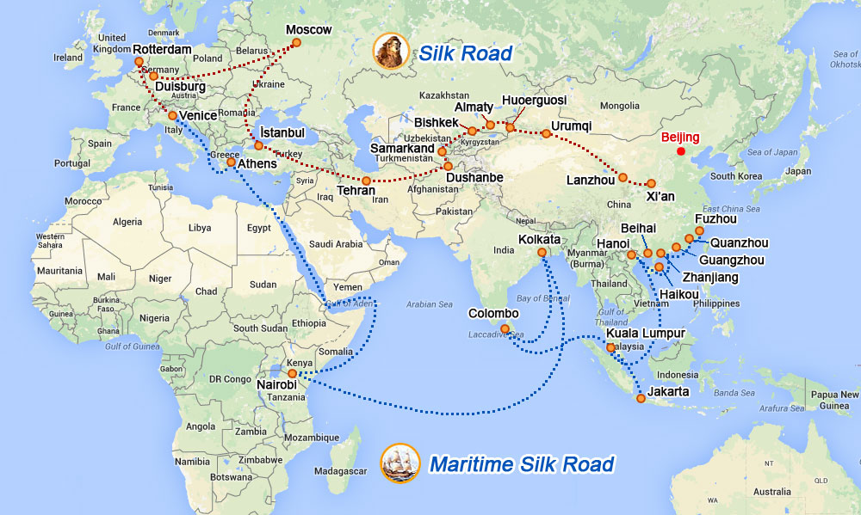
China’s OBOR in World Map
The background for this initiative is that the People's Republic of China is a one-sided landlocked country surrounded by Asian countries on different sides. Take a look in the map above enhance its work. In the past few decades, due to good governance and massive input in the development side, China has managed to emerge as the most potent Asian country. The country further wants to makes position strong by fostering economic development, improving regional integration, accelerating economic growth in other countries as well. There are several reasons behind the initiation of this OBOR project; however, the leading two causes are more related to economic and political aspects. The first reason is that, due to its geographical location as the landlocked country, China wants to have access to seaports also which can only be achieved by extending its one belt road project to Turkey. The second reason behind the OBOR project is that China wants to become economically active and after capturing a large share in the Asian market, now wants to target the European markets. Through OBOR, China will be able to surpass India, Singapore and other central Asian countries and acquire more dominance over the world.
This project OBOR will involve an extended road that will go through all the relevant countries in its way to Turkey and will eventually connect to Europe. Reason for collaborating Turkey is that; Turkey is the only country that acts as a gateway to Europe. If the Google map is examined in detail, then it will be understood that there are two seaports with Turkey which China can easily avail from the one road initiative. The idea is to invest heavily in the development of infrastructure in the areas that are linked through two Silk roads so that they can be joined and one ordered space can be created. The sole purpose is to dominate the world global market and trade to establish itself as a developed country in the world as China wants to position itself as the new world leader.
Importance of Xinjiang and Uighurs for China’s One Belt One road project
Looking at the world map, it can be seen that for China to establish its way of OBOR globally, it is imperative to start from the Xinjiang region of China to access other countries. This is because Xinjiang is the autonomous territory that is situated in the northwest of China towards the direction of Europe. Due to this reason, Xinjiang has a very critical role to play to clear the way for China to enter Europe. Below is the map provided for China's geographical boundaries in which the whole country is highlighted in yellow, but Xinjiang can be seen in the red portion.
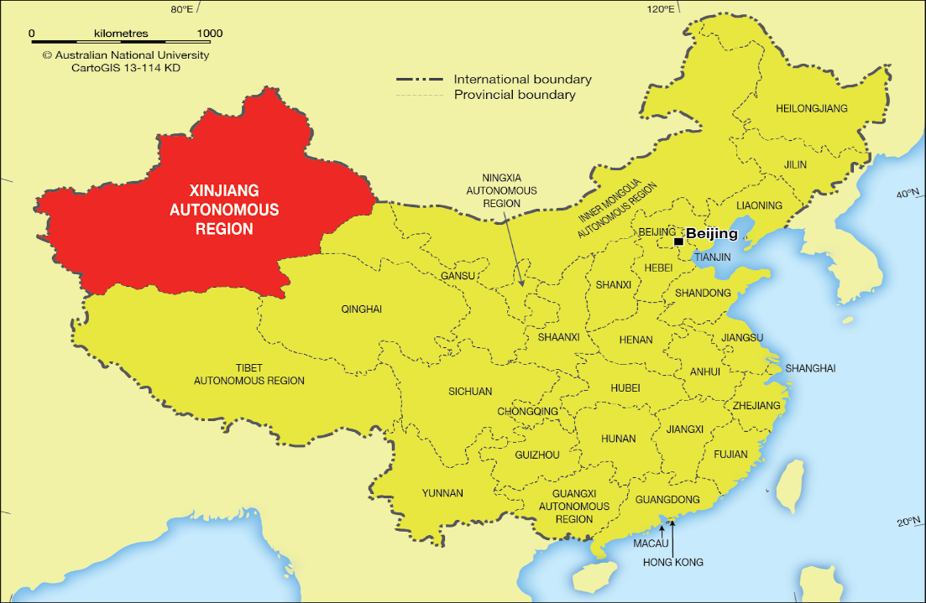

China’s Map
Xinjiang
Apart from its geographical location, Xinjiang holds enormous importance for China in political aspects as well. Xinjiang is the largest region of China that is considered autonomous. This region of China consists wholly of deserts and mountains.
Moreover, Xinjiang is also different from other parts of China in a way that the region is home to numerous ethnic minority groups in which the majority are Turkic Uyghur people. The old Silk Road trade route also passed through Xinjiang to link China with the Middle East. 45% of people there are Uyghur who follows the religion of Islam and speaks the language Uighurs. Xinjiang is the most considerable portion of China to manage and is also the eight largest division of any country in the world. Xinjiang is connected to the borders of Mongolia, Russia, Kazakhstan, Tajikistan, Kyrgyzstan, Pakistan, India and Afghanistan.
Looking at the geopolitical conditions of Xinjiang, it can be examined that China no doubt has severe issues with the Xinjiang. Beijing has always shown concern over the ethnocultural dominance of Uyghur people there and the low economic development making the country watchful on the region's security matters. To manage this tension, Beijing followed a dominant strategy of integration by controlling the area politically, socially and culturally and to encourage the settlement of Han Chinese people. A state-owned modernization program further promotes this procedure and to transform Xinjiang into one of the major hubs of trans-Eurasian connectivity. The motive behind this action is that economic development will eventually surpass the Uyghur objectives to acquire more significant political independence. Under the belt and road initiative, China wants to exploit Xinjiang’s geographical benefits to ease China in the economic expansion towards Europe. Many efforts are put by the Chinese government to assimilate Uighurs into Han culture by imposing targeted programs on them through education etc.
Uighurs
Uighurs are very important to China in this project because they are in the majority in Xinjiang area and the Chinese government is undertaking many actions against them to control and stabilize them according to their requirements. From many years, China is not having good ties with the people of Uyghur and suppressing them. On the other hand, Turkey has always provided them with proper treatment because of the soft corner Turkey has been a Muslim country. Uighurs are or Turkic origin, and many of them are also present in Turkey. This whole matter creates a dilemma for both the countries in the project and makes Uighurs more critical to the project than the Xinjiang region itself.
Importance of Turkey in One Belt One Road Project
Turkey plays a very critical and assertive role in this project because if the situation is analyzed carefully from Turkey's point of view, then it can be assessed that Turkey is not much in an economic advantage with China on this project. China is the one which is receiving maximum political position and economic benefits from its spread to European markets through Turkey. Turkey is only helping China to maintain good foreign relations with China and to gain investment in return from the project for the short term. Whereas, if China undertakes this project then many opportunities will arise for the Chinese citizens as well as the Chinese government. This is one of the primary concerns Turkey has from the OBOR project. Looking further on the political aspects and gains from this side, it may also happen that by collaborating with China. Turkey may even reach a strong position in the region to exercise its political strength. Many other neighbouring countries will rely on Turkey to foster their economic growth and start trading with him. Turkey will be able to influence the decisions in international politics. It ultimately depends on Turkey to ensure and maximize the economic prosperity it will bring in the OBOR project. China is dependent on the Turkish government's support, so this stance provides a golden opportunity for the Turkish government to impose some conditions on China. This will require Turkey to stop the Chinese government’s unjustified and unfair activities in the Xinjiang region. In the OBOR project, Turkey has vital importance, and this is the time when Turkey can make China agree on some internal matters related to the Uighurs ethnic group. China will receive political pressure and might give in to some of the conditions.

Who Uighurs are
Uighurs are the ethnic group Turkic by origin living in East and Central Asia. Uyghur although a minority ethnic group lives in the majority in Xinjiang, China. Uyghur is also one of China's minority ethnic groups that are recognized in its list of officially recognized ethnic groups. Uighurs generally practice Islam and are also present in Turkey. There is also the presence of this ethnic group to Iraq and Syria.
China's policy toward Uighurs in Xinjiang
Xinjiang was a region that had irregular autonomy and often had occasional independence, but in the 18th century China took charge of the Xinjiang and started their rule in the area. Xinjiang which can also be called as East Turkestan was declared as an independent state in 1949, but the independence was for a brief period. In the same year, Xinjiang officially joined China and became a part of communist China. Xinjiang has approximately 21.81 million population according to the 2010 census. Turkic Muslims are in the majority here with the people of almost eight million out of 19 million currently. This region is affluent in resources, and due to large scale immigration of Han Chinese by the Chinese government, the economic development is also gradually improving. Turkic Muslims are in the majority here, but yet again they are treated as minorities. They are not given the Chinese passports by the Chinese governments to travel the world. They cannot practice their religion in public and are victims of heavy policing. The Uighurs are forced to work for low wages and are not given equal employment opportunities. They are experiencing discrimination and marginalization in all the areas, and the intensity is getting higher with every passing day. The Uighurs are forced to radicalize by the Chinese authorities as the authorities have also built hidden camps for the detention of Turkic Muslims. In 2018, after receiving strong evidence of the violation of human rights by the Chinese government, the United Nations stated that more than one million people are held in the counter-extremism centres in Xinjiang. The UN also pointed out that China has turned into a vast imprisonment camp that is hidden in secrecy. To which China reacted and denied all the concerns of detention camps. In response, China, however, justified its position by blaming the Uighurs for acts of religious extremism and said that the Uighurs need re-education and resettlement to live in the region. International media also viewed those hidden camps from a satellite which are now expanding, but China kept on refusing and did not admit their cruelty with Uighurs. China is blamed many times in global politics by many international entities that the once communist country is violating the fundamental human rights of many citizens of Xinjiang. China in defence names its crackdown policies to be re-education and reassessment for the people so that terrorism can be controlled. The irony of the situation is that, because of stricter policies of the Chinese government and the continuous discrimination with Uighur people, the local structure of the region is getting adversely affected. Until now the Chinese government have made thousands of camps in the region, and they imprison the Turkic Muslims without any substantial justification. This is getting common as the Urumqi which is the capital of Xinjiang has become a headquarters of these camps. In many areas of camping, the general public and media's entry is strictly restricted.
Reasons for the formation of concentration camps in Xinjiang by China
There are firm shreds of evidence of the creation of concentration camps in Xinjiang to which China most of the times failed to justify but looking into the history of Xinjiang; many reasons can be identified. Xinjiang was once an independent state although for a brief period and China quickly took control of the region. The Turkic Muslims are in the majority, so the Chinese government is facing some security issues in the area. They have the fear that the Turkic Muslims will rise to power if they are not controlled in time because Xinjiang is the largest division of China and the government want to keep the power with themselves. This is why they want to suppress the Uighurs so that the power stays with the Han Chinese. This also justifies the fact why the government facilitated Han Chinese immigration into the region.
Security risk for the project's Turkey Foot
China has many security risks not from the Xinjiang region but also by the presence of Uighurs in Syria and Iraq who has borders with Turkey. Below is the map the location is highlighted with red lines around the Syria and Iraq.
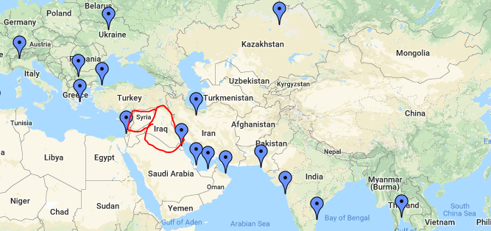
Syria and Iraq are attached geographically with Turkey, and they have Uighurs population quite in the majority. They are radicalized and strongly condemn the acts of the Chinese government about the Uighurs present in the Xinjiang region. So, the topmost risk that China might face with the OBOR project is that the Uighurs present in Syria and Iraq might intervene in the economic trade expansion of China and make matters worse for the Chinese government. They may want to sabotage China's one belt one road project from Turkey's side as they cannot tolerate the injustice happening to their ethnic group in Xinjiang. Through Turkey, it will become effortless for them to take revenge for the political oppression experienced by them for many years. This will land China into big trouble, and the matter will receive international attention. China has a good reputation in the world and is trying to cover the internal conflict through soft power and diplomatic strategies. But, this might not go for much longer.

Risks for the Turkish Government
Uyghur people are from the same ancestors as Turkish people, and they both share the same ethnicity due to which their culture and religious values are also the same. Due to all these similarities and common points, Turkish citizens have a soft corner for Uighur people suffering the injustices in the Xinjiang region of China. Their sentiments are getting hard every time they come to know about the latest restrictions imposed by the Chinese government and the apparent violations of human rights. Uighur problems in Xinjiang leaves a very severe impact on the citizens of Turkey, and they are strictly against Chinese policy there. So, if China keeps on imposing bans on Uighur people and imprisoning them without any trial, Turkish people will soon retaliate if the Turkish government didn't take any action. The current government in Turkey might face a severe backlash from the general public for not speaking up for the Uighur people, and they might lose votes too for election. Because nationalist and conservatives in Turkey do not want to accept friendly relations with China on foreign policy matters if China keeps on eradicating the Uighur identity from Xinjiang. The Turkish government will have to take a wise decision on time before its people go against the government to fight for the rights of their Uighur brothers.
Conclusion
After critically analyzing all the dimensions of “One belt one road project” initiative of China, it is suggested that China should reconsider this decision as the project has numerous risks involved which cannot be ignored. China and Turkey both will get affected by the project as the political and social risks are much higher than the economic and foreign gains they will receive from the project. This project is not feasible for any country as the matters are highly internal that will leave an international impact if they are not taken seriously. Even if we keep the political issues of both the countries on a side, there are still many geographical, security and economic risks involved that will incur huge cost not necessarily monetary.

End Notes

- "China Envoy Says No Accurate Figure On Uighurs Fighting In Syria". 2019. U.S.. Accessed March 8 2019. https://www.reuters.com/article/us-mideast-crisis-syria-china/china-envoy-says-no-accurate-figure-on-uighurs-fighting-in-syria-idUSKCN1L508G.
- "This Map Shows A Trillion-Dollar Reason Why China Is Oppressing More Than A Million Muslims". Business Insider Malaysia. Accessed March 8 2019. https://www.businessinsider.my/map-explains-china-crackdown-on-uighur-muslims-in-xinjiang-2019-2/.
- "Turkey Renews Criticism Of China Over Uighur Minority". 2019. AP NEWS. Accessed March 7 2019. https://www.apnews.com/5f0e055b10994483b30d479c62f20d7f.
- "Turkey Urges China To Respect Uighur Rights, Close Camps". 2019. ABC News. Accessed March 7 2019. https://abcnews.go.com/International/wireStory/turkey-urges-china-respect-uighur-rights-close-camps-60959789.
- Acharya, Arabinda, Rohan Gunaratna, and Wang Pengxin. Ethnic identity and national conflict in China. Springer, 2010.
- Ala, Mamtimin. 2018. "Xi Jinping’S Genocide Of The Uyghurs | Foreign Policy Journal". Foreign Policy Journal. Accessed March 7 2019. https://www.foreignpolicyjournal.com/2018/11/07/xi-jinpings-genocide-of-the-uyghurs/?fbclid=IwAR35Onn1wVFE5NpQwvuTLVOm6z8vSRjnaeeN7TgFmCFkRDfBujHxxwbsK1E.
- Friedrichs, Jörg. "Sino-Muslim relations: the Han, the Hui, and the Uyghurs." Journal of Muslim Minority Affairs 37, no. 1 (2017): 55-79.
- Hyer, Eric. "China's policy towards Uighur nationalism." Journal of Muslim Minority Affairs 26, no. 1 (2006): 75-86.
- Ivan Watson and Ben Westcott, CNN. 2018. "'Cultural Genocide': How China Is Tearing Uyghur Families Apart In Xinjiang". CNN. Accessed March 7 2019. https://edition.cnn.com/2018/11/14/asia/uyghur-china-xinjiang-interview-intl/index.html.
- Vergani, Matteo, and Dennis Zuev. "Analysis of YouTube Videos Used by Activists in the Uyghur Nationalist Movement: combining quantitative and qualitative methods." Journal of Contemporary China 20, no. 69 (2011): 205-229.
- Zang, Xiaowei. "Major determinants of Uyghur ethnic consciousness in Ürümchi." Modern Asian Studies 47, no. 6 (2013): 2046-2071.
- Zang, Xiaowei. "Uyghur islamic piety in Ürümchi, Xinjiang." Chinese Sociological Review 44, no. 4 (2012): 82-100.

Zang, Xiaowei. "Uyghur islamic piety in Ürümchi, Xinjiang." Chinese Sociological Review 44, no. 4 (2012): 82-100.
Zang, Xiaowei. "Major determinants of Uyghur ethnic consciousness in Ürümchi." Modern Asian Studies 47, no. 6 (2013): 2046-2071.
Friedrichs, Jörg. "Sino-Muslim relations: the Han, the Hui, and the Uyghurs." Journal of Muslim Minority Affairs 37, no. 1 (2017): 55-79.
Turkey Urges China To Respect Uighur Rights, Close Camps". 2019. ABC News.
"China Envoy Says No Accurate Figure On Uighurs Fighting In Syria". 2019.
Vergani, Matteo, and Dennis Zuev. "Analysis of YouTube Videos Used by Activists in the Uyghur Nationalist Movement: combining quantitative and qualitative methods." Journal of Contemporary China 20, no. 69 (2011): 205-229.
Ala, Mamtimin. 2018. "Xi Jinping’S Genocide Of The Uyghurs | Foreign Policy Journal". Foreign Policy Journal.
Ivan Watson and Ben Westcott, CNN. 2018. "'Cultural Genocide': How China Is Tearing Uyghur Families Apart In Xinjiang". CNN.
"This Map Shows A Trillion-Dollar Reason Why China Is Oppressing More Than A Million Muslims". Business Insider Malaysia.
Acharya, Arabinda, Rohan Gunaratna, and Wang Pengxin. Ethnic identity and national conflict in China. Springer, 2010.
Hyer, Eric. "China's policy towards Uighur nationalism." Journal of Muslim Minority Affairs 26, no. 1 (2006): 75-86.
"Turkey Renews Criticism Of China Over Uighur Minority". 2019. AP NEWS.

