Student’s Name
Professor’s name
Course Code
Date
MyRA
- Explain the difference between how these terms are used in the article vs. in the system of national accounts
In the article, the myRA is described as a long term national saving started by the government to help people save money. However, in the national accounts, it is described as the retirement saving accounts, which was created by the department of Treasury for Americans who do not have access to the retirement saving plan. It was established during the tenure of President Obama but got terminated during President Trump. The myRA was therefore, started with a good intention to help in growing the economic base of majority of Americans.
- Loanable Curve After the introduction of MyRA
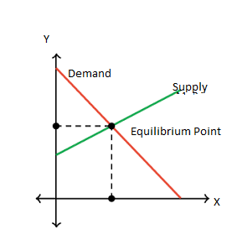
Diagram 1: Loanable Curve
The loanable funds indicate the interaction between the borrowers and the saver. It is described what is being sold and bought from the market by the money. In most cases, the borrowers demand to have loanable money and the savers get to supply the money. However, the introduction of MyRA increased the demand of loanable fund. According to Roell (15), Myra helped individuals to build assets base and therefore, many people become credit worthy. The access to loanable funds is based on saving and therefore, with many people with MyRA the demand for loanable become high hence the supply reduces and the interest rate is likely to increase (Roell 21). The slope indicates the change in demand and supply, and the introduction of MyRA increased the demand of loanable. The slopes exist because of the change of demand in the market. It is noted that when the myRA was introduced in the market, there was shift in demand by people. This was a result of high number of potential customers. Therefore, upward slopes shows that many people started to demand loans from the borrowers.
- The old equilibrium is the equilibrium which existed before the change was introduced in the market and the new equilibrium is introduced by the market changes. The change in equilibrium is affected by supply and demand, when the products are over supplied the prices will be reduced and this affect the equilibrium (Roell 14). In both cases, the equilibrium depends on the how the product is being supplied in the market and the demand in the market.
- The introduction MyRA was meant to give Americans the financial security to ensure that the people can be able to access credits. The myRA was introduced by the government to create a pool of resources through saving for those who do not have retirement benefit scheme. First, it looks into the interest of the future by ensuring that people have enough security which can be used to secure funds. With myRA majority of Americans under the program can secure credit facility without difficulty. This is good for the economy because it increase the flow of money and business activities. It can also help in regulating the inflation rate because of the increase of the cash circulation through the program. It helps people to plan for their future, which is a good thing for the economy. By planning for the future, people would not burden the government after retirement. It would be able to give people who have been into the program, a decent housing, and living standard, which is a good thing for developed economy like the United States.

Works Cited
Roell, Sophie. "The Best Introductions to Economics." Economic Analysis (2018): 2-15.

