Student Name
Teacher’s Name
Course Title
Date
Introduction
Direct distribution refers to the direct sale of products to the customers by the business. On a small level, a jewelry shop owner may opt to sell directly to its customers. If we talk about some big company, Apple uses a direct distribution channel to provide its products to the customers. There are advantages and disadvantages of using direct distribution strategy. A business will have complete control over the marketing and sales activities of its products (Wells Fargo). The downside of this strategy is that the company may have a limited market coverage. In case of indirect distribution, the manufacturers sell the product in bulks to agents or retailers who will then sell the product to customers. This strategy will be less risky as the agents and retailers will have a better knowledge of the market. The down side of this approach is that a small share of profit will have to be shared with these distributors. There is less control on the product sales for the company in this type of distribution channel (Mendiola).
Application
The product under consideration is popcorn which is something that is not a necessity. Thus, the company will be better off to use the direct distribution channel for this product. This will be beneficial because the company will keep a direct contact with its customers and will assess their needs and wants promptly. This will help the company to bring the necessary changes to its products as soon as there is a change in consumer’s tastes. Similarly, the company will be able to react to the actions of competitors in a manner that will benefit the company rather than the competitors. All the profits will be taken up by the company and no share of profit will have to be given to the distributors. From the following picture, the company will use the first distribution channel only.
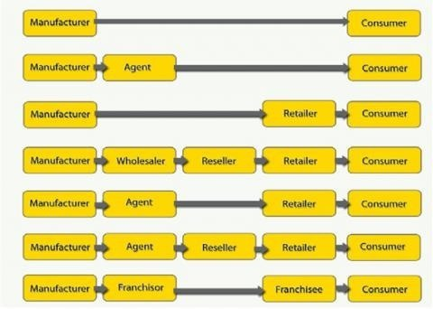
(Bhasin)

Works Cited
Bhasin, Hitesh. "https://www.marketing91.com/distribution-strategies/." 25 May 2018. https://www.marketing91.com. 10 September 2019.
Mendiola, Jessica. "https://ssfllp.com/direct-vs-indirect-distribution-channels/." 10 August 2017. https://ssfllp.com. 10 September 2019.
Wells Fargo. "https://wellsfargoworks.com/marketing-center/article/direct-vs-indirect-distribution-channels." 2019. https://wellsfargoworks.com. 10 September 2019.

