Student Name
Teacher’s Name
Course Title
Date
Introduction
Integrated marketing communication refers to the promotion aspects of the four p’s of marketing. The major aim of the marketing communication is to deliver the right message to the right people (Camilleri). This also means that the promotional objectives are reached and product awareness is increased among the customers and consumers. It involves a combination of different tools of promotion to make a promotion mix. The characteristics of each tool are studied in detail and then it is added to the promotional mix. The businesses today are in need to distinguish themselves from their competitors. The businesses have to choose the right ways of communicating the message according to its customers. The number of channels chosen depends upon the budget that is available to the marketing team of an organization. Smaller organizations may focus on only one or two channels to convey their message due to financial constraints or due to a narrow customer base (Burgmann).
Application
The selected product is popcorn which does not cost much to the customers and thus will not provide a high percentage of revenues to the company. Thus, there should be one or two communication channels used for communicating the message regarding this product. The main consideration for the choice of these channels will be the costs incurred and the reach of the communication channel. In my opinion, billboards near the main office of the company will work because they will communicate the message to the people passing nearby. Popcorn is a product that will be available in different areas through various stalls so the main focus of this company will remain on the local community. Putting the advertisement in the local newspaper in the form of print advertisement or in the form of pamphlet will also work well. Some free samples may also be provided to the trespassers so that the local community comes to know about the product quickly.
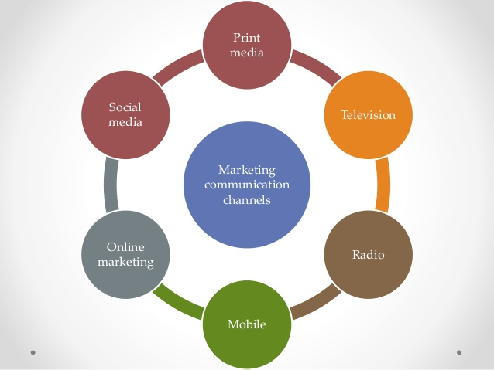
(Pramkaew)

Works Cited
Burgmann, Phillip J. Kitchen:Inga. "https://onlinelibrary.wiley.com/doi/pdf/10.1002/9781444316568.wiem04001." 2010. https://onlinelibrary.wiley.com. 10 September 2019.
Camilleri, M.A. "Integrated Marketing Communications." Camilleri, M.A. Travel Marketing,Tourism Economics and the airline product,Tourism, hospitality and Event Management. Springer International Publishing, 2018. 85-103.
Pramkaew, Team. "https://www.slideshare.net/TeamPramkaew/finding-the-right-imc-channels." 2019. https://www.slideshare.net/TeamPramkaew/finding-the-right-imc-channels. 10 September 2019.

