MS Access
Name
Affiliation
Date

The MS Access is a resourceful software and it is one of the products of MS Suite. Its latest version is MS 2016. My experience with software has been good. It has a lot of possibilities as its use makes it possible to make calculations in the queries, to use conditional formulas in the states, to determine the number of selected records. MS Access functions can be used in queries, reports, or forms. Using the expression generator allows to set each of these functions correctly. The Expression Builder helps in designing the calculation formulas (Slater-Robins, 2019).
Error 80070005 is the error that I encountered during installation. The solution to this error is somewhat cumbersome, but it is not very complicated. The first thing to be done is to disable all the antiviruses, including the Firewall and the Windows antivirus itself. Then, it is required to restart the KB 971058 of Windows Update. Then it is required to launch the update again from Windows Update (Slater-Robins, 2019).
To explore the capacities of MS Access, it is required to double-click the functions folder in the Expression Elements box and click the Integrated Features folder. To insert a function, the category containing the function in the Expression categories box can be selected and double-clicked on the function to be inserted in the Expression values ​​box. MS Access displays the list of functions and identifiers (controls, properties, objects) containing the characters entered. One can use these in the Access expression builder that is available in several objects in the database (Table Properties, Queries, Forms, States, Macros ...). The list also gives the names of the functions and equivalence for the Excel functions. So, the software is easy and very comfortable to use for personal, educational, and commercial purposes (Kishore, 2013).

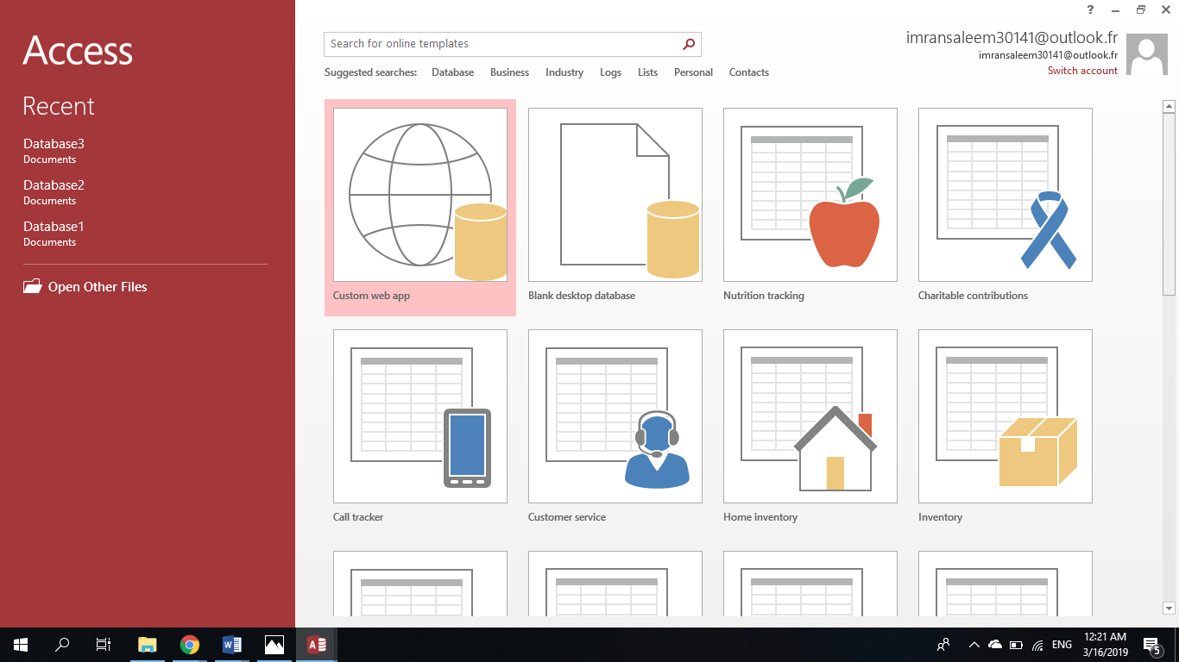

References
Kishore, A. (2013). Ultimate Troubleshooting Guide for Office 2013 Installation Problems. Online-Tech-Tips. Retrieved from https://www.online-tech-tips.com/ms-office-tips/ultimate-troubleshooting-guide-for-office-2013-installation-problems/
Slater-Robins, M. (2019). 100 common Windows 10 problems and how to solve them. Easy Fixes For Widespread Issues. Retrieved from https://www.techradar.com/how-to/100-common-windows-10-problems

