Consumer Behavior

[Name of the Writer]
[Name of the Institution]

Consumer behavior
Introduction
Marketing is an important aspect of a business. It refers to all the activities undertaken by an organization in order to promote the buying and selling of its products. The activities involved in this process are advertisement, selling and finally delivering the product to the end consumer or the other business. Almost every company depends on different marketing practices in order to increase their sales. Ultimately, it results in the upheaval of the revenues and profits of the company.
Marketing is a huge phenomenon and there are a number of concepts that come under this umbrella. One of the very prominent concepts that can be seen in the subject of marketing is consumer behavior. Consumer behavior refers to the study of various individuals, consumers, groups and organizations and their influences in making purchasing decisions. Consumer behavior also includes all the trends and the decisions that a consumer and customer make in order to purchase a product either in bulk or small quantity. A number of experts and scholars have worked on various prospects of consumer behavior and presented different theories in order to explain it. Some of the prominent theories or models that are used to explain this phenomenon are Fishbein’s Multi-attribute Attitude Model and Engel-Kollat-Blackwell Model of Consumer Behavior.

Discussion
The following discussion will entail the details of both the models of consumer behavior, i.e., Fishbein’s Multi-attribute Attitude Model and Engel-Kollat-Blackwell Model of Consumer Behavior. The discussion will also include the analysis of my personal experience of purchasing goods and products on the basis of both these models.

Fishbein’s Multi-attribute Attitude Model
Fishbein’s Multi-attribute Attitude Model (also known as the theory of planned behavior or theory of reasoned action) tries to explain the different reasons or logic that work behind the decision of purchasing a product. This model tends to consider the overall attitude of the consumer towards a particular product. The Fishbein’s Multi-attribute Attitude Model can be symbolically represented as:
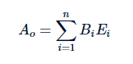
In this model, three basic variables are distinguished.
- Customer’s attitude towards a specific object (Ao),
- Certain perceptions that this particular object has some specified qualities or attributes (benefits, values or features). These perceptions are a result of prior information about the product that has been gained as a result of advertising or marketing (Bi).
- Subjective evaluation of these attributes and positive outcomes benefits from acquiring this object (Ei).

Engel-Kollat-Blackwell Model of Consumer Behavior
I personally applied this whole model to one of my very recent purchases and analyzed each and every step on the basis of my personal experience. Each and every step of the model justified my purchase and I passed through each and every step of the process before I made the purchase. The thing that I purchased was the recently launched iPhone 11 Pro Max. The EKB Model that justified my decision is as under
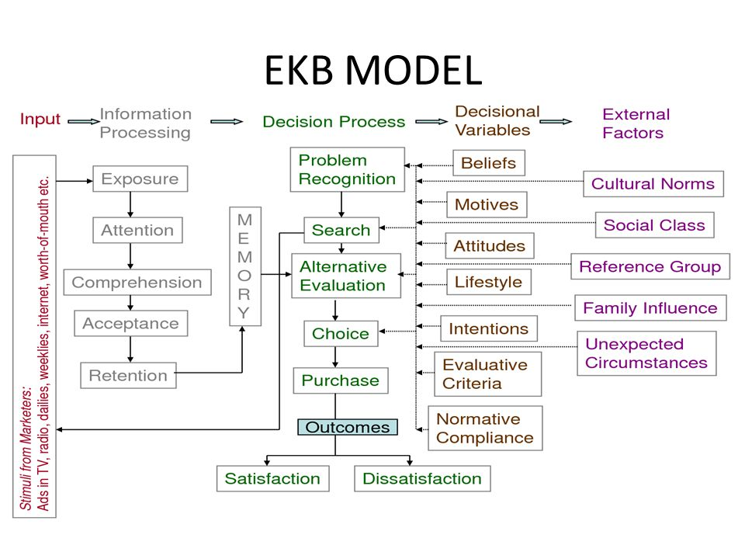
Conclusion
In a nutshell, it can be seen that both the models of consumer behavior, Fishbein’s Multi-attribute Attitude Model and Engel-Kollat-Blackwell Model of Consumer Behavior, play a very important role in the prediction and explanation of the consumer behavior. Many companies and organizations use these models to predict and examine the prevailing trends in market regarding different products and different groups of people. This helps them in modifying the products according to the latest expectations and trends of the customers.

