Marginal Utility
[Name of the Writer]
[Name of the Institution]

Marginal Utility
- 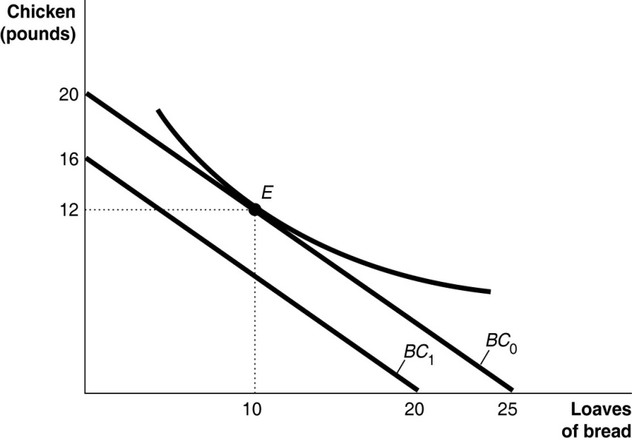
- In the above graph budget constraint is made where the horizontal axis shows bread while the vertical axis shows chicken.
- In the above graph, the indifference curve is made while the bundle is labelled as E.
- Spending = (4*10) + (5*12)
= 100$
Therefore budget is exhausted.
- When the income decreases budget line shifts to left. In the above graph, BC1 is showing budget constraint at income equals to 80$.
- Budget E cannot be affordable by Farah now because it is more than her income that is 80$.
- With the decrease in the income level, her total utility will also fall.

2.

Quantity of Pineapples | Total Utility | Marginal Utility | Marginal Utility per Dollar | Quantity of Green Tea | Total Utility | Marginal Utility | Marginal Utility per Dollar
1 | 32 | 32 | 8 | 1 | 28 | 28 | 14
2 | 52 | 20 | 5 | 2 | 46 | 18 | 9
3 | 64 | 12 | 3 | 3 | 54 | 8 | 4
4 | 68 | 4 | 1 | 4 | 60 | 6 | 3
5 | 70 | 2 | 0.5 | 5 | 64 | 4 | 2
6 | 71 | 1 | 0.25 | 6 | 66 | 2 | 1
7 | 71 | 0 | 0 | 7 | 67 | 1 | 0.5

- The utility is not maximized by Arnold if he buys two bottles of green tea and four pineapples.
As MU of pineapples per dollar = 1 and MU of green tea per dollar = 9
Therefore, TU of the bundle = 114 utils.
Marginal utilities can be equal by buying three pineapples and four bottles of green tea because its total utility will be 124.
- Behavioral economics is the branch of economics that includes the psychological factors which affect the decision making of the consumers and producers (Pesendorfer, 2006). The first mistake that consumers make is the failure to ignore sunk costs like rent of the house that cannot be returned. The second mistake is the ignorance of the nonmonetary opportunity costs like winning a lottery. The third mistake is overly optimistic regarding future decisions like the price of stocks in the future.
References
Pesendorfer, W. (2006). Behavioral Economics Comes of Age: A Review Essay on “Advances in Behavioral Economics.” Journal of Economic Literature, 44(3), 712–721. Retrieved from JSTOR.

