Assignment 1 – Article Analysis
Name of the Writer
Name of the University

Assignment 1 – Article Analysis
Q1 (a)
The supply and demand model quantifies the relationship between what quantity the producers are trying to sell at a selected price of their own in comparison to the volume of the product that the customers are wishing to buy. It is also the main model used in the determination of price in the theory of economics(Farzaneh, et al, 2016, pp. 269-285). The price of a product is then determined by how its supply and production tend to interact with each other. The price that is resulted from this interaction is known as the equilibrium price and is the representation of the agreement between the consumers and the producers of the commodity.
The Australian government have put some actions into motion in order to discourage and decrease the consumption of sugar. These include images that are graphic in nature and show the rotting of teeth’s and fatty organs. These are widely displayed on buses and billboards. Now, this way they are influencing the purchasing behaviour of the consumer of sugar. By associating the consumption of sugar with dire diseases and unhealthy body status they are forcing consumers moving away from sugar (Keenan, 2019). This way the demand for the product is gradually decreasing, whereas the supply for the product is still on the high. If more and more steps like these are taken the demand for the product (sugar) will keep going down while the supply and production will remain the same. This will decrease the price of the product as more and more consumers will be moving away from the product itself. The lower pricing would help in increasing the sales of the product.
Q1 (b)
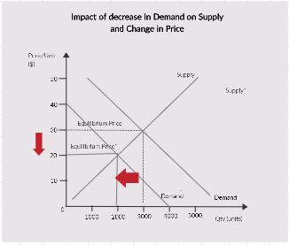
The graph illustrates the relationship between demand and supply of sugar and how it will affect the price and its changing shape over time. The demand and supply relationship is a very complex one in which each has a profound effect on each other. if the supply of the product is decreased and the demand for the product remains same then the price of the product will definitely decrease. If the demand for the product increases and the supply of the product is kept the same then the price of the product will definitely increase. The price that is calculated from the shifting of the supply or the demand curve is called the equilibrium price.
Now with the efforts of the Australian state government, the demand for the commodity (sugar) will decrease. The supply for the product will be the same as the production of the product will definitely be kept the same (Keenan, 2019). With the production kept the same, the demand for the product will decrease. With the decreasing demand the demand curve will move to the left. During this time the supply curve will remain the same. In the original graph, the point of intersection between the supply curve and the demand curve would be the original equilibrium price and this will be the original price at which sugar would be sold at. After the decrease in demand, the price would be shifted downwards and the new equilibrium price would be found. This new equilibrium price would be lower than the old one.
Q2
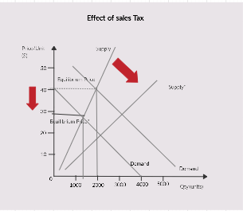
The most prominent effect of the increase in sales tax would be on the price of sugar. This is is because producers would have to pay for equipment, machinery and storing that they use. When the cost of doing business is higher in the form of sales tax, the price of sugar would definitely increase. The price is on the vertical axis of the demand and supply graph, the increasing price will cause the supply curve to move more inward. The reductions that will be witnessed in the supply would then correspond to the prices of sugar that are currently existing in Australia. This way the producers of sugar in Australia would be able to produce sugar for far less money (Keenan, 2019).
The sales tax will indirectly affect the demand for sugar in Australia. It will definitely alter the equilibrium price. When the demand is taken into account, the sales tax has a high effect on the buying power of the customers. When the sales tax would be imposed on producers in Australia, the consumers in Australia have less spending ability on goods because they have to spend more money on paying taxes. This further drives down the general demand and can also force the producers to keep the price low in order to increase the steadiness of demand. Since the sales tax will affect the price of sugar the equilibrium price would definitely fall. Producers would be able to benefit more from selling sugar in Australia.
Q3 (a)
According to economics, some products are considered elastic and some are considered inelastic. Primarily elastic products are those whose price changes with the changes within the supply or demand of the product. If there is any change in the supply or demand of that product it will be reflected in the changing prices of that product (Miller and Alberini, 2016, pp. 235-249). However, inelastic products, on the other hand, are invulnerable to the changes in the changes in its supply and demand. This is because these products are a necessity and will be used even if their prices go up and down. For example, oil prices go up and down but it does not affect its demand. This is because it is a necessity and needs to be fulfilled no matter what.
Now the demand for Kombucha is definitely elastic and this has been determined in light of the determinants of price elasticity of demand. its primary substitute, sugar, has taken a big hit in the market. It is being considered unhealthy with a sales tax being placed on it (Keenan, 2019). This has increased the demand for kombucha as it is considered a healthier option than refined sugar. Secondly, the price of Kombucha is relatively cheaper than the price of sugar in Australia. This is also another factor that explains the fact why Kombucha is price elastic rather than inelastic. Lastly, over two the price elasticity of demand of Kambucha has been great and people have adjusted to the rise in its demand and its increasing price as well.
Q3 (b)
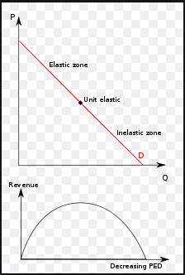
As it has been already been determined above that the Kombucha industry is elastic and this analysis has been done on the basis of the determinants of price elasticity of demand. This means that any change in the supply or demand of the kombucha industry will have a profound effect on its pricing and the profit that is being made in that industry. In Australia, due to the high efforts on diverting the Australian people away from the use of sugar by the government of Australia, the Kombucha industry has seen much growth and profit (Keenan, 2019). More and more sugar substitutes are being sold in the Australian market and people are making huge profits in this industry.
If the market trend remains the same and sugar production and selling is made harder and harder the demand for Kombucha will keep increasing. This means that this industry will keep growing and it will earn even more profits. However, if the consumer behaviour towards sugar changed and the market trend for sugar consumption would be higher than the profit ratio for the kombucha industry would definitely go down. This is sugar is a substitute for kombucha with a higher demand for it. As more and more people will go towards it the demand for Kombucha will decrease. This will affect the price of kombucha as it will be lowered in order to meet the lowering demand. Furthermore, the total revenue will also decrease.

Bibliography
Farzaneh, H., Doll, C.N. and De Oliveira, J.A.P., 2016. An integrated supply-demand model for the optimization of energy flow in the urban system. Journal of cleaner production, 114, pp.269-285.
Keenan, R. (2019). Rotting teeth and fatty organs turn Australians sour on sugar. [online] The Sydney Morning Herald. Available at: https://www.smh.com.au/business/markets/rotting-teeth-and-fatty-organs-turn-australians-sour-on-sugar-20190515-p51nfe.html [Accessed 19 Oct. 2019].
Miller, M. and Alberini, A., 2016. Sensitivity of price elasticity of demand to aggregation, unobserved heterogeneity, price trends, and price endogeneity: Evidence from US Data. Energy Policy, 97, pp.235-249.

