Student
Course
Instructor
Date
Libation Dish
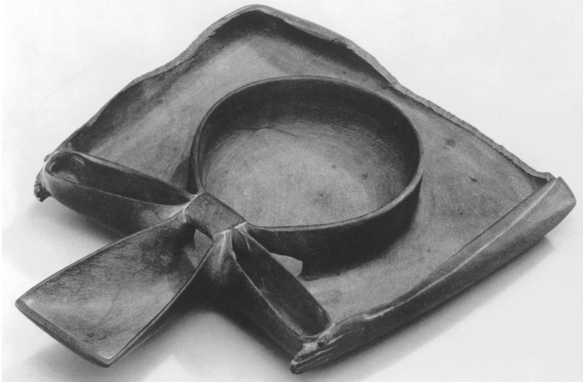
Figure 1: Libation Dish (Metmuseum.org)
The artefact ‘Libation Dish Depicting Ka-Arms Presenting an Ankh Sign’ was discovered in Egypt. It dates back to approximately 3100-2900 B.C., the first dynastic period. The medium used for this artifact is Greywacke. Its dimensions are 17.5 x 14.5 x 2.5 cm. The ownership and the exact location of this object is not known thus its provenance is kept unknown. However, it was purchased in Luxor in the fall of 1918-1919, when Ambrose Lansing was carrying out the Metropolitan Museum’s excavations in Theban Necropolis across Nile. The artisan of this object made it while keeping in mind the limitations of the materials used thus, it is well preserved than others. The subtle plasticity of the object design is strongly based on the solid floor that acts as a precursor for the extra space and there is also a large space for reinforcements at weak points. The practical nature of the dish is enhanced with a class of shape, proportion and symmetry (Fischer). A pair of arms surrounds the scraped outer edges of this dish which is the representation of their hieroglyphic character. The folded arms on the right side say ‘Ka’, representing the ‘spirit’ and on the loop and center of the object, it says ‘Ankh’, that means ‘life’. When these hieroglyphs are combined together, they can be read as ‘Ankh to my Ka’ or ‘Life to my Spirit’.
The fine details on the dish are engraved on a solid mass of siltstone with a chisel. It is quite heavy as it is made up of stone, however, it is manageable due to its design and can be moved easily. The artistry of this object is graceful and elegant as it is so thin and flat yet it was able to hold up for all these centuries. The fine lines on this dish are extremely creative as they are as much functional as they are decorative. The two arms that are folded down on the left and right sides of the hieroglyph create a barrier for preventing the water from being overflown. The loop and knot in the dish also read the hieroglyphs ‘Ka’ and has the same effect as the arms. The loop at the center is the actual bowl that is used for pouring water while the knot and ties give support and act as barriers of the dish. Water flows continuously over the stone thus, the texture of dish is precisely smooth and polished. The symmetry of this artefact is both aesthetic and functional. The dish was used for the water offerings to the soul of the people. They wanted a smooth free flowing of water down their throats without it being jagged. They believed that it gave life to their spirit. The dish itself is made such that it provides a soothing and calming effect to the sight and soul of the users. The siltstone was the right choice of material for making this object as it can endure ages while retaining its form and color. It was meant to be laid down flat on a table or on a rug on the floor as it was supposed to hold water.
In Ancient Egypt, the meanings of life, death, soul and spirit were very different than they are today. The idea of ‘Ka’, meaning spirit, was an important subject for them, as they believed that it must be fed or sustained for it had a life of its own. It was different from ‘Ba’ which meant to deal with an individual’s personality and its association with power. The ‘Ka’ should be provided with food and water through the process of ‘Ma’at’, the spiritual practice. The ‘Ka’ was the reason that made the existence possible. At the moment of death, it was believed that the ‘Ka’ had left the body and thus, ‘Ba’ was also free to move out. Therefore, in accordance to these beliefs, Ancient Egyptians continued the practice of libations of the ‘Ka’ on regular basis. In order to feed the ‘Ka’, the Libation dish was used.
The ritual of libation had its own unique specifications, such as in the first step, clean water must be poured in to the dish, then the individuals would sit in the ‘Henu’ position. The arms had to be kept out at the side bend upwards at the point of elbow and hands raised with palms facing out while all the fingers kept together. This position can also be seen in the arms carved on the rim of the dish. The users then had to use their right hand to pick up another leaf like object while reciting prayers and use it like a fan to pour the water in to their ‘Ka’. The water then flowed down in to the bowl like part of the ‘Ankh’ through various openings before it was poured into the lower part. The ‘Ankh’ was certainly planned to miraculously provide force of life to the water being poured from the dish transforming into a potent libation. However, the exact purpose of arms is still not known. It is assumed that they meant to provide protection to water in the dish or they might have some hieroglyphic importance such as ‘Ankh’. In terms of hieroglyphs, the arms symbolize the concept of ‘Ka’, life force, which was thought to be passed on from the gods to people. Some assume that the word ‘Ka’ might be another spelling for the word ‘Kau’ which means ‘nourishment’. By integrating these concepts in order to find out the meaning of the arms, one can come to a conclusion that the water poured from the Libation dish can absorb life from the ‘Ankh’, the eventual form of nourishment that is needed by the ‘Ka’ (Allen et al.).
The Ancient Egyptians believed that the soul had three shares; the ‘Ka’, the ‘Ba’, and the ‘Ankh’. the ‘Ka’ and ‘Ba’ were considered as the spiritual entities that were possessed by everyone, however, the ‘Ankh’ was a very unique entity that was reserved for only a few people who were deserving of the ‘Ma’at Kheru’. The ‘Ankh’, sign for life, is a spiritual entity as it was the transformed spirit that persisted through the death and blended with the gods. It was an effective entity that had the power to influence the living as well as the evens in this world. According to their beliefs, they held the living responsible for helping the dead while they journey in to the afterlife. It was done my maintaining tombs, which were considered as an interface among time and eternity. The preservation of bodies was also included in this belief. The extensive preparations for the burial of the body were to make sure that the ‘Ka’ had a home in the afterlife. The discovery of the Libation Dish an evidence that Ancient Egyptians were extremely spiritual people who gave importance to health of body as well as mind and souls. It was believed that if people fed their ‘Ka’ properly, they also fed their minds by learning new things every day or improving their knowledge. ‘Ka’ could also be fed by doing what according to them was ‘Ma’at’ or right and stable. Many philosophers and historians have established that Egyptians were the most pious and spiritual people and it could be seen even through their style of art and readings as well.
The Libation dish is such a simple and symmetrical object yet it has great significance. These attributes could also be used for the description of Ancient Egypt as their art was the reflection of their conditions. The Libation dish is from the first period of the early dynasty and it represents their stability, prosperity, strength, and beauty with defined roles and responsibilities of the individuals as well as society. It is perceived that the work of art is tactually the physical expression of the act itself. The physicality of the dish including the hieroglyphs “Ka’ and ‘Ankh’, the loops and the bowl to hold the water, all have their meaning and represent the attributes of the people from that period. Symbolically, the dish is an act of ‘Ka’ itself that it will be fed to the people. It is basically the ideology of the Ancient Egyptians for incorporating the strength and stability of the functions along with beauty. Thus, they believed in personifying the spirituality by benefitting from their embellished creations. The Ancient Egyptians had extremely complex ideologies as they made it evident that they would incorporate meaning with functionality in all of their art. They were also fond of beauty, thus, all of their art had its own unique shape, texture and fine details. Nothing was done or made without any sound purpose. Just as in the case of the Libation dish, the bowl, hieroglyphs, smoothness and the carvings all represent the act of feeding the spirit and giving importance to life. Every aspect of this dish is meaningful and elegant along with its spiritual function. It represents how Egyptians had sound purpose in their life and practiced their rules with dignity and pride.

Works Cited:
Allen, James P., et al. The Art of Medicine in Ancient Egypt. New York : The Metropolitan Museum of Art ; New Haven : Yale University Press, ©2005., 2005, http://www.metmuseum.org/research/metpublications/The_Art_of_Medicine_in_Ancient_Egypt.
Fischer, Henry G. “Some Emblematic Uses of Hieroglyphs with Particular Reference to an Archaic Ritual Vessel.” Metropolitan Museum Journal, vol. 5, 1972, pp. 5–23.
Metmuseum.org. N. p., 2019. Web. 28 Nov. 2019. https://www.metmuseum.org/art/collection/search/543866

