Accounting (Business)
[Author Name(s), First M. Last, Omit Titles and Degrees]
[Institutional Affiliation(s)]

Part 1
Every student thinks about suitable career options in his life. This process goes on until he finds something extremely appropriate, significant and beneficial for his future. Being a student, I have also decided to choose the most appropriate career option for my future. Living on the shore of the 21st century, the field of accountancy has become increasingly important as every profession is business oriented. I want to become an accountant because they= are performing many successful tasks such as systems development, financial analysis, statutory reporting and auditing, organizational redesign, and formulation of useful strategies. The accountants now a days are an essential asset in every business organization as they are expected to satisfy the new demands in the business environment. Nowadays the people in this job work in a relaxed and calm environment. They are no more limited or bounded by numbers, rather they work freely relying on the strategic and creative styles (Griffin & Wright, 2015).

Part 2
The following is the latest statistics displaying the professionals pursuing this career and their achievements.

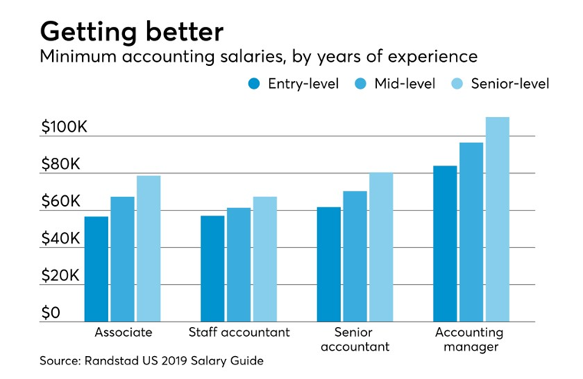
Randstad USA is a famous staffing company that has presented its salary guide of accountants and finance professionals for 2019. It details a wide range of salaries and the trends for hiring the professionals all over the country. According to this report, the job opportunities in the industry of finance and accounting would see a growth rate of almost 10 percent in 2019. This rate is seen to be higher than the combined job rate of all other professions and occupations pursued this year. The Randstad reports that the unemployment rate in the field of accounting is 2.5 percent. It is lower than the average unemployment rate of all the combined professions that is 3.7 percent national average rate, which means that the people will have to work hard twice as the normal to reach the top talent.
The guide states, “With so much competition over the same shrinking pool of talent, employers will need to act fast if they want to secure the market’s most sought-after candidates, yet, lengthy time-to-fill rates continue to impede that goal. Sixty percent of respondents to the Randstad Professionals survey reported that it takes between two to three months to fill a direct hire vacancy — and that’s much too long. Top finance and accounting talent is in high demand, and skilled candidates in these fields will have no shortage of options in 2019. To remain competitive this year, businesses should look to accelerate their hiring cycles as much as possible.”
The guide is divided into categories from entry-level to the executive level, each category is representing a professional experience of five and ten years. The salaries of these professionals is distinct by small, medium, and large companies according to the cost revenues. This shows that even and entry-level professional gets a healthy amount of salary and when he reaches to the executive level, he gets a competitive compensation and becomes part of a tight talent market of the present era (McCabe, 2019).

Part 3
The role of accountant is really important in the business world today. Their roles include auditing, manager level accounting, and the tax accounting. An independent accountant performs the basic role of auditing that consists of tasks like checking the estimate of the organization according to the formulas that are used for auditing every year. The task of managerial accounting is also significant. It is usually performed by the in-house accountants who are considered as the internal auditors or the controllers. They are expected to give the most accurate and appropriate picture of the economic and financial status of the organization or the company so that the exact report of the financial condition is displayed. Tax accounting is the third major task of an accountant. It is also known as book keeping. The tasks in this accounting include the estimation and determination of the tax liabilities of customers and clients be it corporate or individual. Now a days the emerging roles of accountants also include financial planning in which the expertise and knowledge of the accountant about financial investments and taxation laws are used. The accountant is also expected to plan business management strategies for improvement in the productivity and maximization of profitability.
There are other names that are being used for accountants that are book keepers, accounts guide managers, tax preparatory officers, financial planners, and accounts managers. The education that is required to get started with the career in accountancy is a minimum 16 years’ education in the field of accountancy. After getting the degree, an internship or training proves to be helpful and fruitful to get a job in some prestigious organization or company, Some of the skills that an accountant needs to have include good reading and writing skills, understanding of the more complex business processes, the new and innovative managerial philosophies, and changes in the business market conditions (Chaplin, 2017).

Part 4
After this research and study, I have concluded that I want to pursue my career in the field of accountancy because it is a profession in which one can get to learn a lot of technical skills. The person can easily perform long and expanded calculation within a short time along with the technical skills. An accountant becomes able to identify and explain the economic facts using his knowledge and skills (Brouard, Bujaki, Durocher, & Neilson, 2017). The aspect that attracts me the most to pursue this career is the usefulness of decisions. A reasonable knowledge of business and finance helps to make decisions about the economic information and economic activities.

References
Brouard, F., Bujaki, M., Durocher, S., & Neilson, L. C. (2017). Professional accountants’ identity formation: An integrative framework. Journal of Business Ethics, 142(2), 225–238.
Chaplin, S. (2017). Accounting Education and the Prerequisite Skills of Accounting Graduates: Are Accounting Firms’ Moving the Boundaries? Australian Accounting Review, 27(1), 61–70. https://doi.org/10.1111/auar.12146
Griffin, P. A., & Wright, A. M. (2015). Commentaries on Big Data’s Importance for Accounting and Auditing. Accounting Horizons, 29(2), 377–379. https://doi.org/10.2308/acch-51066
McCabe, S. (2019, February 11). Accounting salaries, hiring on the rise in 2019. Retrieved November 6, 2019, from Accounting Today website: https://www.accountingtoday.com/news/accounting-salaries-hiring-on-the-rise-in-2019

