Business Management: Cost-volume-profit analysis
Author’s name
[Institutional Affiliation(s)]

Author Note

Business management: Cost-volume-profit analysis
As per the data provided, the Bargain shoe store is currently working on a new marketing strategy and a business promotional strategy according to which they have hired Mary Willis as their marketing manager. The advertising manager has proposed a number of steps that are to be analyzed in this paper. This paper will revolve around the effects that the steps proposed by Mary Willis will have on the business as a whole and the technical details regarding it. The shifting of the break-even point and the margin of safety will be discussed in great detail in the crux of this analysis.

Business Analysis
The state of business before new strategy is implemented will be discussed in detail in this section. According to the data provided, the total costs are $270,000 which means that the break-even point will be calculated by looking at the total sale for the month. As per the data provided, the total profit will be calculated as,
Total pair of shoes sold = 100,000
Retail revenue per pair of shoes = $40
Cost per pair of shoes = $24
Total cost = $270,000
Total revenue = Total pair of shoes sold * Retail per pair of shoes = 100,000 * $40 = $40,000,000
Break-even point = Fixed costs / (Revenue per unit – Variable cost per unit)
= $270,000 / ($40 - $24) = 16875
Essentially, what the value of the break-even point indicates is the number of units that need to be sold in order to reach the point in which the total cost and revenue generated becomes equal i.e. there is no net profit or net loss.
The cost-volume-profit graph comes out to be,
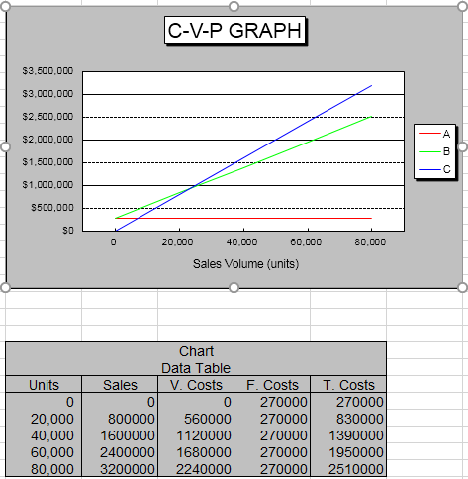

From the earlier marketing strategy and cost prices, we have the break-even point being achieved very early in the month. But if the proposal given by Mary is implemented, the break-even point will be reached a little later. The calculations for break-even point in that case will be given as,
Break-even point = Fixed costs / (Revenue per unit – Variable cost per unit)
= 294,000 / (38 – 24) = 21000
As we can see, the number of items that need to be sold in order to reach the break-even point has increased by more than 5000. The corresponding CPV graph will look something like this,
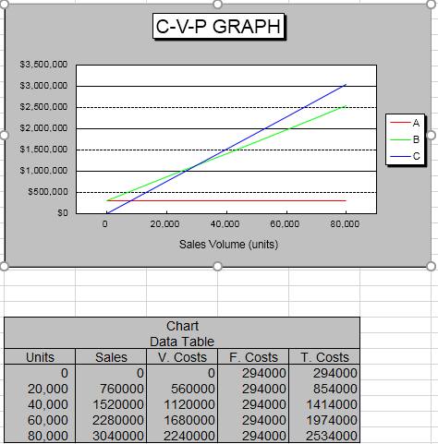
As per the new CPV graph, the value of profit that is generated by implementing Mary’s proposals is less than otherwise, but as per her analysis, the sale will increase by 20%, and if that is the case than the total net profit will increase.
Now, calculating the margin of safety ratio in both scenarios. Before implementing Mary’s proposals, the margin of safety ratio will be calculated in the following way.
Margin of safety ratio = (Actual Sales – Break even point) / Actual sales
= (100,000 – 16,875)/100,000 = 0.83125 = 83.125%
The margin of safety is considerably high and due to that we can say that the organization is relatively safe and has a good margin of employing a new strategy.
After hiring Mary and implementing her recommendations, the margin of safety ratio will be given as,
Margin of safety ratio = (Actual Sales – Break-even point) / Actual sales
= (120,000 – 21,000) / 120,000 = 0.825 = 82.5%

Conclusion
From the detailed Cost-volume-profit analysis conducted in the previous section, I would like to conclude that the company should adopt the recommendations provided by the newly hired Advertising manager. It is true that the break-even point has increased, which means that the number of items that the company has to sell in order to get to the break-even point will increase due to the decrease in selling price, but looking at the piece of insight provided by the margin of safety ratio, it needs to be said that if the decrease in price is adopted, the overall effect on the business will be good. This, also needs to be said that there is a pre-supposition that is considered as the backbone of this analysis. That pre-supposition is that the overall sale of the shoes will increase by 20% due to a small decrease of price. If there is enough evidence that this presupposition will be fulfilled, then in that case, the company should be confident in implementing the proposal of their newly hired advertising manager.

