**Municipal Utilities And 100% Renewable Energy Resources: A Memo**

Your Name

School Name or Class

Memorandum

## To: XYZ

## From: Student’s name

## Date: Date

## Subject: The Complexity of Running a Municipal Utility and Providing 100% Renewable Energy.

Phenomenally, all the cities and movements of the United States are deeming the option of establishing operations for personalized electric utilities. The notion of such initiatives is widely known as municipal utilities, and the practice is extensive and features a reputable tracking record. According to the higher authorities and campaign representatives, the implementation of municipal control as an integral strategy toward democratic and green prospects. In past decades the myriads of movements and endeavors are introduced to modify the electric system and conventional energy resources patterns in most populated territories of the United States (Hendricks, 2019). The implied scope of efforts associates the following advantages.

* Greener and much safer environmental conditions
* Permeates effectiveness in providing and managing energy resources
* The implication proffers enhanced and surpassing benefits to the public
* The system only requires a change of rights of ownership to change the world

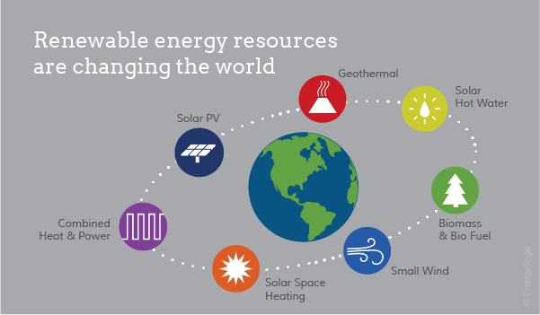

As a matter of fact, the intertwined pros of municipal utilities for 100% renewable energy compelled about more than 114 cities of the United States to depict the precise intention of acquiring renewable energy resources in the upcoming twenty years. The accelerating persuasion of the objective is paving paths for a dynamic transformation in the usage of electricity. In due course, the prevalent goals are as follow:

* Approximately three hundred cities of the United States are seeking a substantial climatic change through the utilization of renewable energy resources.
* World Resource Institute (WRI) asserts that a sizeable amount of 70 million dollars is granted from Bloomberg Philanthropies in order to facilitate the locals in taking steps for better climatic conditions. The efforts, in turn, sustained three USA states in adhering to 100% carbon-free practices.

However, the preciseness and ultimate clarity of interlinked aims and objectives do not simplify the attainment easy and convenient. Municipal utilities and implementation of 100% renewable energy resources is an intricate and tricky task that could also consume several years of setups and adjustments. Take the instance of the case of Boulder City of Colorado that is dealing with mind-tingling bargaining combat with Xcel Energy in order to construct a municipal utility. According to the recent updates, Boulder offered 94 million dollars as a final offer and anticipating the practicality of the proposal in evading the perils of condemned proceeding. Reportedly, the assets are valuated at a total of 62.3 million dollars and do not include the cost of substations. However, the offered bid enwraps approximately 100,000 items and system components integral for the energy distribution. Such elements of the distribution system are comprised of electric poles, feeders, overhead and underground transformers, as well as primary circuits and other relevant pieces of equipment. Taking a stance in creating municipal utility was not a trouble-free and straightforward experience for Boulder as the city has proposed two offers with different amounts but failed to get even a response from Xcel Energy. Nevertheless, the latest offer is under the securitization of Xcel that is seems like a positive progress in this regard (Walton, 2019).

To put it briefly, electric and municipal utilities are complicated, bothersome yet imperative in observing the macro-level commitments to a greener environment through implicating renewable energy resources and mitigation of greenhouse gas emission. Regardless of all involved complexities of running and managing municipal utilities, the fruition of hardships is worth striving. In the absence of municipal utilities, economic may encounter dwindling expansion and utilities may lose consumers to the providers of nontraditional electricity (Trabish, 2019)

**References**

Hendricks, S. (2019). What are municipal utilities and why are they suddenly popular?.   
 Retrieved 10 December 2019, from https://bigthink.com/politics-current-  
 affairs/municipal-electricity-utility

Trabish, H. (2017). Join or die: How utilities are coping with 100% renewable energy   
 goals. Retrieved 10 December 2019, from [https://www.utilitydive.com/news/join-  
 or-die-how-utilities-are-coping-with-100-renewable-energy-goals/512664/](https://www.utilitydive.com/news/join-%20%20%20%20%20%20%20%20%20%20or-die-how-utilities-are-coping-with-100-renewable-energy-goals/512664/)

Walton, R. (2019). Boulder makes $94M 'final offer' for Xcel Energy assets, in bid to   
 avoid condemnation. Retrieved 10 December 2019, from   
 https://www.utilitydive.com/news/boulder-makes-94m-final-offer-for-xcel-energy-  
 assets-in-bid-to-avoid-co/568121/