English

[Name of the Writer]

[Name of the Institution]

English
Introduction:
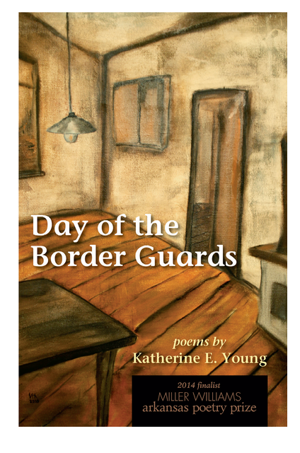
History of Author and Piece of Art:
Katherine E. Young lives in Arlington, Virginia. Katherine E. Young has studied at the Smith College and the University of Maryland (4). She has the honor to be the first Poet Laureate of Arlington (4), Virginia from year 2016 to 2018. She has written Day of the Border Guards (University of Arkansas Miller Williams Prize Series, 2014) (3), which was the winner of the Split This Rock’s “eagerly anticipated” award in 2014 (3), also the winner of Beltway Poetry’s “Best Books of 2014”(3). Her book Border Guards (University of Arkansas Press, 2014), also had an Honorable Mention for the North Carolina Poetry Society’s Brockman-Campbell Award and two chapbooks (3), her book was a finalist for the 2014 Miller Williams Arkansas Poetry Prize. Her poems and reviews (3) both have (3) been published in (3) the Prairie (3) Schoomer, Shenandoah (3), The Iowa Review (3) and in many (3) other publications. Katherine E. Young is an award-winning translator of Russian language poems and prose. She was named (3) the 2017 National Endowment for the Arts Translation Fellow for (3) the work (3) she did on a trio of novellas by Akram Aylisli (Azerbaijan), Farewell, Aylis (3). She translated the Russian poet Xenia Emelyanova (3) and came on third place (3) in 2014 Joseph Brodsky-Stephen Spender Prize competition (3). Katherine E. Young also translated the work of Inna Kabysh’s (3) and got third place in the 2011 Joseph Brodsky-Stephen Spender Prize competition and (3) was also given the 2012 Brodsky-Spender Prize. Blue Birds and Red Horses (3) is a chapbook of Inna Kabysh’s Poems (3), it was published by Toad Press in 2018 (3). Inna Kabysh’s poetry was launched in a dual-language iPad edition which included both text and audio. Artists Proof Editions in 2014 published Two Poems. Cat and Mouse is a full collection Kabysh’s work and it was nominated a finalist (3) in the Becker Book Prize in Translation (3). Katherine E. Young (3) has translated Vladimir Kornilov’s (3) work and has appeared in The Penguin Book of Russian Poetry (3). Her individual translations have (3) also been published in The Notre Dame Review, The White Review, Words Without Borders and many (3) more. She was named a Hawthornden Fellow (Scotland) in 2015.

Poem:
The process of getting old can be sore yet tender
The memories of past can be hurting yet enjoyable
A lady that's aging yet recalling the wrongs committed
Using magic in the name of hymn to be at leisure but
Still worried about what she heard at 34
Sometimes, when light is seen in the dark, it's not always the egress
The old lady has a piece of herself that's dying
Conceivably the house is also gloomy
Sometimes, what's shining isn't treasure
What's shining can be detrimental too, sometimes!
Things gravitate to lose value when you are losing yourself
The old lady's haleness dwindles ceaselessly
My heart wrenches while she drenches in torment
And so does her grand-daughter's heart
Breaks out a gut wrenching feeling
The air sounds like a sudden sigh
And a silent cry reaches up the sky
Like autumn, everything seems alluring yet tragic
Reminders can even be drawn from the words of a 9 year old
Who is Thrilled and excited for the jaunt
Wearing classic country dress with his dad
And playing around with his Aunt
Upon arriving the adolescent takes a name of a woman
Achieving attention instantly from her
Drawing a reminder in her mind of the look on her mother's face
Little does she knows, her mother's standing deadpan holding back for her to get back!

References:
- Young, K E. (2007). Poetry Sampler. Retrieved from https://katherine-young-poet.com/poetry-sampler/
- Young, K E. (2007). The Innisfree poetry journal. Retrieved from http://www.authormark.com/article_823.shtml
- Young, K E. (2007). About. Retrieved from https://katherine-young-poet.com/about-2/
- Academy of American poets. (1996). Katherine E. Young. Retrieved from https://poets.org/poet/katherine-e-young

