Network design and implementation
Smart Digital Networks Company
Student’s Name
Institution
Course Code
Date

Executive Summary
The implementation of the project, require several media or devices to make the entire project successful to achieve its objectives. Smart Digital Network intends to increase the bandwidth consumption and speed and therefore, it will require hardware which can provide the best speed and security required to attain better performance. The purpose of the project is to increase network performance and therefore, the entire network infrastructure is required to be changed. This proposal therefore, provides the type of network structure proposed, the media required for the implementation of the project and the needed devices to secure the network system.

Introduction
Smart Digital Network Company is a new firm with its headquarters building in the city. It has branches in Hornsby, Sutherland and Parramatta. It has also other small offices in Epping and Bansktown. The company’s head office is connected with all its branches using Wide Area Network (WAN). It is a retail firm, selling computers and other hardware to clients across the country and in the global market (Langer & Bayerl, 2014, p. 21). Smart Digital Network Company intends to expand its operations over the next five years so that it can accommodate the expansion plan. The expansion of end users will make the number of devices to double and therefore, there is a need for network re-structuring to be done efficiently to allow the service to be efficient after the project is completed. Currently, the firm is using four (4) servers, which is enough for the expansion process. The company will establish 14 subnets, in the head office and the branches. The subnets include the WAN links of all the branches to the office.
Problem statement
Smart digital Network Company experiencing growth and intends to expand its workforces. It is also problem with bandwidths and poor network and therefore, it caused a lot of poor connection hence delayed the operation of the company. The network infrastructure is also not designed well. The network infrastructure is not expandable and scalability is poor and therefore, it makes the entire system not durable. With poor network structure, the internet connection is also low and this needs immediate attention to solve the problem. The branches of the company are not linked to the head office. This derails the data transfer, and therefore, slows down the performance of the company. Poor connection due to lower bandwidths results to high latency, which does not allow the system to operate efficiency. These problems are some of the issues, Smart Digital Network Company is facing, which need to be solved to improve the performance of the company. In order to solve the problem, media, and network structure or layout must be changed.
Media requirement
For complete implementation of the project, several media or devices would be needed. Smart Digital Network intends to increase the bandwidth consumption and speed and therefore, it will require hardware which can provide the best speed and security required to attain better performance. For successful implementation of the project, Smart Digital Network Company will use CISCO router and Switches. The types of Cisco router preferred for the update of the network is RV300 Series. It is one of the best Cisco routers offered by Cisco Company in the market. It is preferred to be used because of its premium performance, durability and security its offers. It is high efficiency to Power Offer Ethernet. Besides it has Dual WAN ports, four or sixteen Switch Ports, firewall, AnyConnect VPN, Web Filtering, Anti-Virus, Intrusion Prevention System (IPS), and Cisco Umbrell (Lee, Chul Choy, & Bae Cho, 2014). This makes the router to be one of the secure routers, which provide high performance in the market.
Table 1: Media requirement
Nos | Devices | Purpose | QTY | Unit Price | Amount
 | Cisco Router | It is premium performance, durability and security. Above all high efficiency to Power Offer Ethernet. Besides it has Dual WAN ports, four or sixteen Switch Ports, firewall, AnyConnect VPN, Web Filtering, Anti-Virus, Intrusion Prevention System (IPS), and Cisco Umbrell | 4 | $1,449.99 | $5,799.96
 | Cisco Switch | Cisco 3560 WS-C3560  SPONSORED  Cisco 3560 WS-C3560-48TS LAYER-3 SWITCH BEST FOR CCNA CCNP CCIE ios 15 | 8 | $250 | $2000
 | Firewall | It is a supper performance LAN Cable with 550MHz of bandwidth and 10Gbps speed, and therefore, this makes it a perfect solution for the company. | 5 | $145 | $725
 | Cat6 LAN cable | Deliver high speed bandwidth. It is a supper performance LAN Cable with 550MHz of bandwidth and 10Gbps speed, and therefore, this makes it a perfect solution for the company. | 5 boxes | $80 | $400
 |  | Total |  | Total | 8929.99

Table 1: IPv4 Addressing
Subnet name | Subnet Address | Size allocated | Subnet Mask | Host range of addresses | Broadcast Address
Sales Department | 192.168.1.0 | 62 | 255.255.255.192 | 192.168.1.1 - 192.168.1.62 | 192.168.1.63
Chatswood branch | 192.168.1.64 | 62 | 255.255.255.192 | 192.168.1.65 - 192.168.1.126 | 192.168.1.127
City Head office marketing | 192.168.1.128 | 62 | 255.255.255.192 | 192.168.1.129 - 192.168.1.190 | 192.168.1.191
City Head office Account | 192.168.1.192 | 30 | 255.255.255.224 | 192.168.1.193 - 192.168.1.222 | 192.168.1.223
Leichhart branch | 192.168.1.224 | 30 | 255.255.255.224 | 192.168.1.225 - 192.168.1.254 | 192.168.1.255
Rockdale Branch | 192.168.2.0 | 30 | 255.255.255.224 | 192.168.2.1 - 192.168.2.30 | 192.168.2.31
Bankstown headquarter | 192.168.2.32 | 6 | 255.255.255.248 | 192.168.2.33 - 192.168.2.38 | 192.168.2.39
Server network | 192.168.2.40 | 6 | 255.255.255.248 | 192.168.2.41 - 192.168.2.46 | 192.168.2.47
Epping H.O | 192.168.2.48 | 2 | 255.255.255.252 | 192.168.2.49 - 192.168.2.50 | 192.168.2.51
Chatswood WAN
Leichhart WAN
Rockdale WAN
Bankstown WAN
Epping WAN

It is important to point that the WAN IP addresses and for the links will be provided by Internet Service Provider (ISP). It is the reason the table of WAN address are empty on the Table 2: IPv4 addressing above. This will be ensure that there is an improve flow bandwidth and connection. The provision designed will also help the company to reduce the latency and therefore, the download and uploads would be higher due to reduced traffic congestion.
Table 2: IPv6 Addressing
Subnet name | Subnet Address | Subnet Mask | Host range of addresses | Broadcast Address
City Head office Account | 192.168.1.0 | 255.255.255.192 | 192.168.1.1 - 192.168.1.62 | 192.168.1.63
City Head office marketing | 192.168.1.64 | 255.255.255.192 | 192.168.1.65 - 192.168.1.126 | 192.168.1.127
City Head office sales | 192.168.1.128 | 255.255.255.192 | 192.168.1.129 - 192.168.1.190 | 192.168.1.191
Chatswood branch | 192.168.1.192 | 255.255.255.224 | 192.168.1.193 - 192.168.1.222 | 192.168.1.223
Leichhart branch | 192.168.1.224 | 255.255.255.224 | 192.168.1.225 - 192.168.1.254 | 192.168.1.255
Rockdale Branch | 192.168.2.0 | 255.255.255.224 | 192.168.2.1 - 192.168.2.30 | 192.168.2.31
Bankstown headquarter | 192.168.2.32 | 255.255.255.248 | 192.168.2.33 - 192.168.2.38 | 192.168.2.39
Epping H.O. | 192.168.2.40 | 255.255.255.248 | 192.168.2.41 - 192.168.2.46 | 192.168.2.47
Server network | 192.168.2.48 | 255.255.255.252 | 192.168.2.49 - 192.168.2.50 | 192.168.2.51
Chatswood WAN
Leichhart WAN
Rockdale WAN
Bankstown WAN
Epping WAN

The VCLM table of the IPv6 would look like the illustrated above, the WAN link for the company will be provided by the ISP provided and therefore, it empty in the diagram above.
Proposed Smart Digital Network Company Logical Structure
Network Topology
The proposed topology for Smart Digital network Company is tree topology. First, network topology is the structure of the network, and it may represent the physical or logical structure of the network. It illustrates the data transfer fashion within the network. The network topology represents how the data is structured to function and therefore, it is important to ensure that there is proper flow of data within the network structure. According to Vipin (2019), there are bus network topology, point-to-point, star, ring, and tree hybrid and mesh network topology. In the case of Smart Digital network Company, a tree topology will be used for the network setup and connection. A tree topology is a hybrid network setup system where all the networks are connected through a bus. It is known as the combination of a bus and star topology and therefore, it is one of the widely used types of network topology. The reason for the choice of star topology is due to its expandability nature. A study conducted by Aliabad (2012, p. 21), concluded that star topology is easy to implement. The hybrid system gives a better bandwidth in a larger network like what Smart Digital Network Company is setting up. It is also scalable and its durability is high. It has capacity to handle. It provides interconnected method which helps in addressing the problem of IP and therefore, it provides high connection compared to other topology, which is being used for network setup.
The tree topology is implemented using multiple topologies, which include the use of variety of single nodes which is connected to a central node. The multiple stars are used either in series or tertiary nodes attached to several secondary nodes and these secondary notes are attached to the tree primary trunk node as illustrated in the diagram below of logical topology of the designed network structure of the Smart Digital Network Topology. The below topology is the, the tree topology for Smart Digital Network Company. From the look of the diagram it is noticeable that point to point is also used for the connection. In this the hierarchy is created and it is has point to point connection. The tree topology is connected in such as way that each node is linked to both primary and secondary node

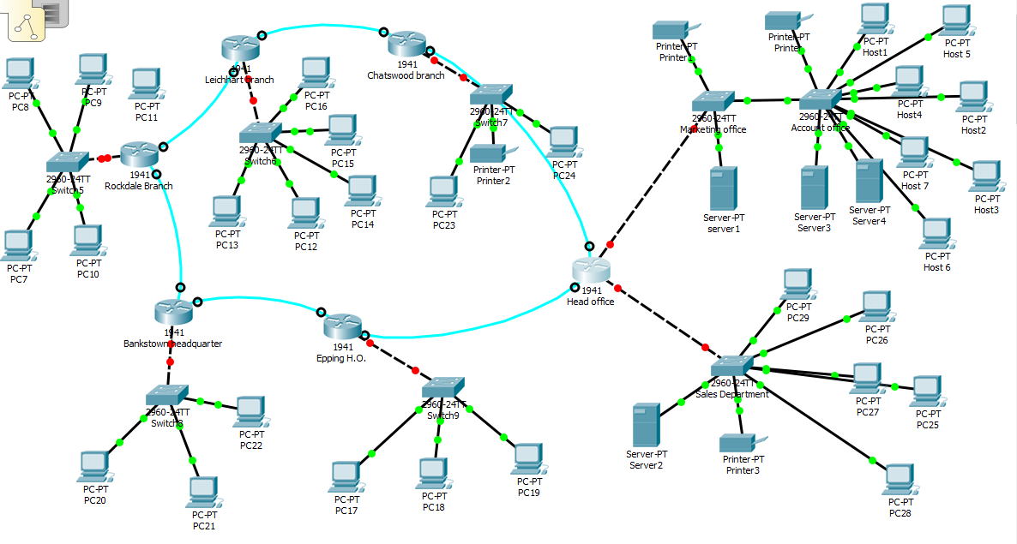
Diagram 1: Logical topology of Smart Digital Network Company
However, some of the drawback of the tree topology is that the system or structure can be crippled by any damage of the primary node. Therefore, it is recommended to have a protect tree to safeguard the system and therefore, the primary node is given a special attention to ensure that the any kind of damages are limited.
Recommendation
It is recommended to use highly durable network devices. The proposed network structure should have premium router and switches to improve the performance of the network. Since the main concern of the company is to improve the performance of its network by improving bandwidth, it is recommended to have a subscription of ISP with higher download and uploads. This could help in the provision of high speed connection and reduce high level of latency being experienced. It is also recommended to secure the network infrastructure using firewalls. Therefore, there will be installation of firewall to protect the network infrastructure from being hacked.
Conclusion
The network structure is very dynamic and the establishment of the network structure requires proper understanding of the network layout. For efficient establishment and setup of the network infrastructure it is appropriate to understand the current system. It is establishment that the best topology for the Smart Digital Network Global is Star topology. For installation of the network infrastructure to be successful, it is recommended to use Cisco Router, Switches and firewall. The usage of Cisco router and Switch and other rest of the hardware are meant to improve the bandwidth. The usage of high capacity, high speed and scalable Cisco Switches and router intend to improve the general performance of the network system of the company. With the use of star topology, which is expandable, scalable and durable, the network performance of the company will improve. It will make it easier for branches to communicate effectively and therefore, the general performance of the company will increase. The network tree topology will provide the efficiency, which is needed by the company to provide service and remain secure. Since the main concern of the company is moving from IPv4 to IPv6, the stated platform would be the best and changing the infrastructure is more likely to provide the necessary speed in terms of bandwidth required by the company.

Bibliography
Aliabad, A. R. (2012). Tree Topology.
https://www.researchgate.net/publication/228521721_Tree_Topology , 2-31.
Langer, H., & Bayerl, P. S. (2014). Text type structure and logical document structure.
https://www.researchgate.net/publication/228744651_Text_type_structure_and_logical_document_structure , 2-14.
Lee, K.-H., Chul Choy, Y., & Bae Cho, S. (2014). Logical structure analysis and generation for
structured documents: A syntactic approach. IEEE Transactions on Knowledge and Data Engineering , 2-15.
Vipin, K. (2019). AsyncBTree: Revisiting Binary Tree Topology for Efficient FPGA-Based NoC
Implementation. International Journal of Reconﬁgurable Computing , 2-15.

