Caribbean Artist -Postmodern Art, Era 1980
[Name of the Writer]
[Name of the Institution]

Caribbean Artist -Postmodern Art, Era 1980
Tamara Natalie Madden:
Tamara Natalie Madden was a Jamaica-born Painter. She was born in Kingston, Jamaica. She died at her home because of ovarian cancer on November 4. She died at the age of forty two. Tamara studied in various universities to complete her studies. She was not only the painter but also a professor at Spelman College. She migrated to America in her adulthood. In 1997, she suffered from a rare disease known as nephropathy. This was the time when she took art as a source of healing and motivation. She had a kidney transplant in 2001, and her brother donated his kidney for her sister; afterward, she perused her talent of art and participated in many exhibitions. She attended both solo and group exhibitions. Her first solo exhibition was in 2004 after her kidney transplant (Murphy, 2017).
She was one of the black artists who showed the power of black and represented her native land. Most of the artwork done by Jamaica indicates the love and dedication to her native land and people. Colleagues and friend of Madden remember her as a devoted and dedicated artist. In one of her interview she told about her inspiration. She told about her uncle, Carl in Jamaica, who was a dedicated painter. Madden found his work so inspiring and fascinating that she started drawing in picture books.
Besides deteriorating health, Madden got success and respect throughout her career. Her work graced various publications. It includes Upscale Magazine, the New York Times International, Heart & Soul Magazine, and many more. In the country of white privilege, Madden a black artist became a hope and legacy painter.
Madden did not choose painting as a career to earn money, she wanted to inspire others especially common people through her life experiences. Therefore most of her artwork reflects the objects and symbol that indicates the different aspect of her own life.
Madden Paintings and Hidden Meaning:
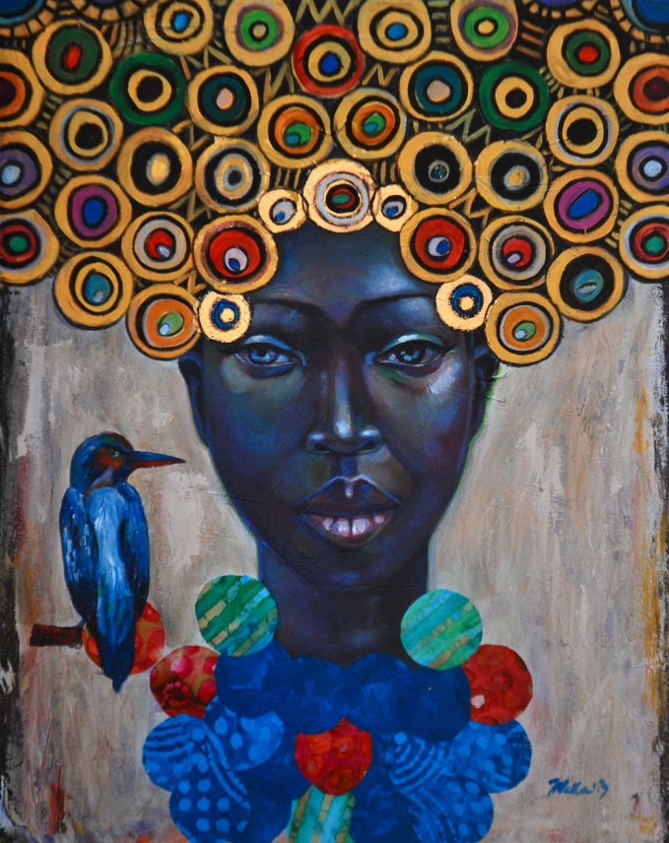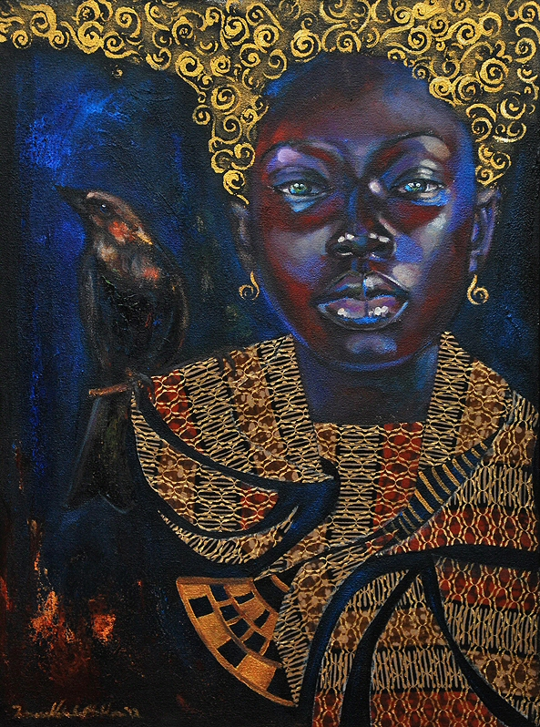
Cycles Spatial
Madden was so proud of her origin and heritage. Her paintings were different and unique from other artists because most of her work shows folk honor and prestige. She successfully presented the status of the royalty of the people around whom she grew up. In her painting, she presented a struggle and illness through birds. Also, she represented spiritual warriors and their crowns, weaponry, and armor by making golden headpiece in various paintings. As in the above paintings, i.e. cycles and spatial, Madden painted birds and golden headpiece. Madden paintings were not about the egotism. They were representative of beauty within and spiritual empowerment.
Below are some more paintings of Madden representing the same pattern and object's selection. After the recovery from her illness and struggle during her hard time, she wanted to pursue motivation, will power, struggle to the common people. This is why she always painted a bird flying or sitting on the shoulder so that people get motivated and work efficiently during her struggle and hard time.
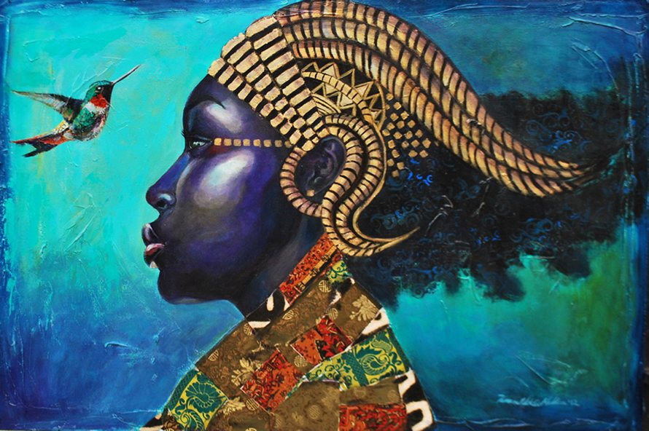
Conqueror
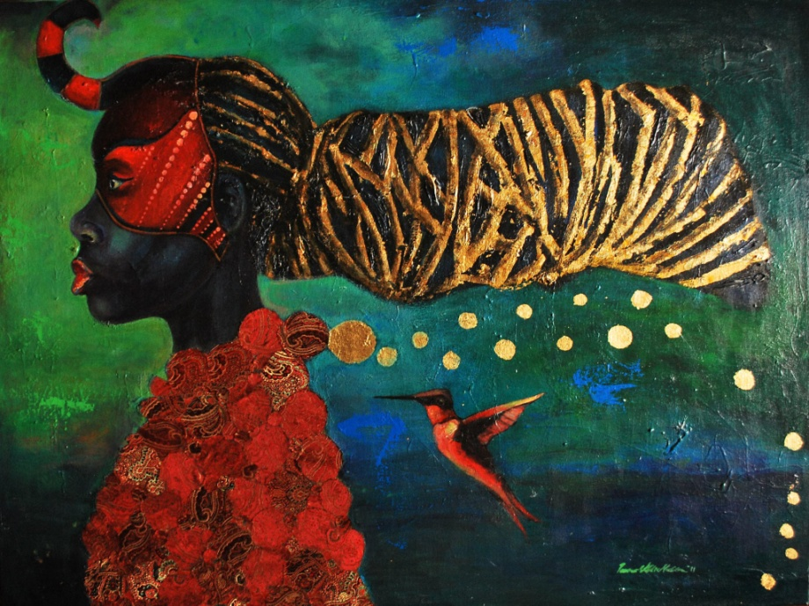
Goldilocks
Madden ‘s persuasion was varied includes artist Ras Ammar Nsorma, Gustav Klimt, Asia, Egypt, African royalty, and clothing of Indian women and Arfican people. Madden painted dress of goddess with boldly pattern dress and a tie over it in various works. It was similar to the Gustav Klimt work (“Obituary,” 2017). The exclusive coverage of dress indicates the wearer while tie to the honest labor, nature, and feelings of native land. Various Madden's paintings are in the collection of departments like Alverno College, Charles H. Wright Museum of African, etc. Madden's life and her work both are inspiration and motivation for the people.

References
Murphy, X. (2017, December 3). Obit: Artist Tamara Natalie Madden Transformed ‘Everyday Folk’ into Royalty through Painting. Retrieved March 23, 2019, from http://jamaicans.com/obit-artist-tamara-natalie-madden-transformed-everyday-folk-royalty-painting/
Obituary: Tamara Natalie Madden, Atlanta artist and Spelman professor. (2017, November 16). Retrieved March 23, 2019, from https://www.artsatl.org/obituary-tamara-natalie-madden-atlanta-artist-spelman-professor/

