Assessment 2: Case Study 2
[Name of the institution]
[name of the Author]
Class Diagram:

A class diagram describes and represent the structure of the software by representing the classes, attributes, operations and the relationship between them.
In the given case study of training Inc, the class diagram will be of 5 different classes each with different attributes and functions. The logistic department is linked with the coordinator as it have to hire it and then the coordinator which is the main class is linked with all other classes as it have to deal with all of them, the following picture is the class diagram of training Inc.
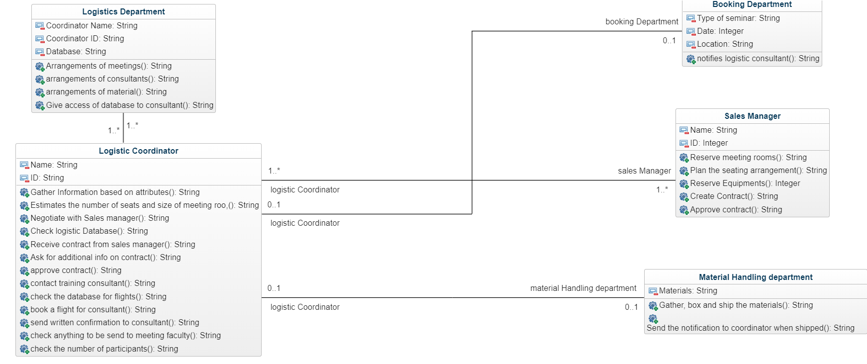

ERD Diagram:
ERD stands for entity relationship diagram. It is used in database design as it is a structural diagram. It includes different symbols like connectors that visualize two important information.
In the following ERD diagram the relationship between the class is represented. The relationship of coordinator class with the booking department and the sales manager is many to many as each pass many requests to the other. The attributes are also mentioned.

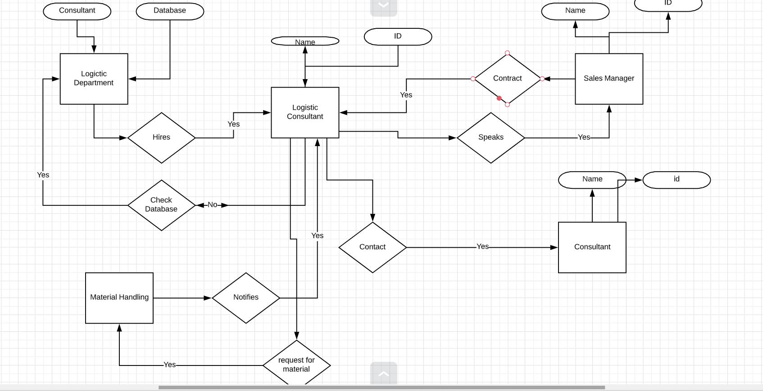

State machine diagram:
It is a diagram which shows behavior (discrete) of the designed system. Following is the state machine diagram against the given case study.

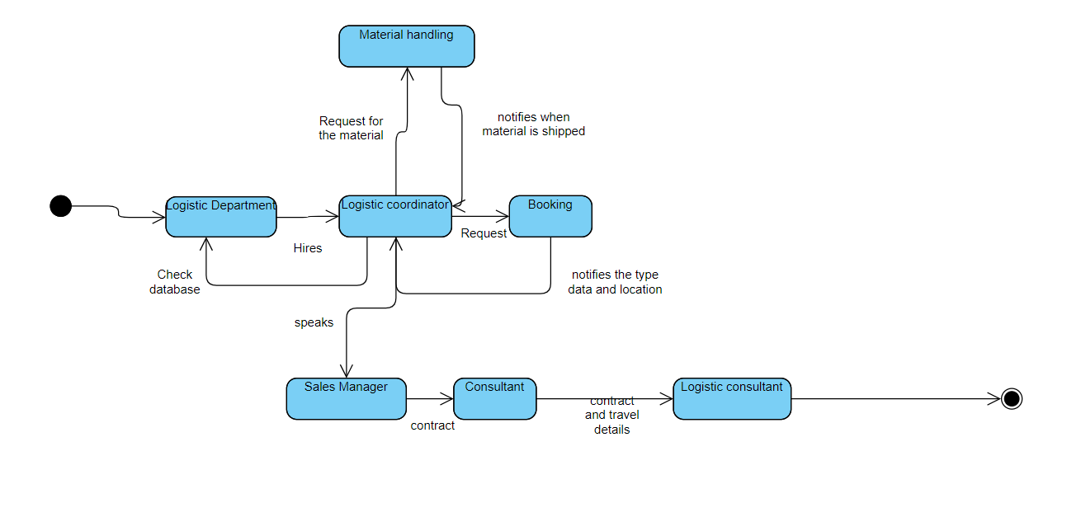

Sequence diagram:
A sequence diagram shows the interaction between the objects in an order. The following diagram is the sequence diagram against the given case study and it shows the interaction between all 5 objects and an actor.

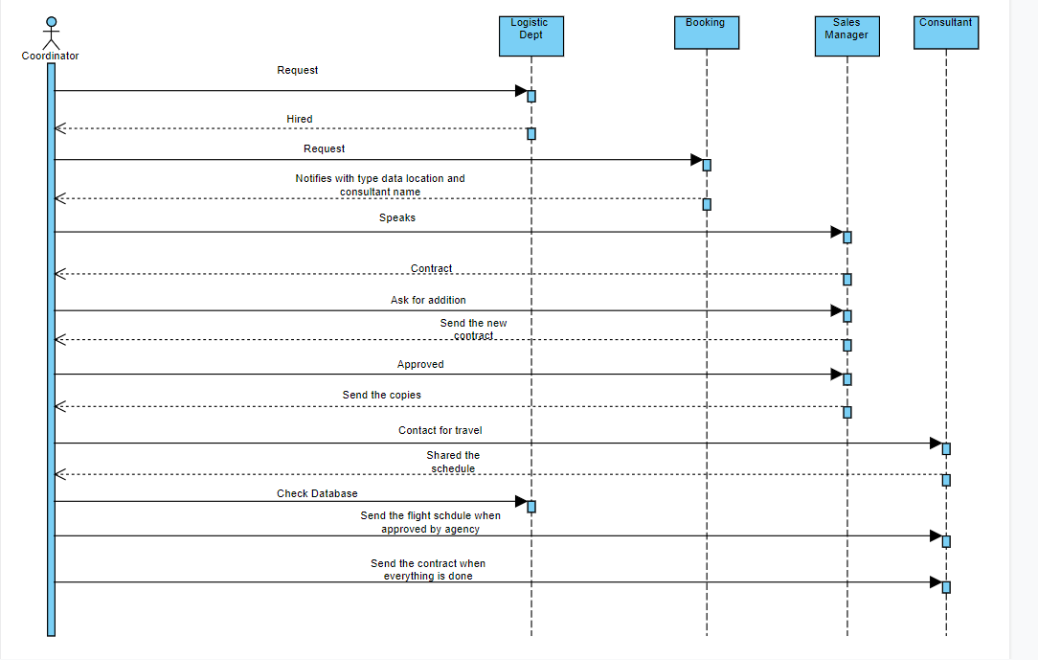

Activity Diagram:
The activity diagram is basically represents the flow of the system from one activity to another. The following diagram is the activity diagram of the case study given and it shows the flow of the system accordingly.

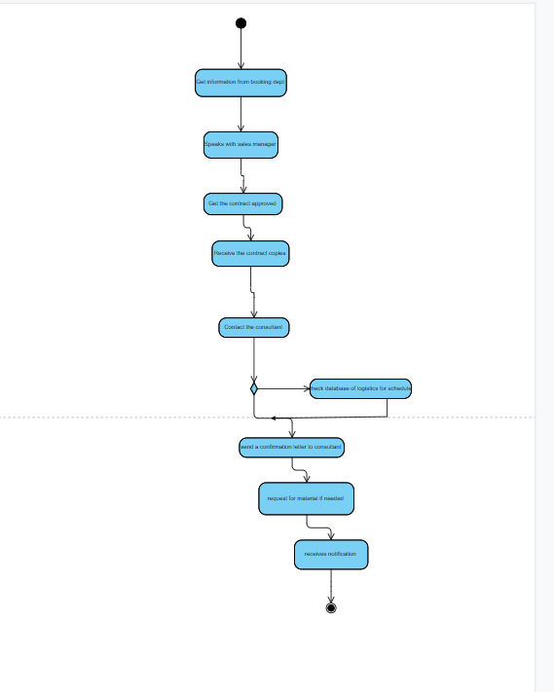

System Architecture Diagram:

It is used to show relationship of different components and mostly it is designed for systems which include hardware and software both. The following diagram is the architecture diagram of the given case study. This design is for multi-user software.

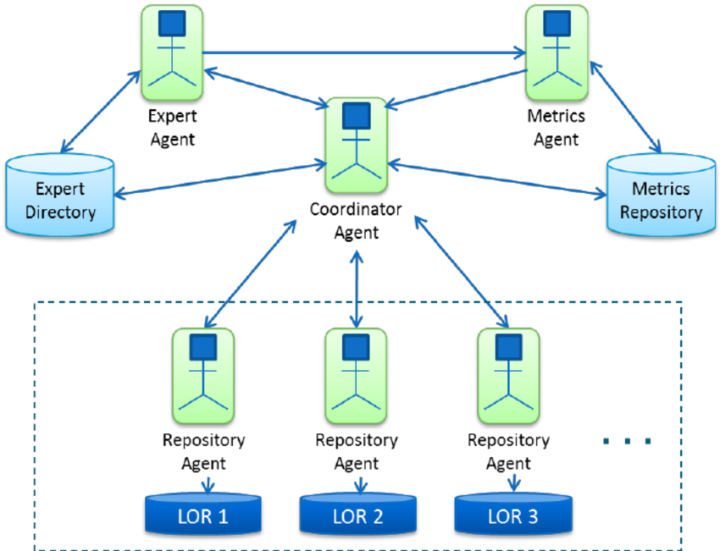

Suitable User Interface:
This is the graphical view of the system which user can read it easily. The following picture is the user interface of the software given in case study.

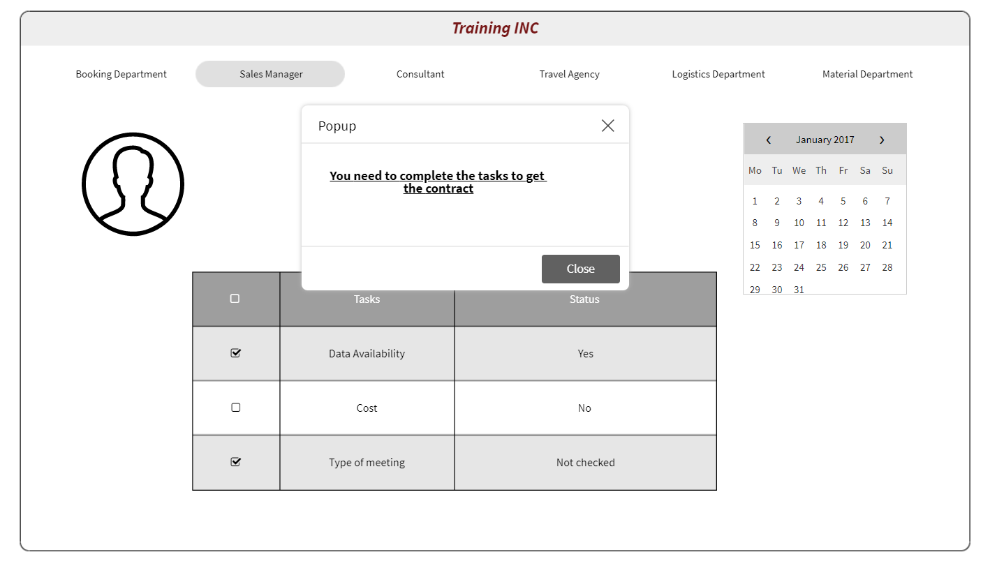

Testing and deployment activities:

Now the system is complete and ready to deploy. The quality assurance team will now test the system for the last time and then deploy it. The following picture is the plan.

