Hemoglobin
Author name
Affiliations

Structure and function of the heme group
There are four heme groups in hemoglobin. Each heme group in hemoglobin consists of a protoporporphoryn IX ring and an iron ion (ferrous). This ferrous ion can bind with four nitrogen atoms and make two additional bonds on either side of the porphyrin ring(Yuan, Tam, Simplaceanu, & Ho, 2015).In the deoxygenated state, the heme group is nonplanar that results in the pulling of the iron atom from the plane of the porphyrin in the direction of the histidine residue. In the oxygenated state, the porphyrin ring has a planar configuration.
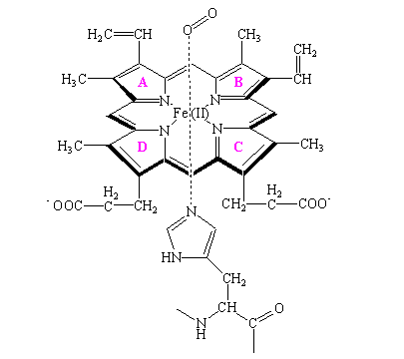
Hemoglobin has a functional specificity due to Heme group. Presence of heme group allows the binding of four oxygen molecules.This allows the hemoglobin to effectively carry the oxygen from the lungs and transport it to all tissues.
Conformational difference between the oxy-Hb and deoxy-Hb
Oxy hemoglobin is a state when oxygen is bonded to the iron. It has a relaxed structure as a result of oxygen binding and porphyrins ring gets dome form. Now the size of the iron is condensed and it is easy for it to get into the cavity of the planar porphyrin ring.Therefore, there are less intra- and inter-subunit salt bridges in this configuration.Proximal histidine is dragged with these changes and brings conformational changes in other globin subunits. Thus, heme sites get opened for oxygen binding.On the other hand, deoxyhemoglobin is a state when oxygen is not bounded to the iron and all four of the corresponding locations of iron are engaged by nitrogen of porphyrin ring.A fifth site there is Histidine residue known as proximal Histidine of globin. Deoxy hemoglobin has a tense structure.It has two alpha-globin and two beta-globin subunits, each containing a heme group. Moreover, several salt bridges are present that stabilize this structure.
Specific amino acid change as a result of the sickle cell mutation in the beta-globin polypeptide
Mutations in the β-globin gene cause sickle cell anemia. It is a single nucleotide substitution (A to T) at amino acid 6. This substitution results in valine codon (GTG) in place of a glutamic acid codon (GAG). These people have altered hemoglobin known as HbS. the valine for glutamic acid substitution deforms the red blood cell resulting in a sickle-like shape(Steinberg & Sebastiani, 2012). It is comparativelyunbending and incapable to cross the capillary couches. Now there are recurrent cycles of oxygenation and deoxygenation producing irreversible sickling(Gabriel & Przybylski, 2010). These sickling red cells then block the fine capillary beds and bring further complications such as reduced blood flow and severe bone pain.
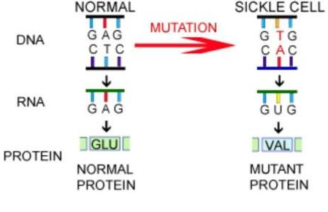
Other mutations involved in some genotypes of the sickle cell disease
Change in a single nucleotide, known as point mutation causes sickle-cell anemia. There are different causes of mutations; unequal crossing-over during meiosis. Moreover, some areas of the genome are moresusceptible to mutation as compared to others. The UV light can also cause mutations and affect DNA. Whenever a person goes into the UV light, there is a danger or risk of mutation. In addition, different chemicals can also cause alternations in the genes causing this disease in a person.

It is a blood disorder and it is possible for a person to inherit this but do not develop the symptoms. Usually, a person gets two genes that generate beta-globin. It is a protein that is required for the normal hemoglobin production known as hemoglobin A. in case of sickle cell anemia, a person has one normal beta-globin gene/ hemoglobin A and one defective gene/ hemoglobin S. These traits can be passed to childrenand result in serious problems.

References
Gabriel, A., & Przybylski, J. (2010). Sickle-cell anemia: a look at global haplotype distribution.
Steinberg, M. H., & Sebastiani, P. (2012). Genetic modifiers of sickle cell disease. American Journal of Hematology, 87(8), 795–803.
Yuan, Y., Tam, M. F., Simplaceanu, V., & Ho, C. (2015). A new look at hemoglobin allostery. Chemical Reviews, 115(4), 1702–1724.

