Lab Report
[Name of the Writer]
[Name of the Institution]

Lab Report
Hydroponics is a method of growing plants in a nutrient rich solution. In this method instead of using soil, the root system is supported by using an inert medium like perlite, Rockwool or peat moss. The main purpose of this type of solution is to allow the plant roots to come in direct contact with a solution containing all the required nutrients also providing it with easy access to oxygen which is required for the proper growth of the plant. The growing of plants without soil dates back to the fabled Hanging Gardens of Babylon which was among one of the seven wonders of the Ancient world. These gardens flourished of an intricate watering system which supplied a steady stream of river water which were rich in oxygen and also minerals ("What is Hydroponics?" n.d.).
Likewise, the ancient Egyptian hieroglyphics which dated back to several hundred years BC shows the plant growth along with the River Nile without the presence of soil. Then in 1627, Francis Bacon wrote a book on the growth of land plants without soil which was printed a year after his death and from that point hydroponics started. Then John Woodward in 1699 published his water culture experiment with spearmint, in his experiment he found that plants were grown better in less pure water than in distilled water, later in 1842 nine elements were believed to be vital for plant growth and development and then the discoveries of Julius von Sachs resulted in the discoveries of soilless cultivation, in the mineral nutrient solution, without using soil the growth of terrestrial plants is called solution culture. He published his formula of nutrient solution for water in one of his books and his formula was used as a standard formula while researching plant nutritional needs. His studies brought revolution in the hydroponic trail. Later Hogland introduced another hydroponic nutrient solution which was developed by Hogland and Snyder in 1933, this medium is one of the most rapidly used solutions for plant growth. One of the prominent property of Hogland solution is that it contains all the important nutrients for plant growth, therefore, it can be used for the growth of a wide variety of plants.
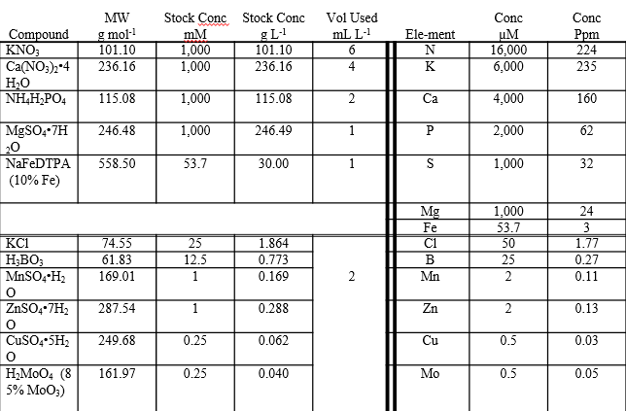
Figure 1 Hogland Medium
It is important to optimize the concentration of elements for plant growth especially those elements that are used for mankind because some of the elements that are used for plants are useful for plant growth but if they are present in higher amount in mankind then it is possible that they have detrimental effects on human health. Therefore it is important to optimize their concentration in plants that are consumed for the humans so that they do not cause any harmful effects in plants.
Hydroponic farming is better than conventional farming because hydroponic farming is physically less demanding which is why it is one of the best technique for physically handicapped people. In this case, there is not tilling, no backbreaking weeding and also the farmers are not supposed to take tension about the weather because hydroponics are mostly used inside of greenhouses. Also, hydroponics does not require any pesticides, therefore, they are safe even for human consumptions and they require less space as compared to the conventional method of farming, therefore, they are better than the conventional farming.in this particular experiment, the two plants that were used were tomato and kidney bean plants (“Hydroponics vs Soil – Hydroponics Gardening Equipment & Supplies,” n.d.). Tomato plants can grow in most of the climates, the temperature that is required is 68-80 F, in some cases it takes a longer time to germinate they need a nutrient-rich medium, the soil needs to be fast draining and also loamy. In order to produce consistent growth, they need a continuous supply of water. Kidney beans need a temperature around 60 degrees Fahrenheit to grow and they grow best in loose soil so that the roots can expand themselves better, while the plant is growing it must be kept in mind that the soil should be moist. Both of these plants are used ion daily basis and they are sources of some rich components (“Hydroponics vs Soil – Hydroponics Gardening Equipment & Supplies,” n.d.)..
Phosphorus is an essential nutrient, it is part of various plant structures and also acts as a catalyst in most biochemical reactions. It plays a vital role in capturing the sunlight and then converting it into useful plant compounds. It is also a vital component of ATP which is the energy unit of the plants. ATP is synthesized during photosynthesis and it has phosphorus as its structural component. It helps in root development, it improves crop quality and also increases the resistance to plant diseases. Magnesium is also one of the important components in plant cells and one of the most important functions of magnesium is that it is the central atom in the chlorophyll molecule (“Role of Magnesium in Plant Culture | PRO-MIX Greenhouse Growing,” n.d.). It helps to activate many plant enzymes which are needed for growth and also helps in protein synthesis. Plants that are deficient in phosphorus are stunted in growth and also they have an abnormal dark green colour. In case of Magnesium as it is mobile in plants so if they are deficient then the symptoms appear in the older leaves. The leaves will turn in to yellow colour with green veins. So in order to demonstrate the deficiency symptoms of Phosphorous and Magnesium, we created a medium in which all the other vital elements were present but only these two components were deficient and the plants that were grown in this medium are then compared with the nutrient-rich or complete medium plants and then the differences were studied in brief.
Materials and Methods:
In order to prepare each 250ml batch of the medium, we used three Solo cups this medium was deficient in phosphorus and magnesium. Apart from this medium one complete medium was also prepared and the composition of the complete medium is given below:
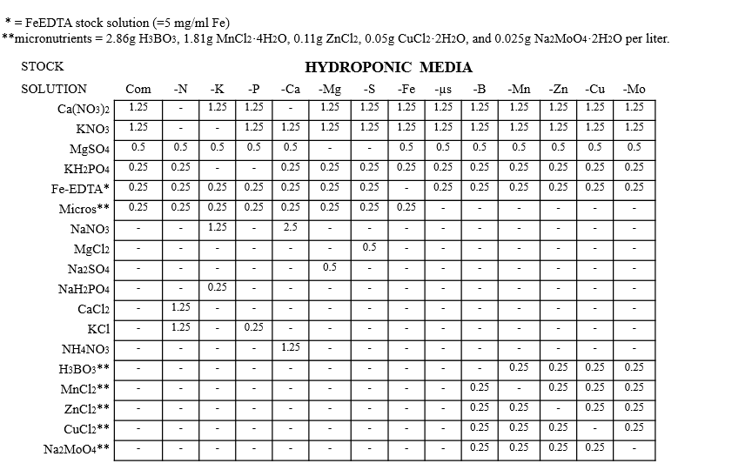
Figure 2 Complete Medium Composition
Then we labelled the cups with the name of the medium, our group name and also date. On one cup we labelled it –P, on another cup we wrote –Mg and on the third one we wrote Complete. For the batch, we put 250mL of distilled water into both of the cups. Then we added the medium components one by one into each of the cups while transferring the components we took care of contamination and also put the pippete stand near us. Once all the minerals were added we swirled the medium in order to mix them well. one-half cup of perlite was added into each cup, we added the perlite slowly and rolled the cups slowly while adding so that the perlite will set properly. In each cup, we placed one tomato seedling and on the other sup, one kidney seed plant was added. Each week we observed the growth of the plant in each of the seedling, the volume of the solution was replenished by adding distilled water. Once the trail was terminated then we made our final observation, shoot and root length were measured gently.
Results:
The plants that were grown in a complete medium were healthier and active as compared to those plants that were deficient in phosphorous and magnesium. The growth of the plants that were grown in medium all the requirements was better in their root and shoot length and also in their health, the plants were having a green colour and both the tomato and kidney beans plants looked healthier in all aspects. While the plant that was deficient in phosphorous and sulphur were weaker as compared to the plant that was grown in full medium. The plants grown in magnesium deficient medium were weaker their root and shoot length was quite less and mottled or chronic older leaves was observed, size of the plant was much smaller as compared to the controls and also the colour of the leaves was much lighter not full green. While the plants that were deficient in Phosphorous their root and shoot length was smaller as compared to the control but no apparent colour change was observed in the plants.

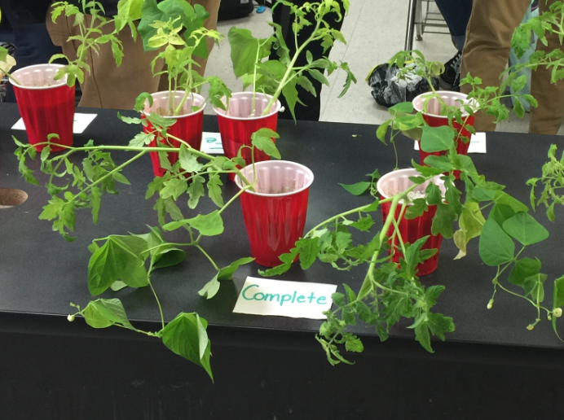
Figure 3 The growth of the plant is shown in a complete medium.

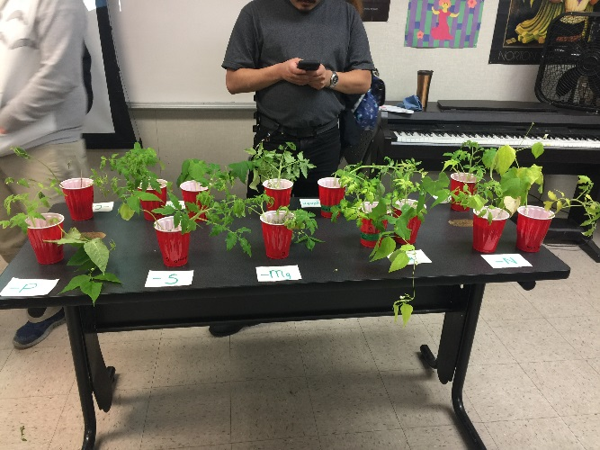
Figure 4Plants growth in nutrient deficient medium is shown
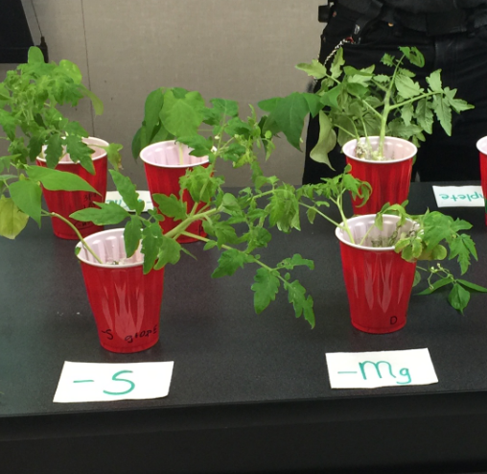
Figure 5Growth of plant in Sand Mg-deficient medium is shown
Discussion
The expected results were quite different. At the beginning of the experiment we were expecting that the plants that are deficient in magnesium will be reddened, the leaves or the tip of the plants will turn upward and stems will be slender and the plants that were deficient in phosphorous we expected them to be dark green, and also red or purple due to the accumulation of anthocyanins although some of the changes were observed in the plants but the changes were not very clear. Although the plants were weaker and also their shoot and root length was smaller but as far as the colour changes were concerned they were not observed in the plants clearly. So some of the results were expected and then they were obtained but not all the results were obtained. This experiment was a viable way of farming in the future because here the entire experiment is done inside a lab and under controlled conditions so in future as well it would be easy to increase the production of the plants through this method. Because in this method there is very little chance of plant damage and also the plants are nutrient rich so on the basis of this, we can say the hydroponics is preferable than conventional farming.
This entire experiment gave a clear idea about the nutrient requirements of the pants that how every nutrient is significant in plants for their growth and also for their overall production. This can give an insight for the farmers to find out ways that will fulfil all the nutrition requirements of the plants.

References
Hydroponics vs Soil – Hydroponics Gardening Equipment & Supplies. (n.d.). Retrieved April 10, 2019, from https://www.farmhydroponics.com/hydroponics/hydroponics-vs-soil
Role of Magnesium in Plant Culture | PRO-MIX Greenhouse Growing. (n.d.). Retrieved April 10, 2019, from https://www.pthorticulture.com/en/training-center/role-of-magnesium-in-plant-culture/
What is Hydroponics? (n.d.). Retrieved April 10, 2019, from https://generalhydroponics.com/about-us

