[Name of the Writer]
[Name of Instructor]
[Subject]
[Date]
Fragile X Syndrome
1: Fragile X Syndrom is a genetic disorder which occurs when a mutation takes place in the FMR1 gene, the FMR1 gene is normally involved in providing instructions for the synthesis of a protein that is called FMRP. This protein is present in many tissues including the brain, ovaries and also testes (Fragile X Syndrome - Genetics Home Reference - NIH).
2: The Fragile X Syndrome is inherited in an X-linked dominant pattern. X-linked dominant means that in women mutation in any one of the two copies of a gene is enough to cause the disorder (Fragile X Syndrome - Genetics Home Reference - NIH).
3: There are various symptoms of fragile X syndrome including large, protruding ears, long face, hyperextensible thumbs, flats, soft skin and also flat feet.
4: Conservative estimates suggest that this particular syndrome can affect 1 in 2500-4000 males and 1 in 7000-8000 women. The prevalence of females carrier status is considered to be as high as 1 in 130-250 population and also the prevalence of men carries status is thought to be 1 in 250-800 population. As it is an X linked syndrome, therefore, there are chances that it can effect females more as compared to males (Fragile X Syndrome: Practice Essentials, Background, Pathophysiology).
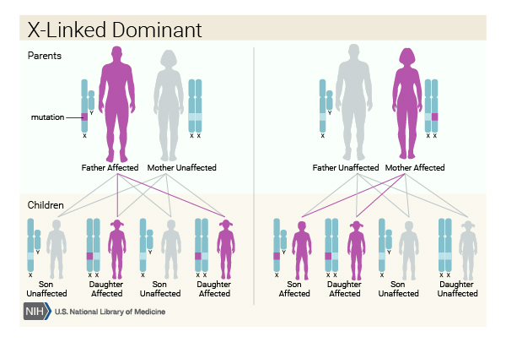
Credit: U.S. National Library of Medicine

Work Cited
Fragile X Syndrome - Genetics Home Reference - NIH. https://ghr.nlm.nih.gov/condition/fragile-x-syndrome. Accessed 10 Apr. 2019.
Fragile X Syndrome: Practice Essentials, Background, Pathophysiology. https://emedicine.medscape.com/article/943776-overview. Accessed 10 Apr. 2019.

